








Lead tour groups in a responsible manner
D2.TTG.CL3.11
Trainer Guide

Lead tour groups in a responsible manner
D2.TTG.CL3.11
Trainer Guide





Project Base
William Angliss Institute of TAFE
555 La Trobe Street
Melbourne 3000 Victoria
Telephone: | (03) 9606 2111
Facsimile: | (03) 9670 1330
Acknowledgements
Project Director: | Wayne Crosbie
Project Manager | Jim Irwin
Chief Writer: | Alan Hickman
Subject Writer: | Nick Hyland
Editor: | Jim Irwin
DTP/Production: | Daniel Chee, Mai Vu, Cindy Curran

The Association of Southeast Asian Nations (ASEAN) was established on 8 August 1967. The Member States of the Association are Brunei Darussalam, Cambodia, Indonesia, Lao PDR, Malaysia, Myanmar, Philippines, Singapore, Thailand and Viet Nam.
The ASEAN Secretariat is based in Jakarta, Indonesia.
General Information on ASEAN appears online at the ASEAN Website: www.asean.org.
All text is produced by William Angliss Institute of TAFE for the ASEAN Project on “Toolbox Development for Tourism Labour Divisions for Travel Agencies and Tour Operations”.
This publication is supported by the Australian Government’s aid program through the ASEAN-Australia Development Cooperation Program Phase II (AADCP II).
Copyright: Association of Southeast Asian Nations (ASEAN) 2015.
All rights reserved.
Disclaimer
Every effort has been made to ensure that this publication is free from errors or omissions. However, you should conduct your own enquiries and seek professional advice before relying on any fact, statement or matter contained in this book. The ASEAN Secretariat and William Angliss Institute of TAFE are not responsible for any injury, loss or damage as a result of material included or omitted from this course. Information in this module is current at the time of publication. Time of publication is indicated in the date stamp at the bottom of each page.
Some images appearing in this resource have been purchased from stock photography suppliers Shutterstock and iStockphoto and other third party copyright owners and as such are non-transferable and non-exclusive. Clip arts, font images and illustrations used are from the Microsoft Office Clip Art and Media Library. Some images have been provided by and are the property of William Angliss Institute.
Additional images have been sourced from Flickr and SXC and are used under Creative Commons licence: http://creativecommons.org/licenses/by/2.0/deed.en
File name: TG_Lead_tour_groups_in_a_resp_manner_150115





Table of contents
Competency Based Training (CBT) and assessment – An introduction for trainers 1
Competency standard 11
Notes and PowerPoint slides 23
Recommended training equipment 163
Instructions for Trainers for using PowerPoint – Presenter View 165
Appendix – ASEAN acronyms 167

Competency Based Training (CBT) and assessment – An introduction for trainers

Competency
Competency refers to the ability to perform particular tasks and duties to the standard of performance expected in the workplace.
Competency requires the application of specified knowledge, skills and attitudes relevant to effective participation, consistently over time and in the workplace environment.
The essential skills and knowledge are either identified separately or combined.
Knowledge identifies what a person needs to know to perform the work in an informed and effective manner.
Skills describe the application of knowledge to situations where understanding is converted into a workplace outcome.
Attitude describes the founding reasons behind the need for certain knowledge or why skills are performed in a specified manner.
Competency covers all aspects of workplace performance and involves:
- Performing individual tasks
- Managing a range of different tasks
- Responding to contingencies or breakdowns
- Dealing with the responsibilities of the workplace
- Working with others.

Unit of competency
Like with any training qualification or program, a range of subject topics are identified that focus on the ability in a certain work area, responsibility or function.
Each manual focuses on a specific unit of competency that applies in the hospitality workplace.
In this manual a unit of competency is identified as a ‘unit’.
Each unit of competency identifies a discrete workplace requirement and includes:
- Knowledge and skills that underpin competency
- Language, literacy and numeracy
- Occupational safety and health requirements.
Each unit of competency must be adhered to in training and assessment to ensure consistency of outcomes.

Element of competency
An element of competency describes the essential outcomes within a unit of competency.
The elements of competency are the basic building blocks of the unit of competency. They describe in terms of outcomes the significant functions and tasks that make up the competency.
In this manual elements of competency are identified as an ‘element’.

Performance criteria
Performance criteria indicate the standard of performance that is required to demonstrate achievement within an element of competency. The standards reflect identified industry skill needs.
Performance criteria will be made up of certain specified skills, knowledge and attitudes.

Learning
For the purpose of this manual learning incorporates two key activities:
- Training
- Assessment.
Both of these activities will be discussed in detail in this introduction.
Today training and assessment can be delivered in a variety of ways. It may be provided to participants:
- On-the-job – in the workplace
- Off-the-job – at an educational institution or dedicated training environment
- As a combination of these two options.
No longer is it necessary for learners to be absent from the workplace for long periods of time in order to obtain recognised and accredited qualifications.

Learning approaches
This manual will identify two avenues to facilitate learning:
Competency Based Training (CBT)
This is the strategy of developing a participant’s competency.
Educational institutions utilise a range of training strategies to ensure that participants are able to gain the knowledge and skills required for successful:
- Completion of the training program or qualification
- Implementation in the workplace.
The strategies selected should be chosen based on suitability and the learning styles of participants.

Competency Based Assessment (CBA)
This is the strategy of assessing competency of a participant.
Educational institutions utilise a range of assessment strategies to ensure that participants are assessed in a manner that demonstrates validity, fairness, reliability, flexibility and fairness of assessment processes.

Flexibility in learning
It is important to note that flexibility in training and assessment strategies is required to meet the needs of participants who may have learning difficulties. The strategies used will vary, taking into account the needs of individual participants with learning difficulties. However they will be applied in a manner which does not discriminate against the participant or the participant body as a whole.
Catering for participant diversity
Participants have diverse backgrounds, needs and interests. When planning training and assessment activities to cater for individual differences, trainers and assessors should:
- Consider individuals’ experiences, learning styles and interests
- Develop questions and activities that are aimed at different levels of ability
- Modify the expectations for some participants
- Provide opportunities for a variety of forms of participation, such as individual, pair and small group activities
- Assess participants based on individual progress and outcomes.
The diversity among participants also provides a good reason for building up a learning community in which participants support each other’s learning.
Participant centred learning
This involves taking into account structuring training and assessment that:
- Builds on strengths – Training environments need to demonstrate the many positive features of local participants (such as the attribution of academic success to effort, and the social nature of achievement motivation) and of their trainers (such as a strong emphasis on subject disciplines and moral responsibility). These strengths and uniqueness of local participants and trainers should be acknowledged and treasured
- Acknowledges prior knowledge and experience – The learning activities should be planned with participants’ prior knowledge and experience in mind
- Understands learning objectives – Each learning activity should have clear learning objectives and participants should be informed of them at the outset. Trainers should also be clear about the purpose of assignments and explain their significance to participants
- Teaches for understanding – The pedagogies chosen should aim at enabling participants to act and think flexibly with what they know
- Teaches for independent learning – Generic skills and reflection should be nurtured through learning activities in appropriate contexts of the curriculum. Participants should be encouraged to take responsibility for their own learning
- Enhances motivation – Learning is most effective when participants are motivated. Various strategies should be used to arouse the interest of participants
- Makes effective use of resources – A variety of teaching resources can be employed as tools for learning
- Maximises engagement – In conducting learning activities, it is important for the minds of participants to be actively engaged
- Aligns assessment with learning and teaching – Feedback and assessment should be an integral part of learning and teaching
- Caters for learner diversity – Trainers should be aware that participants have different characteristics and strengths and try to nurture these rather than impose a standard set of expectations.
Active learning
The goal of nurturing independent learning in participants does not imply that they always have to work in isolation or solely in a classroom. On the contrary, the construction of knowledge in tourism and hospitality studies can often best be carried out in collaboration with others in the field. Sharing experiences, insights and views on issues of common concern, and working together to collect information through conducting investigative studies in the field (active learning) can contribute a lot to their eventual success.
Active learning has an important part to play in fostering a sense of community in the class. First, to operate successfully, a learning community requires an ethos of acceptance and a sense of trust among participants, and between them and their trainers. Trainers can help to foster acceptance and trust through encouragement and personal example, and by allowing participants to take risks as they explore and articulate their views, however immature these may appear to be. Participants also come to realise that their classmates (and their trainers) are partners in learning and solving.
Trainers can also encourage cooperative learning by designing appropriate group learning tasks, which include, for example, collecting background information, conducting small-scale surveys, or producing media presentations on certain issues and themes. Participants need to be reminded that, while they should work towards successful completion of the field tasks, developing positive peer relationships in the process is an important objective of all group work.

Competency Based Training (CBT)
Principle of Competency Based Training
Competency based training is aimed at developing the knowledge, skills and attitudes of participants, through a variety of training tools.
Training strategies
The aims of this curriculum are to enable participants to:
- Undertake a variety of subject courses that are relevant to industry in the current environment
- Learn current industry skills, information and trends relevant to industry
- Learn through a range of practical and theoretical approaches
- Be able to identify, explore and solve issues in a productive manner
- Be able to become confident, equipped and flexible managers of the future
- Be ‘job ready’ and a valuable employee in the industry upon graduation of any qualification level.
To ensure participants are able to gain the knowledge and skills required to meet competency in each unit of competency in the qualification, a range of training delivery modes are used.
Types of training
In choosing learning and teaching strategies, trainers should take into account the practical, complex and multi-disciplinary nature of the subject area, as well as their participant’s prior knowledge, learning styles and abilities.
Training outcomes can be attained by utilising one or more delivery methods:
Lecture/tutorial
This is a common method of training involving transfer of information from the trainer to the participants. It is an effective approach to introduce new concepts or information to the learners and also to build upon the existing knowledge. The listener is expected to reflect on the subject and seek clarifications on the doubts.
Demonstration
Demonstration is a very effective training method that involves a trainer showing a participant how to perform a task or activity. Through a visual demonstration, trainers may also explain reasoning behind certain actions or provide supplementary information to help facilitate understanding.
Group discussions
Brainstorming in which all the members in a group express their ideas, views and opinions on a given topic. It is a free flow and exchange of knowledge among the participants and the trainer. The discussion is carried out by the group on the basis of their own experience, perceptions and values. This will facilitate acquiring new knowledge. When everybody is expected to participate in the group discussion, even the introverted persons will also get stimulated and try to articulate their feelings.
The ideas that emerge in the discussions should be noted down and presentations are to be made by the groups. Sometimes consensus needs to be arrived at on a given topic. Group discussions are to be held under the moderation of a leader guided by the trainer. Group discussion technique triggers thinking process, encourages interactions and enhances communication skills.
Role play
This is a common and very effective method of bringing into the classroom real life situations, which may not otherwise be possible. Participants are made to enact a particular role so as to give a real feel of the roles they may be called upon to play. This enables participants to understand the behaviour of others as well as their own emotions and feelings. The instructor must brief the role players on what is expected of them. The role player may either be given a ready-made script, which they can memorize and enact, or they may be required to develop their own scripts around a given situation. This technique is extremely useful in understanding creative selling techniques and human relations. It can be entertaining and energizing and it helps the reserved and less literate to express their feelings.

Simulation games
When trainees need to become aware of something that they have not been conscious of, simulations can be a useful mechanism. Simulation games are a method based on "here and now" experience shared by all the participants. The games focus on the participation of the trainees and their willingness to share their ideas with others. A "near real life" situation is created providing an opportunity to which they apply themselves by adopting certain behaviour. They then experience the impact of their behaviour on the situation. It is carried out to generate responses and reactions based on the real feelings of the participants, which are subsequently analysed by the trainer.
While use of simulation games can result in very effective learning, it needs considerable trainer competence to analyse the situations.
Individual /group exercises
Exercises are often introduced to find out how much the participant has assimilated. This method involves imparting instructions to participants on a particular subject through use of written exercises. In the group exercises, the entire class is divided into small groups, and members are asked to collaborate to arrive at a consensus or solution to a problem.
Case study
This is a training method that enables the trainer and the participant to experience a real life situation. It may be on account of events in the past or situations in the present, in which there may be one or more problems to be solved and decisions to be taken. The basic objective of a case study is to help participants diagnose, analyse and/or solve a particular problem and to make them internalize the critical inputs delivered in the training. Questions are generally given at the end of the case study to direct the participants and to stimulate their thinking towards possible solutions. Studies may be presented in written or verbal form.
Field visit
This involves a carefully planned visit or tour to a place of learning or interest. The idea is to give first-hand knowledge by personal observation of field situations, and to relate theory with practice. The emphasis is on observing, exploring, asking questions and understanding. The trainer should remember to brief the participants about what they should observe and about the customs and norms that need to be respected.
Group presentation
The participants are asked to work in groups and produce the results and findings of their group work to the members of another sub-group. By this method participants get a good picture of each other's views and perceptions on the topic and they are able to compare them with their own point of view. The pooling and sharing of findings enriches the discussion and learning process.
Practice sessions
This method is of paramount importance for skills training. Participants are provided with an opportunity to practice in a controlled situation what they have learnt. It could be real life or through a make-believe situation.

Games
This is a group process and includes those methods that involve usually fun-based activity, aimed at conveying feelings and experiences, which are everyday in nature, and applying them within the game being played. A game has set rules and regulations, and may or may not include a competitive element. After the game is played, it is essential that the participants be debriefed and their lessons and experiences consolidated by the trainer.
Research
Trainers may require learners to undertake research activities, including online research, to gather information or further understanding about a specific subject area.

Competency Based Assessment (CBA)
Principle of Competency Based Assessment
Competency based assessment is aimed at compiling a list of evidence that shows that a person is competent in a particular unit of competency.
Competencies are gained through a multitude of ways including:
- Training and development programs
- Formal education
- Life experience
- Apprenticeships
- On-the-job experience
- Self-help programs.
All of these together contribute to job competence in a person. Ultimately, assessors and participants work together, through the ‘collection of evidence’ in determining overall competence.
This evidence can be collected:
- Using different formats
- Using different people
- Collected over a period of time.
The assessor who is ideally someone with considerable experience in the area being assessed, reviews the evidence and verifies the person as being competent or not.
Flexibility in assessment
Whilst allocated assessment tools have been identified for this subject, all attempts are made to determine competency and suitable alternate assessment tools may be used, according to the requirements of the participant.
The assessment needs to be equitable for all participants, taking into account their cultural and linguistic needs.
Competency must be proven regardless of:
- Language
- Delivery Method
- Assessment Method.
Assessment objectives
The assessment tools used for subjects are designed to determine competency against the ‘elements of competency’ and their associated ‘performance criteria’.
The assessment tools are used to identify sufficient:
- Knowledge, including underpinning knowledge
- Skills
- Attitudes
Assessment tools are activities that trainees are required to undertake to prove participant competency in this subject.
All assessments must be completed satisfactorily for participants to obtain competence in this subject. There are no exceptions to this requirement, however, it is possible that in some cases several assessment items may be combined and assessed together.
Types of assessment
Allocated Assessment Tools
There are a number of assessment tools that are used to determine competency in this subject:
- Work projects
- Written questions
- Oral questions
- Third Party Report
- Observation Checklist.
Instructions on how assessors should conduct these assessment methods are explained in the Assessment Manuals.
Alternative assessment tools
Whilst this subject has identified assessment tools, as indicated above, this does not restrict the assessor from using different assessment methods to measure the competency of a participant.
Evidence is simply proof that the assessor gathers to show participants can actually do what they are required to do.
Whilst there is a distinct requirement for participants to demonstrate competency, there are many and diverse sources of evidence available to the assessor.
Ongoing performance at work, as verified by a supervisor or physical evidence, can count towards assessment. Additionally, the assessor can talk to customers or work colleagues to gather evidence about performance.
A range of assessment methods to assess competency include:
- Practical demonstrations
- Practical demonstrations in simulated work conditions
- Problem solving
- Portfolios of evidence
- Critical incident reports
- Journals
- Oral presentations
- Interviews
- Videos
- Visuals: slides, audio tapes
- Case studies
- Log books
- Projects
- Role plays
- Group projects
- Group discussions
- Examinations.
Recognition of Prior Learning
Recognition of Prior Learning is the process that gives current industry professionals who do not have a formal qualification, the opportunity to benchmark their extensive skills and experience against the standards set out in each unit of competency/subject.
Also known as a Skills Recognition Audit (SRA), this process is a learning and assessment pathway which encompasses:
- Recognition of Current Competencies (RCC)
- Skills auditing
- Gap analysis and training
- Credit transfer.
Assessing competency
As mentioned, assessment is the process of identifying a participant’s current knowledge, skills and attitudes sets against all elements of competency within a unit of competency. Traditionally in education, grades or marks were given to participants, dependent on how many questions the participant successfully answered in an assessment tool.
Competency based assessment does not award grades, but simply identifies if the participant has the knowledge, skills and attitudes to undertake the required task to the specified standard.
Therefore, when assessing competency, an assessor has two possible results that can be awarded:
- Pass Competent (PC)
- Not Yet Competent (NYC).
Pass Competent (PC)
If the participant is able to successfully answer or demonstrate what is required, to the expected standards of the performance criteria, they will be deemed as ‘Pass Competent’ (PC).
The assessor will award a ‘Pass Competent’ (PC) if they feel the participant has the necessary knowledge, skills and attitudes in all assessment tasks for a unit.
Not Yet Competent’ (NYC)
If the participant is unable to answer or demonstrate competency to the desired standard, they will be deemed to be ‘Not Yet Competent’ (NYC).
This does not mean the participant will need to complete all the assessment tasks again. The focus will be on the specific assessment tasks that were not performed to the expected standards.
The participant may be required to:
a) Undertake further training or instruction
b) Undertake the assessment task again until they are deemed to be ‘Pass Competent’.

Competency standard
UNIT TITLE: LEAD TOUR GROUPS IN A RESPONSIBLE MANNER |  | NOMINAL HOURS: 40
UNIT NUMBER: D2.TTG.CL3.11
UNIT DESCRIPTOR: This unit deals with skills and knowledge required to apply co-ordination, communication, leadership and conflict resolution skills to enable a tour group to be led in a responsible manner while on tour
ELEMENTS AND PERFORMANCE CRITERIA | UNIT VARIABLE AND ASSESSMENT GUIDE
Element 1: Identify the pre-requisites for responsible tour leadership  - Describe host enterprise policies and procedures relating to tour guiding and tour activities  - Describe the legal implications involved in conducting guiding activities  - Describe the characteristics of effective tour group leaders  Element 2: Co-ordinate tour group movements and activities  - Advise tour group members of the type of tour and the proposed movements and activities and  - Maintain adherence to the tour itinerary to the greatest extent possible  - Provide tour-related advice and information to the tour group members | Unit Variables  The Unit Variables provide advice to interpret the scope and context of this unit of competence, allowing for differences between enterprises and workplaces. It relates to the unit as a whole and facilitates holistic assessment  This unit applies to the use of manual or computerised front office systems within the labour divisions of the hotel and travel industries and may include:  - Tour Operation  Host enterprise policies and procedures may relate to:  - Safety and security requirements  - Regular counting/checking of tour group numbers, including counting tour group members back onto transport between activities, sites and destinations  - Protocols relating to unexpected events  - Plans that are in place to address emergency situations  - Need to comply with third party provider requirements regarding activities, sites and equipment  - Compliance with legislated obligations.
- Supervise movement and activities of the tour group  - Encourage tour group members to participate in the tour  - Modify planned activities, add new activities and/or delete activities where required to meet identified special needs of tour group members  - Optimise compliance with host enterprise policies and procedures, and host country legal requirements while on tour  Element 3: Facilitate tour group interaction with each other and the tour environment  - Introduce tour group members to each other, where appropriate  - Explain the objectives and opportunities provided by participating in the tour  - Use techniques to build and maintain group cohesion on tour  - Share and explain general rules that apply to group members while on tour  - Balance the needs of the group with individual needs  Element 4: Deal with on-tour problems  - Predict the potential for problems and take appropriate avoidance action  - Assess and respond to emergencies and unexpected events | Legal implications can relate to:  - Duty of care  - Due diligence  - Occupational health, safety and welfare  - Criminal offences  - Potential for civil action  - Liability issues  - Ethical conduct  - False, misleading and deceptive advertising  - Breach of contract, including conditions, terms and warranties.  Characteristics of effective tour group leaders may include:  - Ability to be proactive  - Being an effective communicator  - Respect for others  - Confidence  - Enthusiasm  - Fairness and consistency  - Open-mindedness  - Knowledgeable, skilful and competent  - Organisational ability  - Initiative  - Ability to direct and delegate.

- Resolve person-to-person conflict  - Take action to resolve tour group member dissatisfaction with the tour  - Seek to maximise tour group member enjoyment with the tour under adverse conditions | Tour group members may include:  - Domestic and international people  - Males and females  - People from different age groups  - Special interest groups  - Special needs customers  - Open groups, i.e., groups comprising an unpredictable mix of the general public  - Homogenous target market groups as defined by various demographic characteristics.
Tours will vary by type and duration and may include:
- Half and full day tours
- Extended tours
- City, rural and remote area tours
- Cultural and eco-tours
- Adventure and recreational tours
- Special interest tours
- Walking tours
- Four-wheel drive tours
- Boating, aerial and cruise tours.
Advise tour group members of proposed movements and activities may include:
- Using appropriate techniques to attract the attention of tour group members
- Explaining the itinerary
- Up-dating tour group members regarding schedules and changes to the itinerary
- Explaining reasons for changes to the itinerary
- Providing verbal and printed information
- Conducting demonstrations
- Sharing personal experience/s
- Ensuring instructions are understood.
Maintain adherence to the tour itinerary may include:
- Monitoring times to maximise the chance of staying on schedule
- Adjusting destinations and activities on the basis of events arising and time blow-outs
- Modifying allocated timelines on the basis of events arising and time blow-outs
- Liaising with staff, tour group members and providers to vary the itinerary, as necessary
- Applying effective communication and negotiation skills to provide the basis for regaining the scheduled itinerary.
Provide tour-related advice and information must include consideration of the most effective way to deliver this information based on the needs/profile of the group and may relate to:
- Describing and explaining itinerary information
- Describing and explaining carrier, supplier, venue and activity provider information
- Issuing vouchers and tickets
- Supplying contact details for tour leader and tour staff
- Explaining procedures if tour group members become separated from the group
- Providing promotional materials.
Supervise movement and activities may include:
- Providing advance warning and information of up-coming activities and destinations
- Directing tour group members to locations
- Leading tour group members to activities and locations
- Taking action to minimise unscheduled tour group member activities that jeopardise the itinerary
- Taking action to encourage tour group compliance with requirements
- Monitoring the duration of movements and activities to determine remedial action to be taken.
Encourage tour group members to participate may include:
- Providing incentives
- Issuing challenges
- Encouraging engagement
- Posing questions
- Acknowledging attempts and achievements
- Providing assistance, advice and information
- Ensuring sufficient equipment
- Positioning of activity items t appropriately where possible
- Planning for maximum participation of customers.
Special needs may relate to:
- Accommodating the needs of special needs customers – including people with disabilities, elderly, children and infants or other needs identified on the tour booking details
- Meeting promises in regard to service delivery on tour
- Incidents occurring on tour that create special need that was not present on tour departure.
Techniques to build and maintain group cohesion may include:
- Utilising initial introduction techniques
- Encouraging interaction between group members
- Initiating group activities or games
- Inviting individuals to address the group
- Utilising the skills of individual tour group members within the tour
- Focusing the group on shared experiences
- Using seat rotations systems
- Creating opportunities for individual interaction
- Accommodating individual preferences, where possible
- Keeping group informed about the itinerary and planned changes
- Facilitating attempts at group cohesion
- Creating and supporting attempts to optimise goodwill and group morale.
General rules may include:
- Acceptable and unacceptable behaviour in relation to other tour group members, local/host communities and in relation to scheduled activities and sites
- Respect for others and the environment
- Need for sharing
- Need to observe time constraints
- Basic requirements to ensure safety and security of tour group members and their possessions
- Action to take in the event of an accident or emergency
- The need to communicate and provide feedback to tour leader.

Balancing the needs of the group with individual needs may include:
- Introducing supplementary activities to cater for identified need
- Ensuring inclusiveness to the greatest extent possible
- Explaining unique individual needs to the group and asking their permission for special treatment of the special needs person.
Predicting the potential for problems may include:
- Monitoring people – including their verbal and body language
- Monitoring the physical and natural environment
- Liaising withy other staff
- Encouraging tour group members to communicate indicators of emerging or existing problems.
Responding to emergencies and unexpected events may include:
- Implementing emergency and contingency plans – including taking charge and issuing directions for action, evacuation or first-line response
- Notifying the authorities
- Seeking assistance from emergency services
- Placing the safety of people above the protection of assets
- Minimising harm, damage and disruption.
Person-to-person conflict may include:
- Conflict between tour group members – including intra-family conflict
- Conflict between tour group members and non-tour group members – including members of the public, and staff related to third-party carriers or providers
- Conflict between tour group members and host enterprise tour staff/guides

- Conflict involving authorities
- Conflict involving local communities
- Dominant, domineering and/or disruptive group members – including those affected by alcohol and/or drugs
- Sub-groups/cliques within the wider tour group
- Perceptions of favouritism by tour leader to certain tour group members.
Action to resolve tour group member dissatisfaction may include:
- Listening to the complaint to identify the cause
- Acknowledging the emotion involved in the dissatisfaction
- Suggesting or soliciting potential resolutions
- Agreeing on an acceptable solution, where possible
- Implementing the agreed solution, where practicable.
Assessment Guide
The following skills and knowledge must be assessed as part of this unit:
- Enterprise policies and procedures in regard to on-tour protocols
- Legal requirements relating to the provision of tours
- Principles of safety and security as they relate to people and assets
- Principles of group management, people management and group dynamics
- Ability to use co-ordination, communication, negotiation and conflict resolution techniques
- Ability to organise, direct, monitor and lead a group on tour
- Ability to create and maintain rapport and a professional relationship with tour group members
- Ability to generate and maintain group cohesion while on tour.

Linkages To Other Units
- Provide basic first aid procedures
- Conduct pre-departure checks
- Conduct interpretive activities in the field
- Co-ordinate and operate a day-tour (or short excursions)
- Develop and co-ordinate appropriate cultural tourism activity
- Establish and maintain safe touring conditions
- Work as a tour guide
- Manage and facilitate an extended tour experience
- Provide arrival and departure assistance
- Develop and update tourism industry knowledge
- Manage operational risk
- Maintain tourism vehicles in safe and clean operational condition
- Operate and maintain a 4 Wheel Drive vehicle in safe working condition
- Operate tours in remote areas.
Critical Aspects of Assessment
Evidence of the following is essential:
- Understanding of host enterprise policies and procedures in regard to on-tour protocols
- Demonstrated ability to co-ordinate the movements and activities of tour group members on a nominated tour to ensure adherence to a supplied itinerary
- Demonstrated ability to optimise group cohesion, goodwill and moral on a nominated tour
- Demonstrated ability to provide information to, and take appropriate proactive and remedial action with, tour group members in order to optimise their safe, enjoyable and meaningful experience while participating in a nominated tour
- Demonstrated ability to successfully and effectively resolve at least one nominated, simulated instance of person-to-person conflict between tour group members while on tour
- Demonstrated ability to respond appropriately to a simulated emergency situation that is likely to occur within the context of a nominated tour.
Context of Assessment
Assessment must ensure:
- Actual or simulated tours
- More than one assessment may be conducted on the one real or simulated tour.
Resource Implications
Training and assessment must include a real or simulated tour and itinerary, real or simulated tour group members and access to a range of actual tour-related situations.
Note:
- Emergency and conflict situations may be simulated.
Assessment Methods
The following methods may be used to assess competency for this unit:
- Observation of practical candidate performance
- Role plays
- Feedback from tour group members
- Oral and written questions
- Third party reports completed by a supervisor

- Project and assignment work
- Simulations.
Key Competencies in this Unit
Level 1 = competence to undertake tasks effectively
Level 2 = competence to manage tasks
Level 3 = competence to use concepts for evaluating
 | Key Competencies | Level | Examples
 | Collecting, organising and analysing information | 3 | Analysing safety, security and legislated tour-related issues
 | Communicating ideas and information | 2 | Communication with tour group members while on tour
 | Planning and organising activities | 1 | Leading customers on tour
 | Working with others and in teams | 2 | Liaising with tour group members, other guides/staff and attraction operators
 | Using mathematical ideas and techniques | 1 | Calculating times and revised schedules  Counting tour group members
 | Solving problems | 2 | Resolving conflict situations that arise while on tour
 | Using technology | 2 | Using emergency equipment and communication systems

Notes and PowerPoint slides
Slide
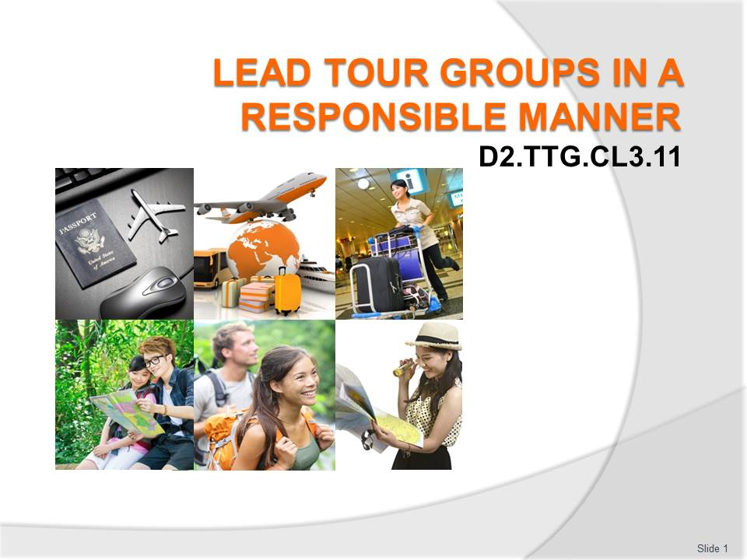
Slide No | Trainer Notes
 | Trainer welcomes students to class.

Slide
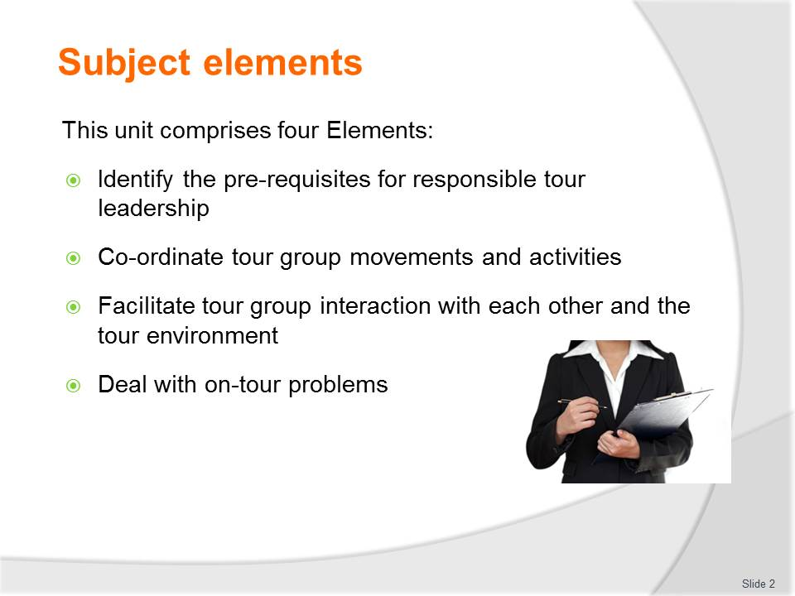
Slide No | Trainer Notes
Trainer advises this Unit comprises four Elements, as listed on the slide explaining:
- Each Element comprises a number of Performance Criteria which will be identified throughout the class and explained in detail
- Trainees can obtain more detail from their Trainee Manual
- At times the course presents advice and information about various protocols but where their workplace requirements differ to what is presented, the workplace practices and standards, as well as policies and procedures must be observed.

Slide
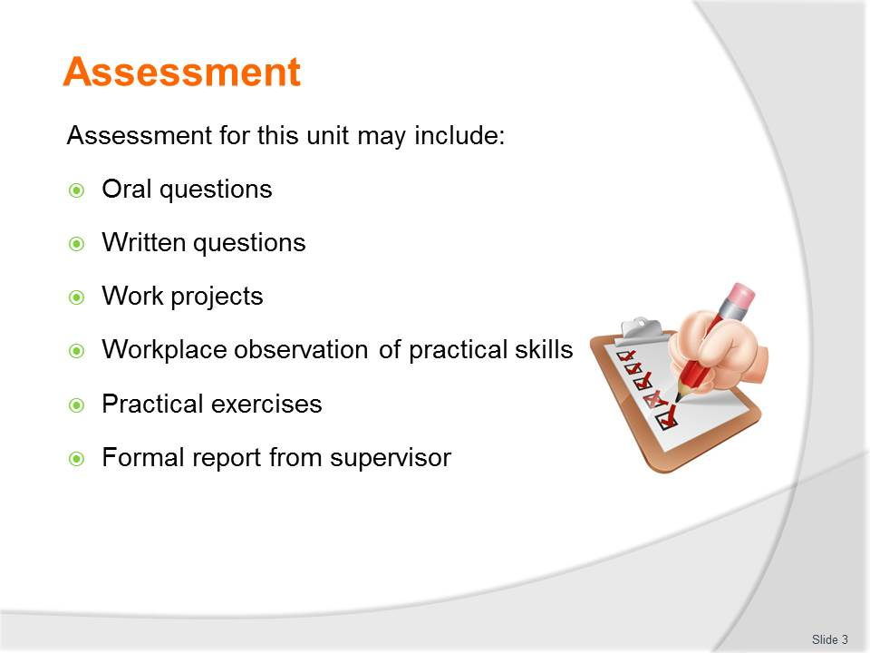
Slide No | Trainer Notes
Trainer advises that assessment for this Unit may take several forms all of which are aimed at verifying they have achieved competency for the Unit as required.
Trainer indicates the methods of assessment that will be applied to them for this Unit.

Slide
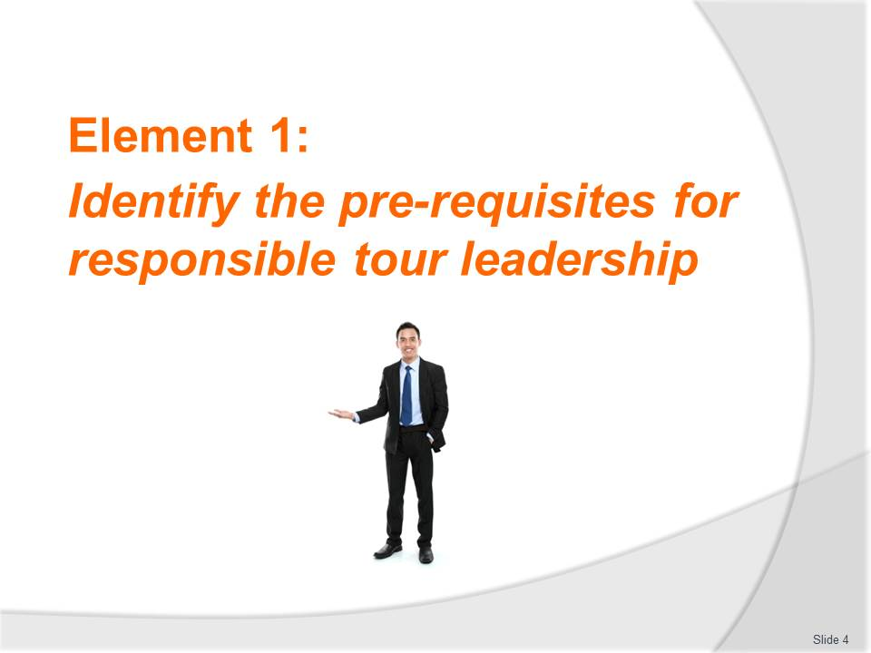
Slide No | Trainer Notes
Introduce topic
Class Activity – General Discussion
Ask general questions:
- What are the key roles of a tour guide?
- What personal characteristics are required to undertake this role?

Slide
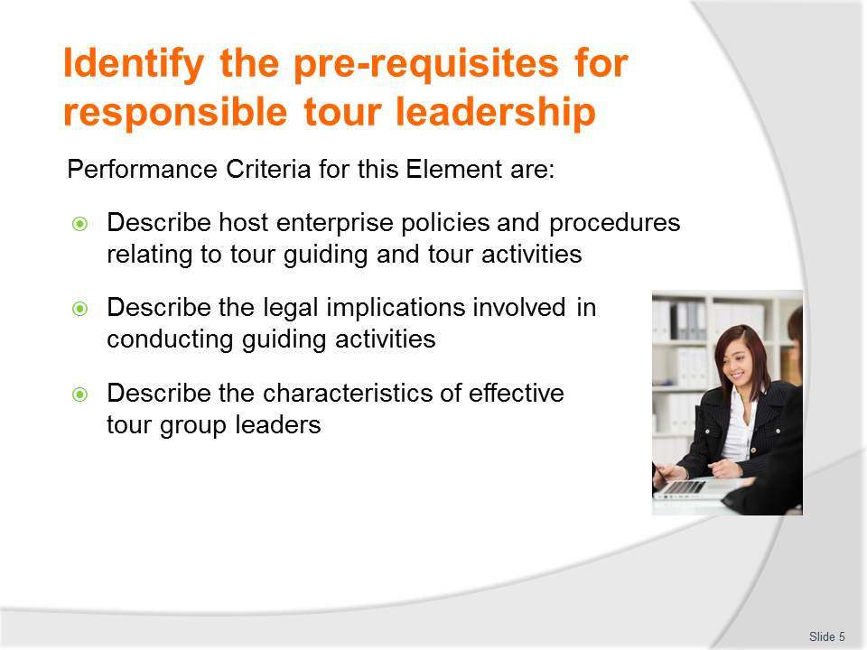
Slide No | Trainer Notes
 | Trainer identifies the Performance Criteria for this Element, as listed on the slide.

Slide
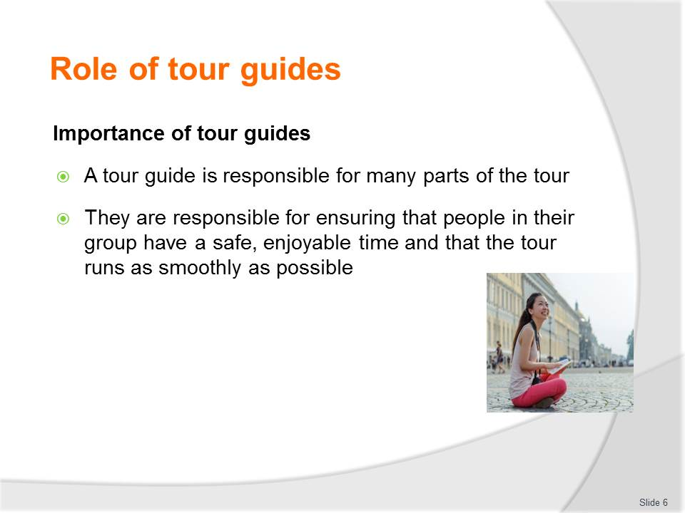
Slide No | Trainer Notes
Class Activity –Discussion & Review of Job description
- What are the key functions of tour guides?
- Review a job description for a tour guide.

Slide
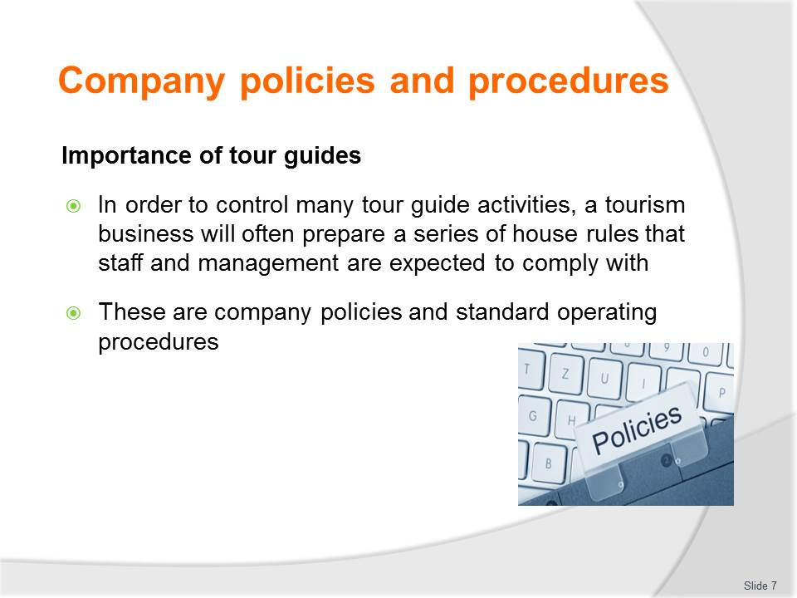
Slide No | Trainer Notes
Class Activity –Discussion & Review of SOP’s
- What are company policies and standard operating procedures that impact on a tour guide?
- Review company policies and standard operating procedures.

Slide
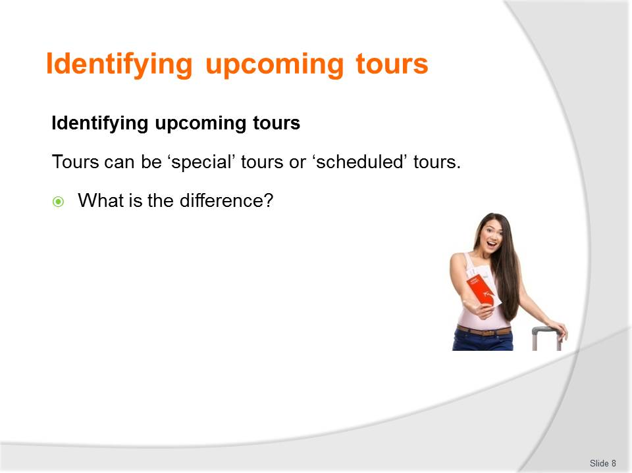
Slide No | Trainer Notes
Class Activity –Discussion
- Discuss the difference between ‘special’ tours or ‘scheduled’ tours
- Provide examples of how they are different.

Slide
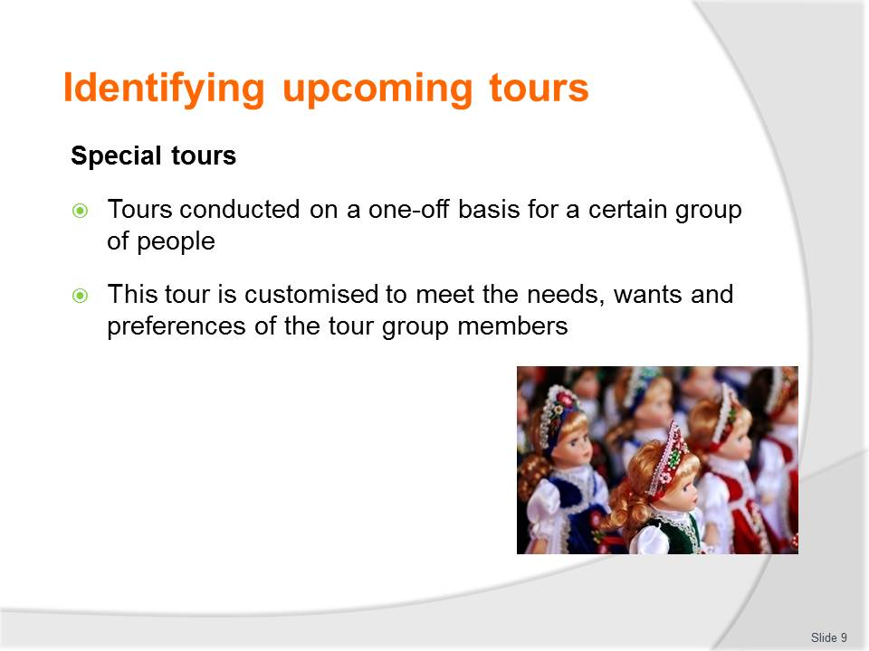
Slide No | Trainer Notes
Class Activity –Discussion
- Identify types of ‘special’ tours
- Discuss the inclusions / suggested itinerary of these tours.

Slide
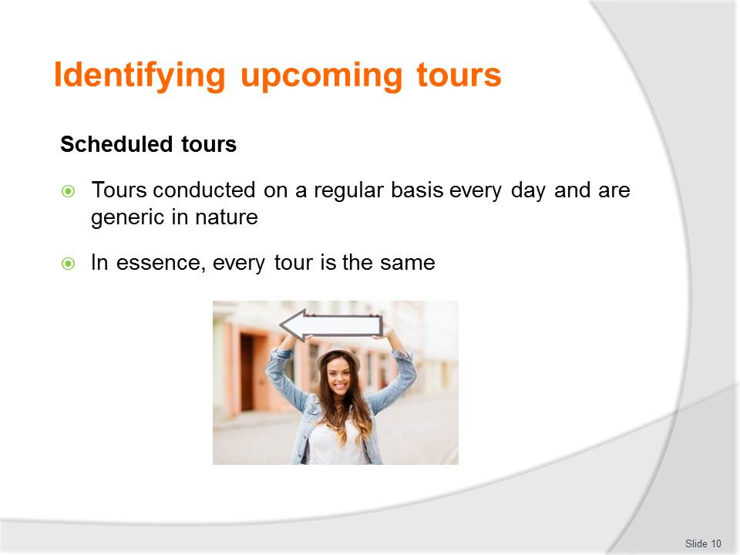
Slide No | Trainer Notes
Class Activity –Discussion
- Identify types of ‘scheduled’ tours
- Discuss the inclusions / suggested itinerary of these tours.

Slide
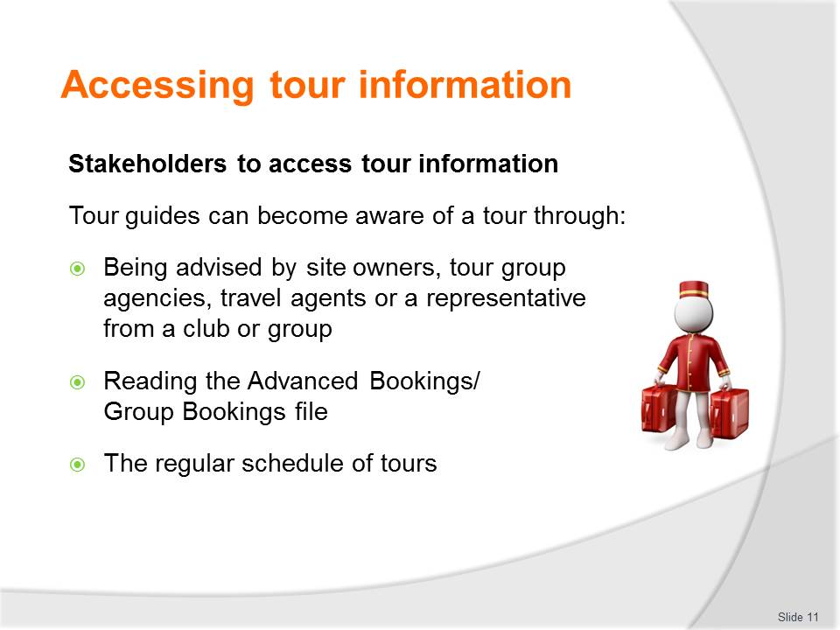
Slide No | Trainer Notes
Class Activity –Discussion & Review Advanced Bookings/Group Bookings file
- What stakeholders need information regarding a tour?
- What information do each of these stakeholders need?
- Review copy of Advanced Bookings/Group Bookings file.

Slide
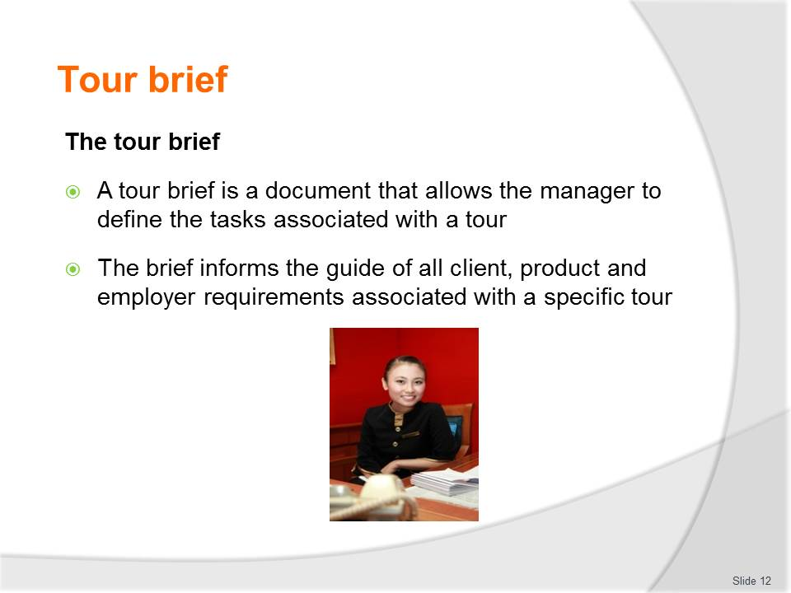
Slide No | Trainer Notes
Class Activity –Discussion & Review tour briefs
- What information is contained in a tour brief?
- Review copies of various tour briefs.

Slide
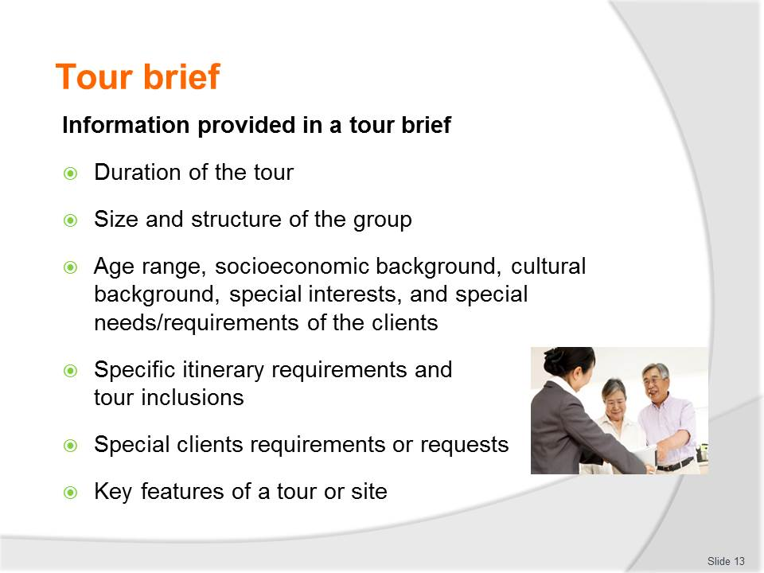
Slide No | Trainer Notes
Class Activity –Discussion contents of a tour brief
- Discuss information included in each of these tour brief points.

Slide
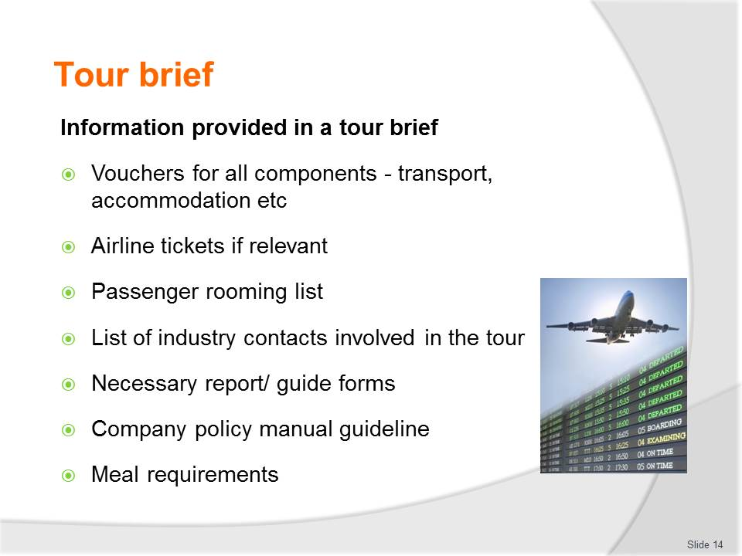
Slide No | Trainer Notes
Class Activity –Discussion contents of a tour brief
- Discuss information included in each of these tour brief points.

Slide

Slide No | Trainer Notes
Class Activity –Review & discuss contents of a contract
- Review tour contracts
- Discuss information included in contracts.

Slide
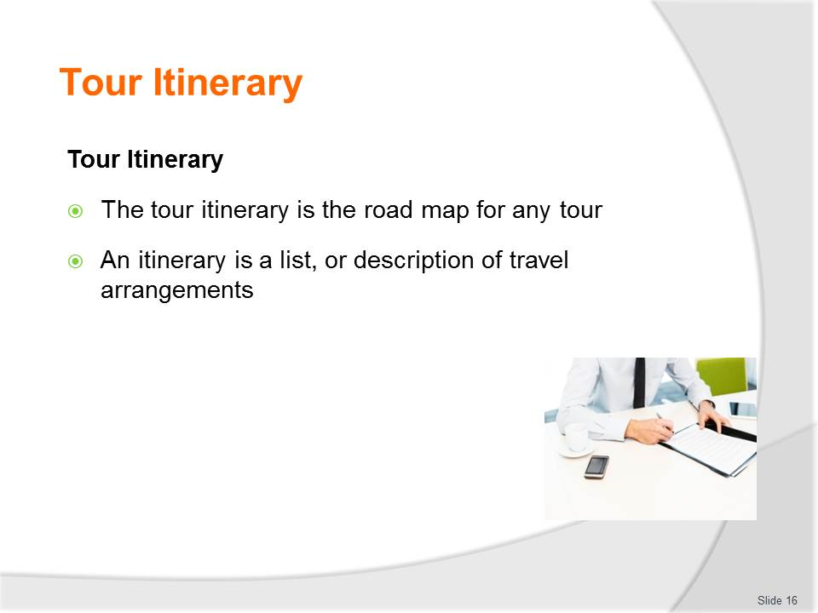
Slide No | Trainer Notes
Class Activity –Discussion & Review tour itineraries
- What information is contained in a tour itinerary?
- How does it differ to a tour brief?
- Review copies of various tour itineraries.

Slide
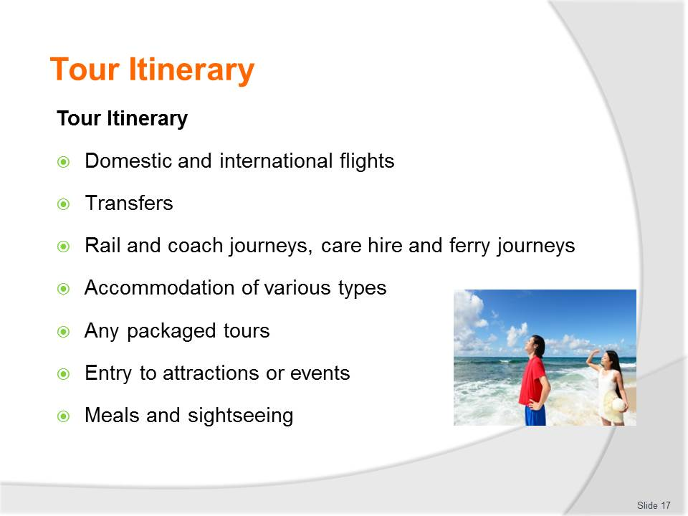
Slide No | Trainer Notes
Class Activity –Discussion contents of a tour itinerary
- Discuss information included in each of these tour itinerary points.

Slide
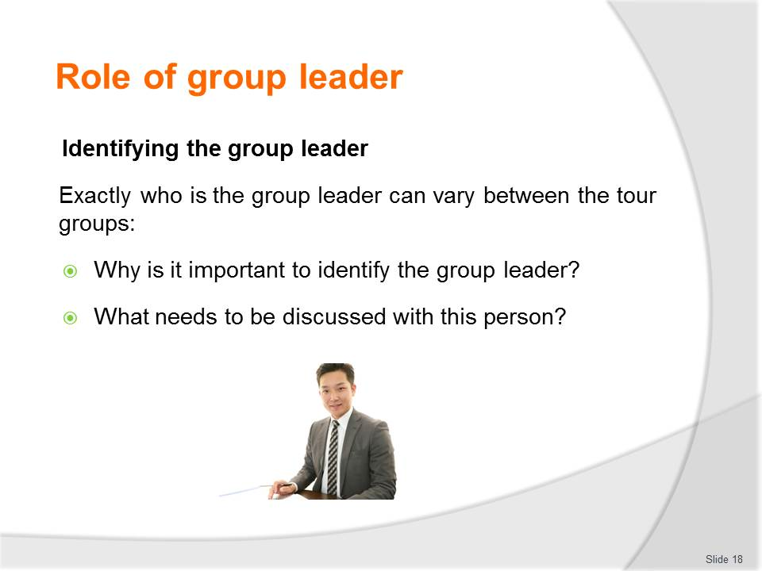
Slide No | Trainer Notes
Class Activity –Discussion
- Discuss the questions in the slide.

Slide
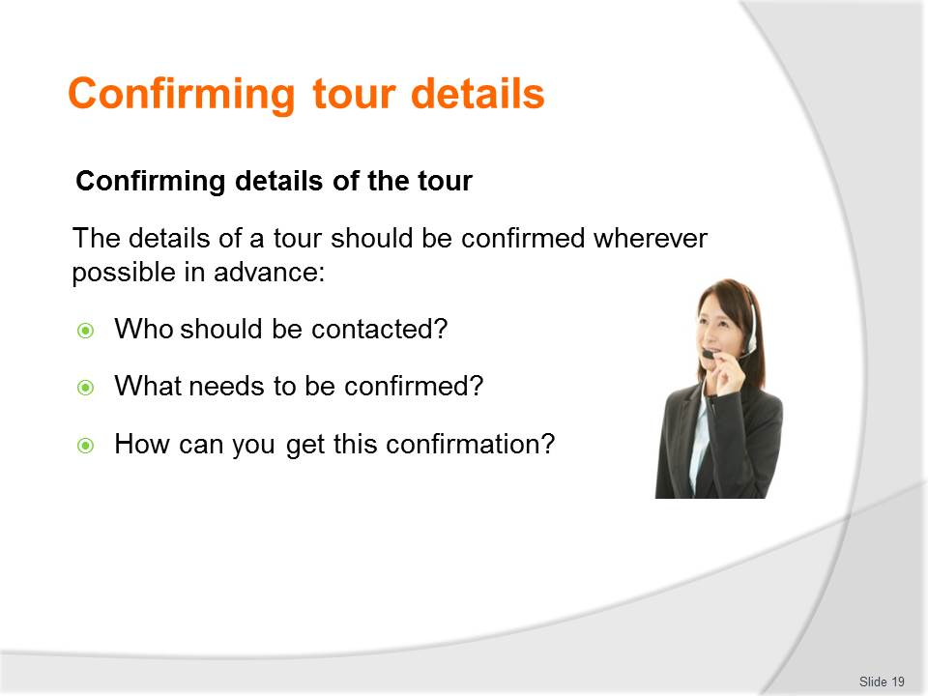
Slide No | Trainer Notes
Class Activity –Discussion
- Discuss the questions in the slide.

Slide
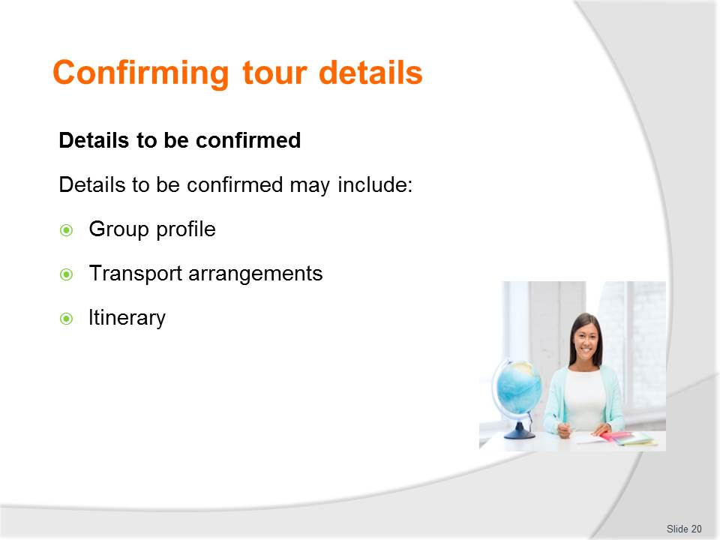
Slide No | Trainer Notes
Class Activity –Discussion
- Discuss information to be confirmed for each of these points.
- When do details need to be confirmed by?
- Who needs this information?

Slide
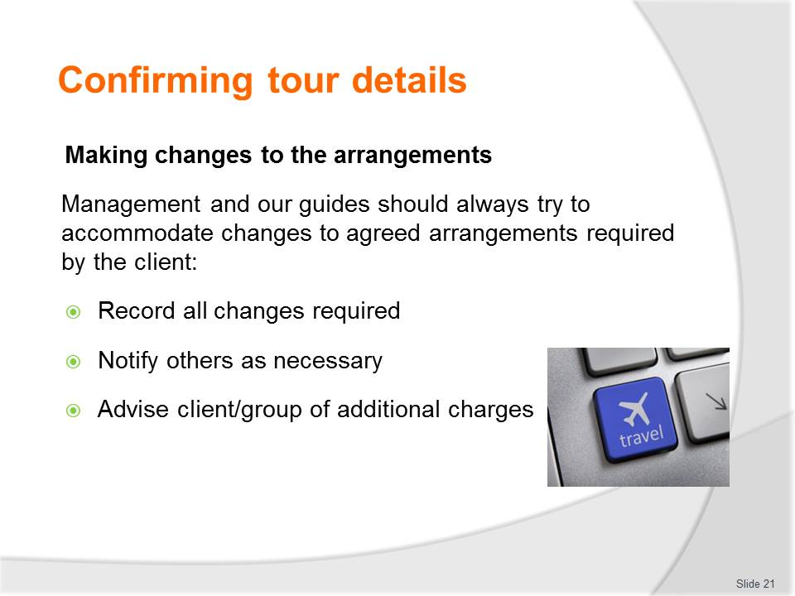
Slide No | Trainer Notes
Class Activity –Discussion about making changes to arrangements
- What are policies about changes being made to tour arrangements
- Where are changes recorded?
- How do you know which is the current version of tour arrangements?
- What are examples of changes that can be made and costs associated with making these changes?

Slide
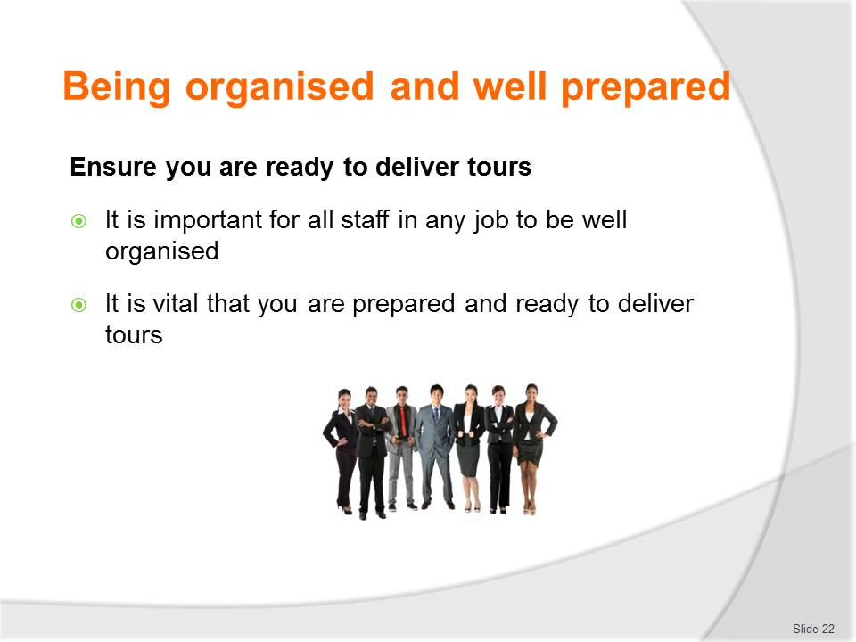
Slide No | Trainer Notes
Class Activity –Identify pre-tour planning activities
- Prepare a list of all activities to be performed before a tour takes place.

Slide
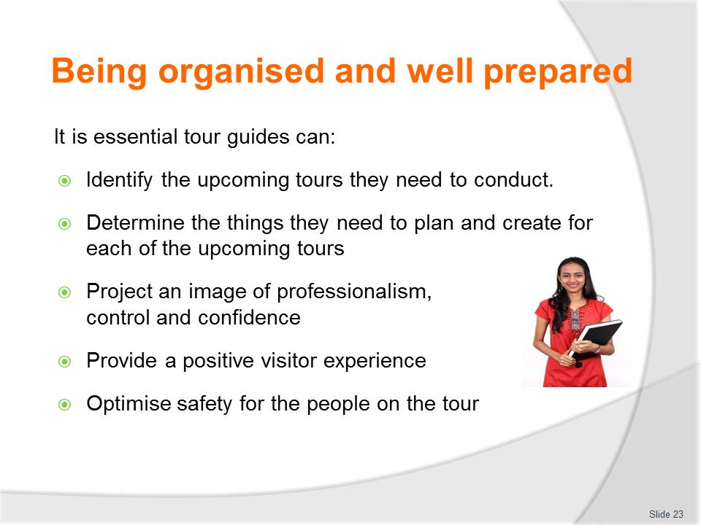
Slide No | Trainer Notes
Class Activity – Discuss pre-tour planning activities
- Discuss the activities associated with each of these points.

Slide
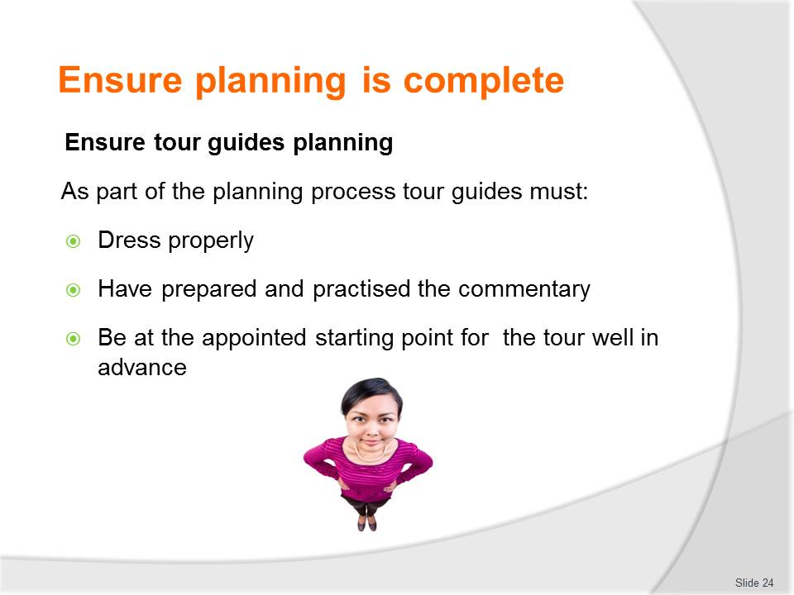
Slide No | Trainer Notes
Class Activity –Discuss pre-tour planning activities
- What is considered to be ‘proper’ or ‘appropriate’ attire for a tour guide.

Slide
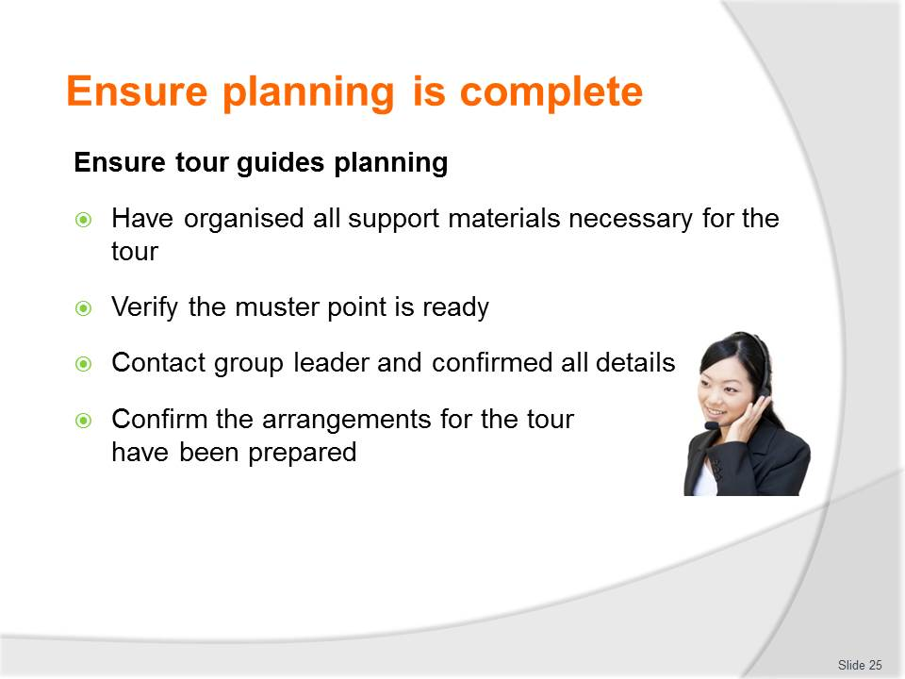
Slide No | Trainer Notes
Class Activity – Discuss pre-tour planning activities
- Discuss the activities associated with each of these points.

Slide
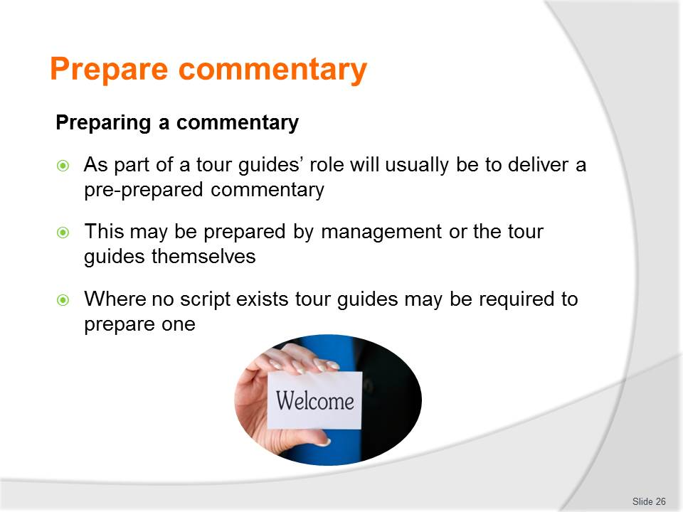
Slide No | Trainer Notes
Class Activity – Discuss purpose of a commentary
- What is commentary?
- What is the purpose of having commentary?
- What parts of a tour require commentary?

Slide
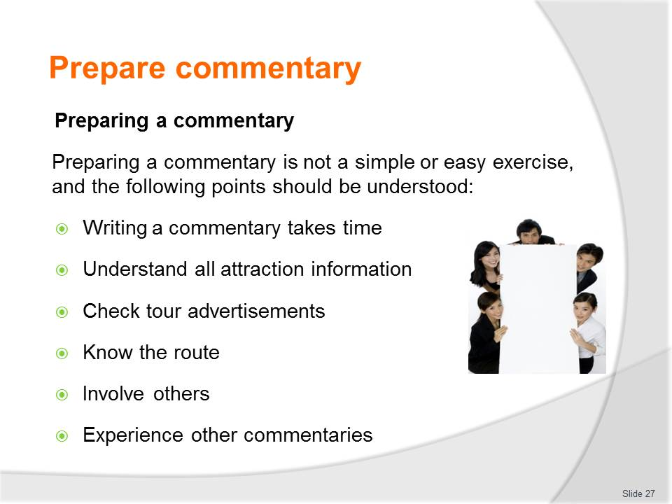
Slide No | Trainer Notes
Class Activity – Discuss purpose of a commentary
- Discuss the importance of these points.

Slide
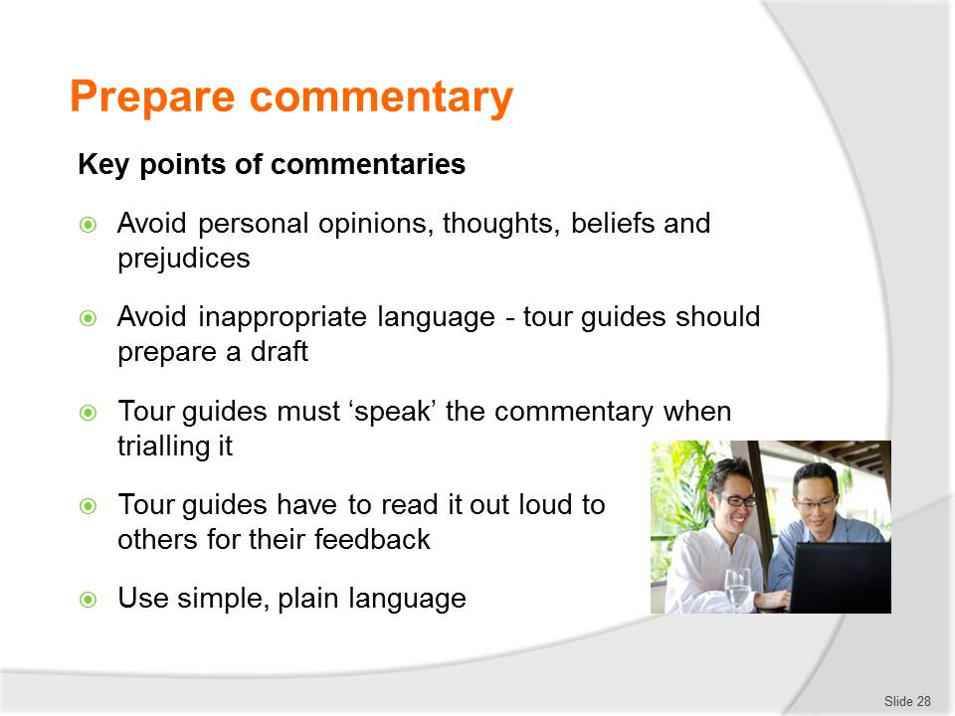
Slide No | Trainer Notes
Class Activity – Prepare, print and deliver a commentary (Refers to slides 28 – 30)
- Participants are to prepare a commentary for an aspect of a tour
- They are then to deliver their commentary to the audience.

Slide
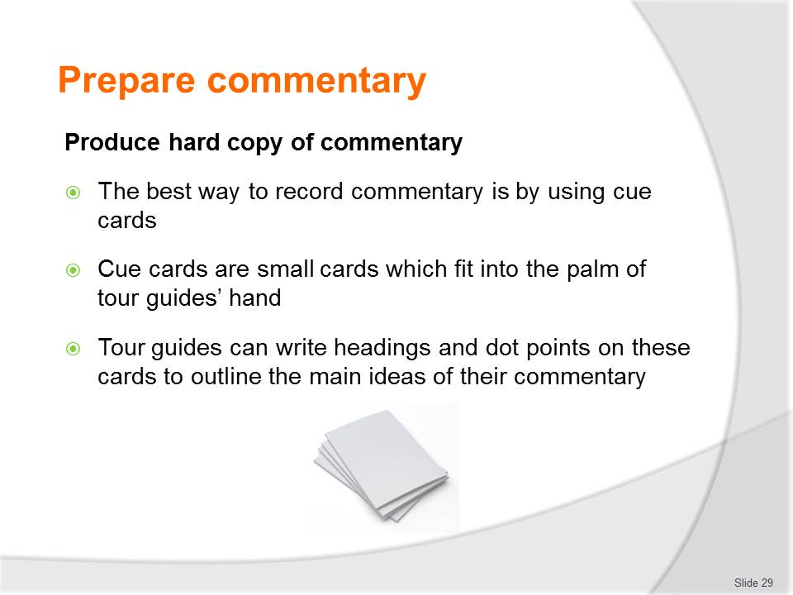
Slide No | Trainer Notes
Class Activity – Prepare, print and deliver a commentary (Refers to slides 28 – 30)
- Participants are to prepare a commentary for an aspect of a tour
- They are then to deliver their commentary to the audience.

Slide
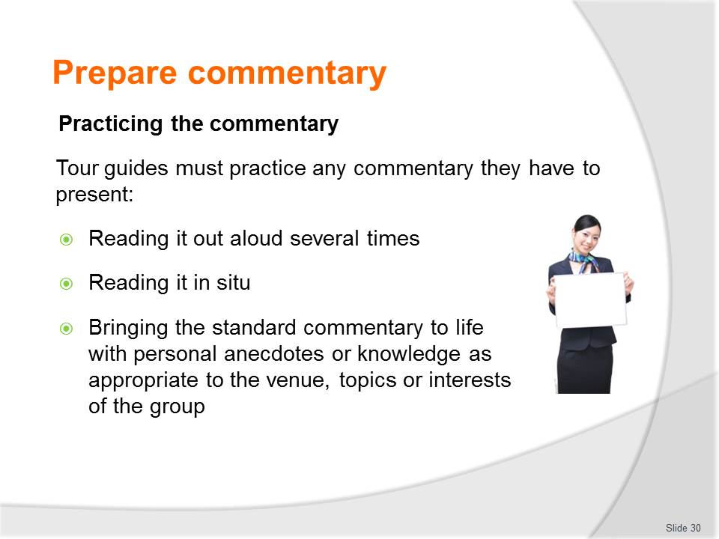
Slide No | Trainer Notes
Class Activity – Prepare, print and deliver a commentary (Refers to slides 28 – 30)
- Participants are to prepare a commentary for an aspect of a tour
- They are then to deliver their commentary to the audience.

Slide
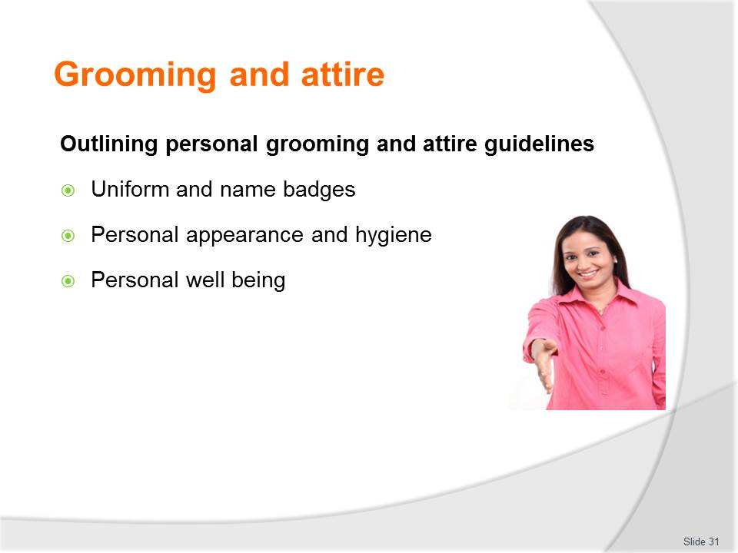
Slide No | Trainer Notes
Class Activity – Discuss importance of personal grooming and attire
- Discuss the importance of these points
- What aspects of personal appearance and hygiene must be considered?
- How can you maintain personal well-being.

Slide

Slide No | Trainer Notes
Class Activity – Discuss information and materials to be organised
- What information needs to be arranged? Prepare a list
- What materials need to be arranged? Prepare a list
- What activities are associated with arranging information and materials?

Slide
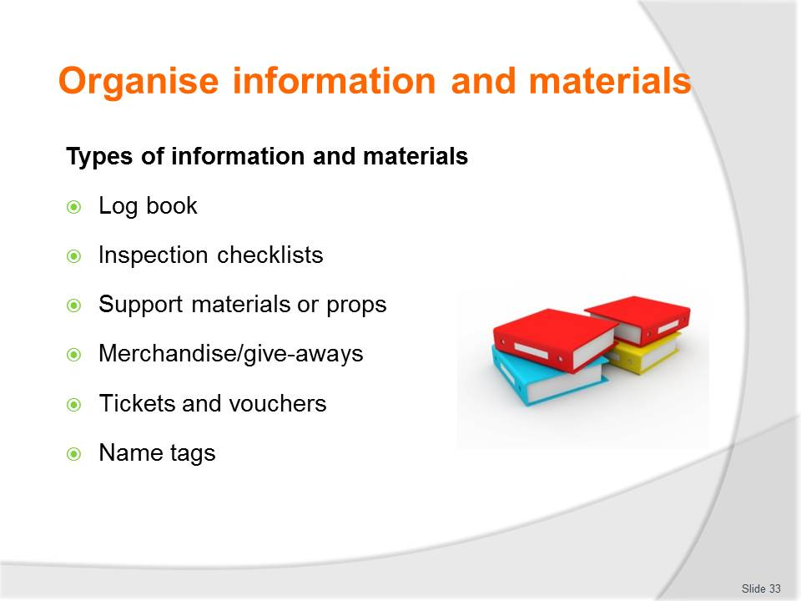
Slide No | Trainer Notes
Class Activity – Discuss information and materials to be organised
- Discuss the importance of each of these points
- What is there purpose?
- What needs to be arranged?

Slide
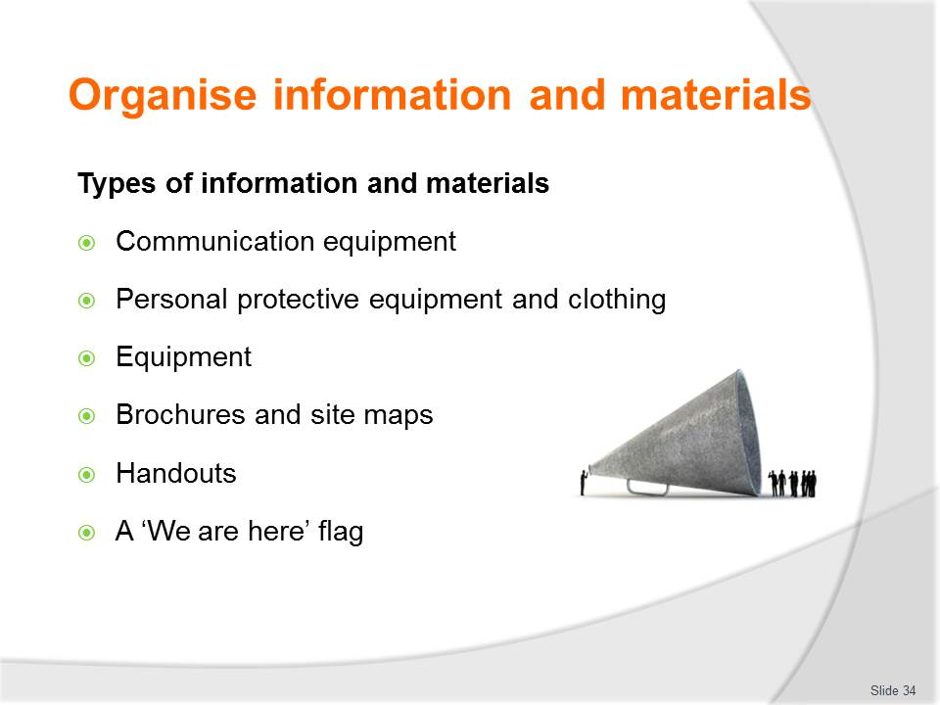
Slide No | Trainer Notes
Class Activity – Discuss information and materials to be organised
- Discuss the importance of each of these points
- What is there purpose?
- What needs to be arranged?

Slide
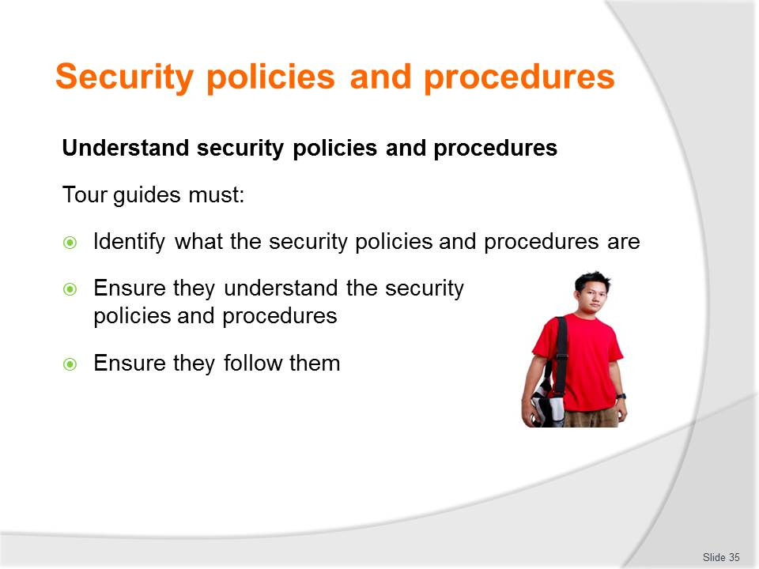
Slide No | Trainer Notes
Class Activity – Discuss importance and review security policies and procedures
- Why is it important to have security policies and procedures?
- Review various security policies and procedures.

Slide
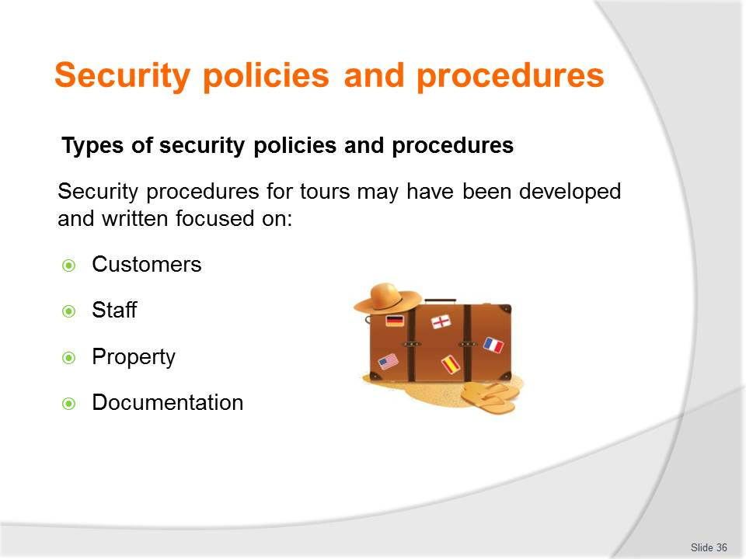
Slide No | Trainer Notes
Class Activity – Discuss security policies and procedures
- What are examples of security policies and procedures for each of these audiences?

Slide
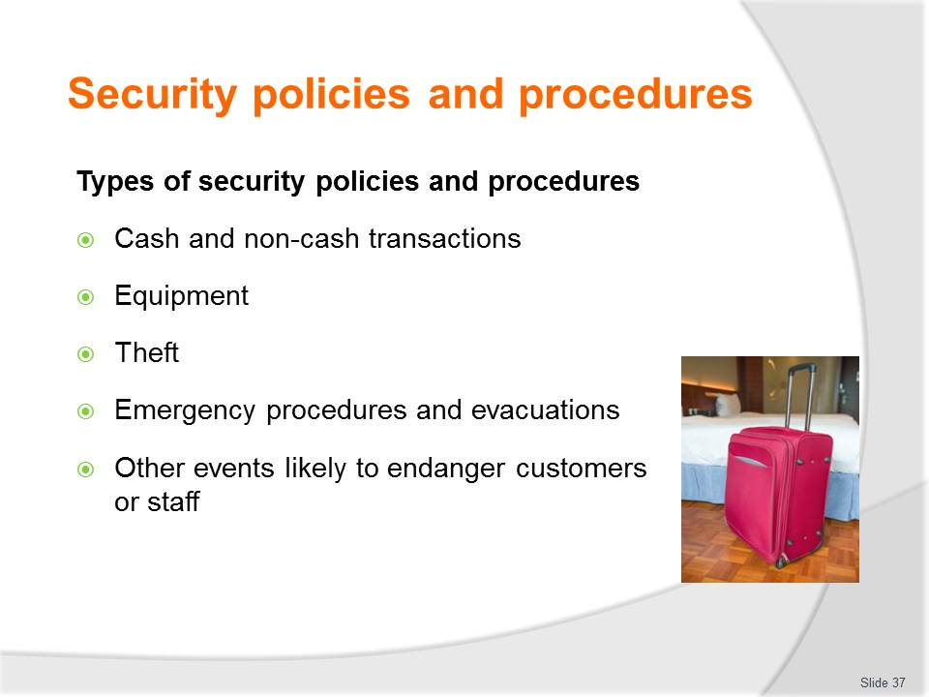
Slide No | Trainer Notes
Class Activity – Discuss & review security policies and procedures
- Review examples of security policies and procedures for each of these points?

Slide
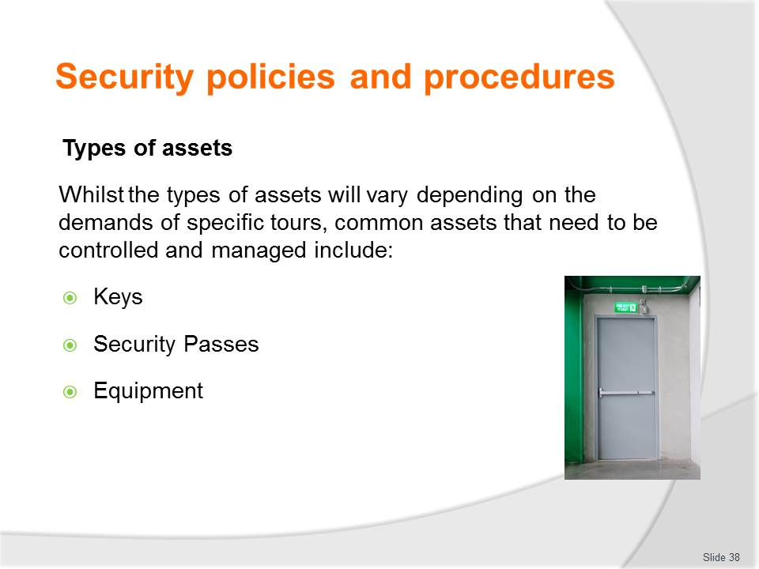
Slide No | Trainer Notes
Class Activity – Discuss role and examples of assets
- What are examples of assets for each of these points?
- What is their purpose?

Slide
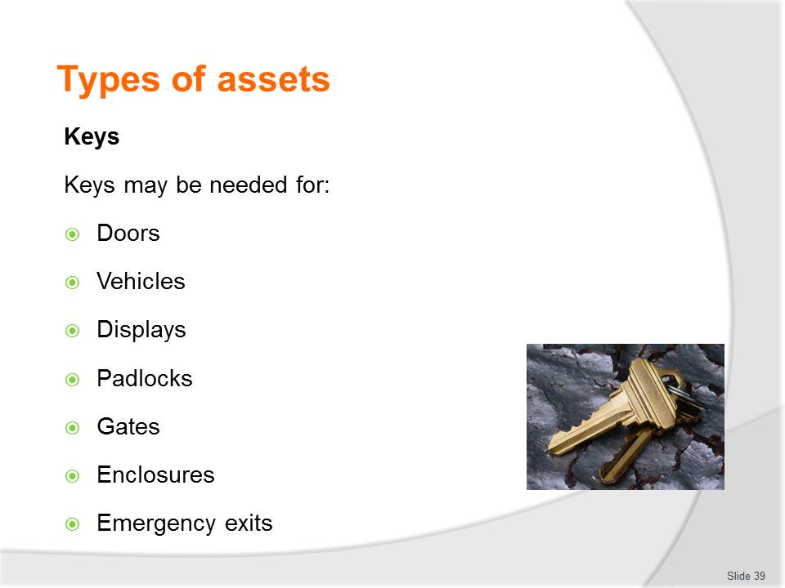
Slide No | Trainer Notes
Class Activity – Discuss role and examples of keys
- What is their purpose?
- How are keys kept secure?

Slide
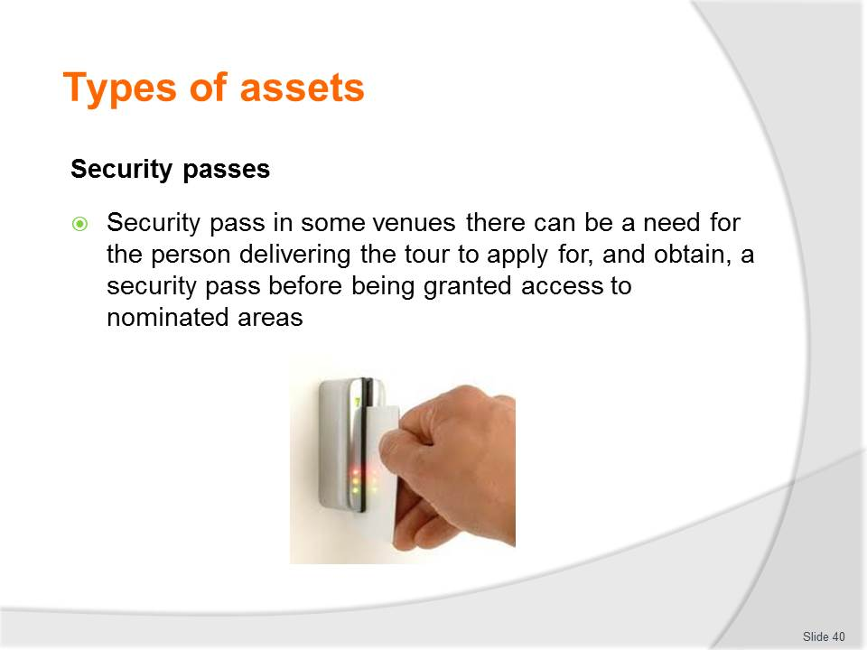
Slide No | Trainer Notes
Class Activity – Discuss role and examples of security passes
- What is their purpose?
- How are security passes kept secure?

Slide
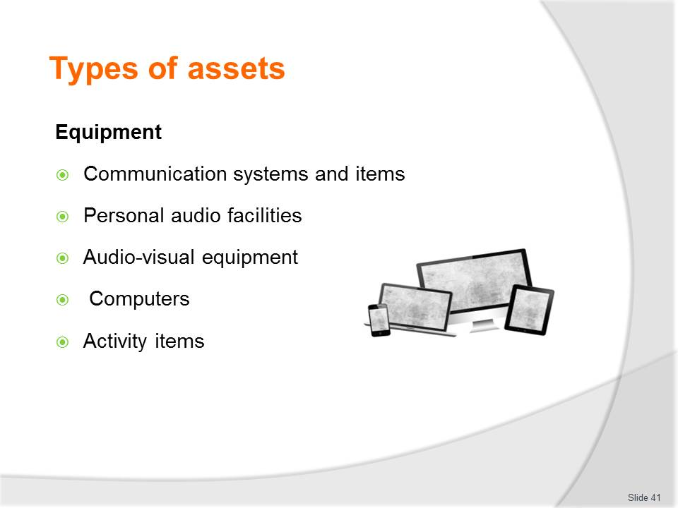
Slide No | Trainer Notes
Class Activity – Discuss role and examples of equipment
- What is their purpose?
- What are examples of each type of equipment?
- How are these pieces of equipment kept secure?

Slide
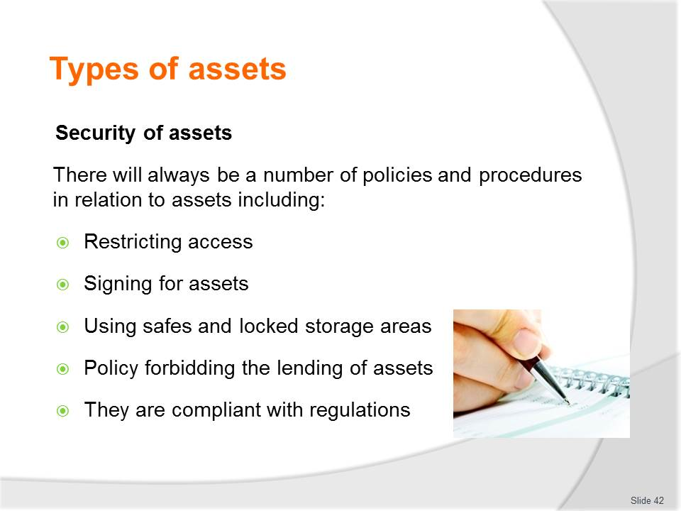
Slide No | Trainer Notes
Class Activity – Discuss importance of securing assets
- Discuss how these security measures can be implemented
- What other methods can be used?

Slide
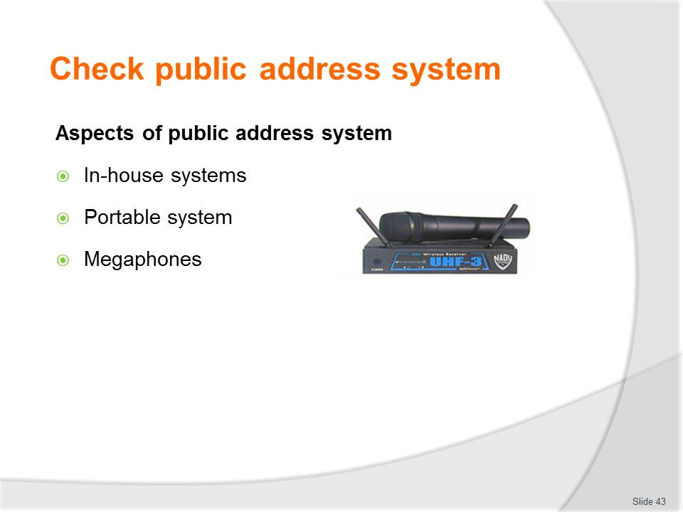
Slide No | Trainer Notes
Class Activity – Discuss & demonstrate purpose and aspects of public address system
- Trainer to demonstrate each aspect of public address system.

Slide
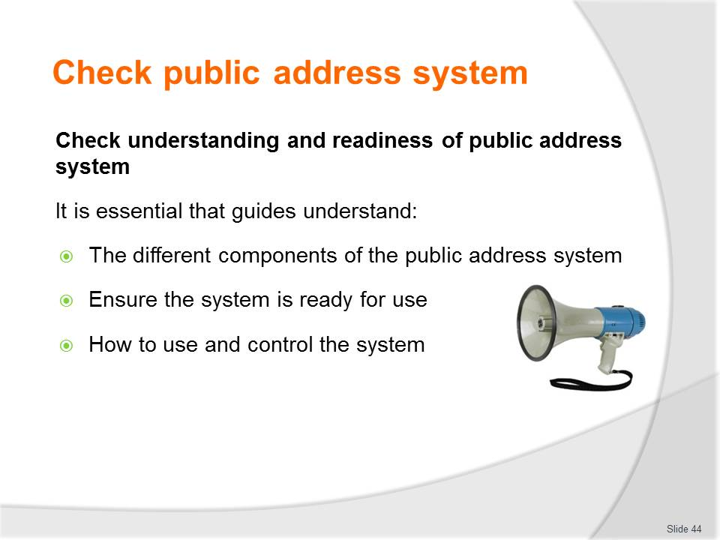
Slide No | Trainer Notes
Class Activity – Discuss & demonstrate how to check understanding and readiness of public address system
- Trainer to demonstrate how to check understanding and readiness of public address system.

Slide
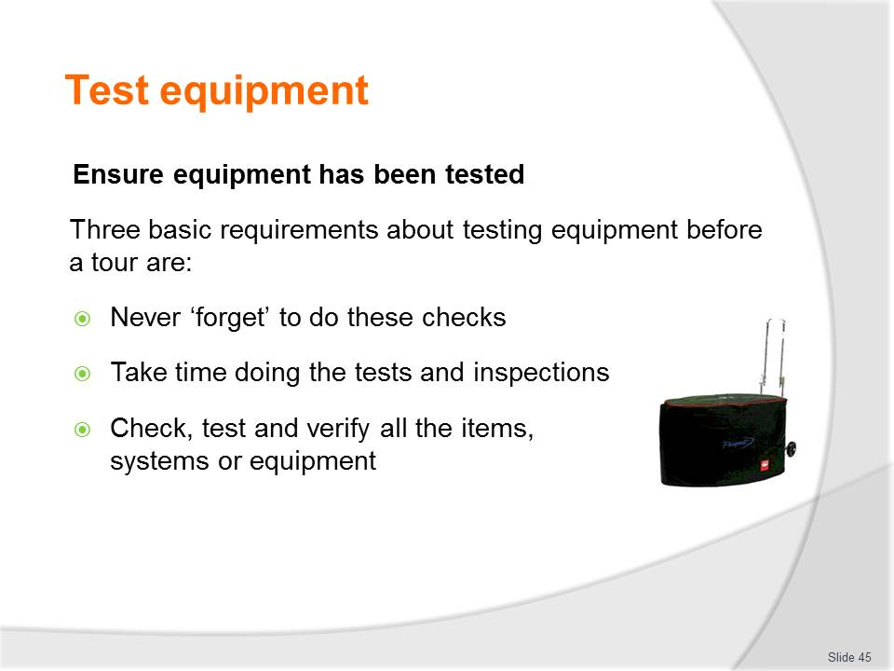
Slide No | Trainer Notes
Class Activity – Discuss & demonstrate how to ensure equipment has been tested
- Trainer to demonstrate how to ensure equipment has been tested.

Slide
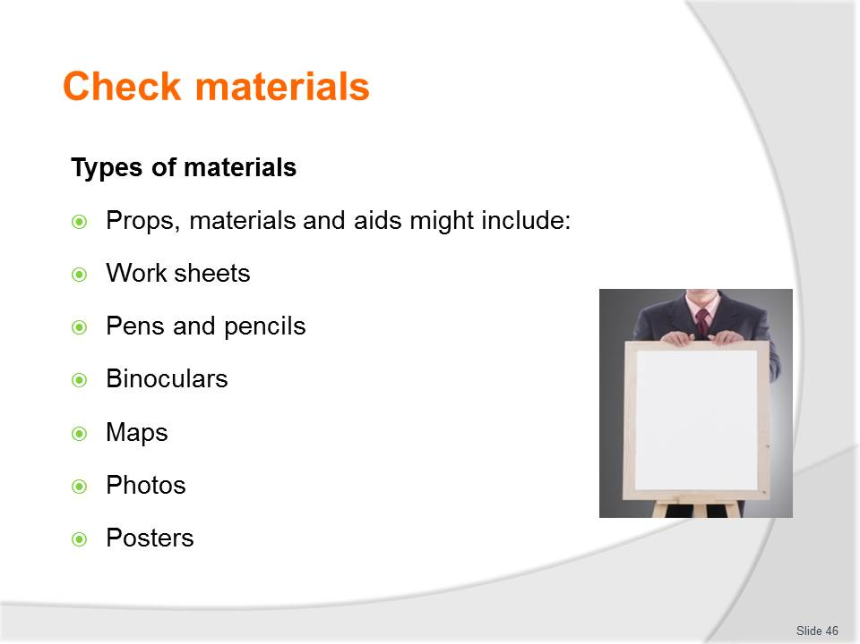
Slide No | Trainer Notes
Class Activity – Discuss types of materials
- Discuss the importance and examples of each type of material
- How can you check to ensure each of these are ready for a tour?

Slide
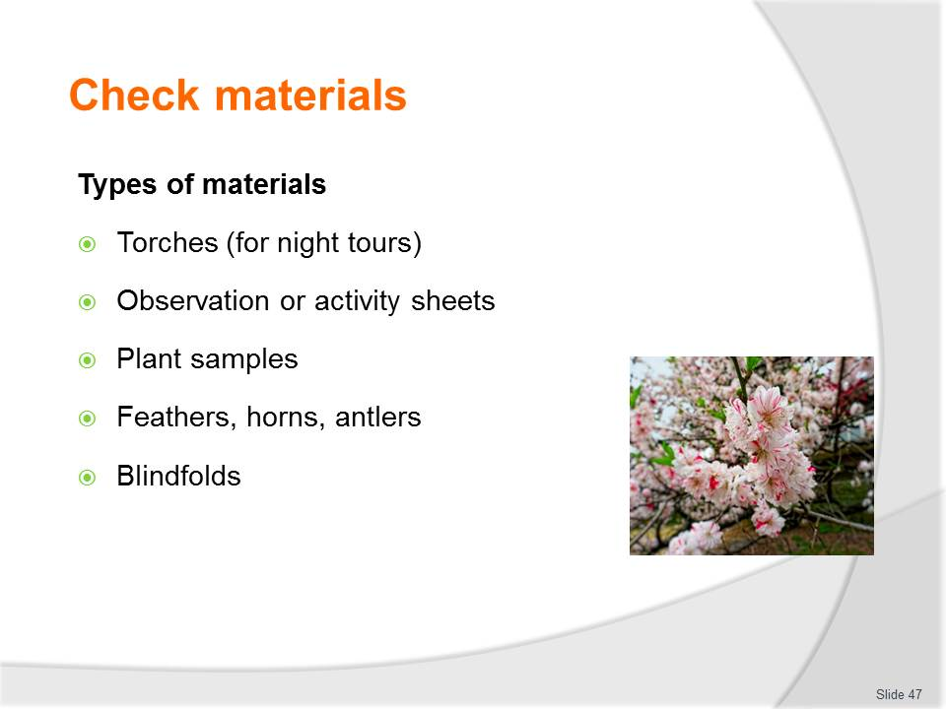
Slide No | Trainer Notes
Class Activity – Discuss types of materials
- Discuss the importance and examples of each type of material
- How can you check to ensure each of these are ready for a tour?

Slide
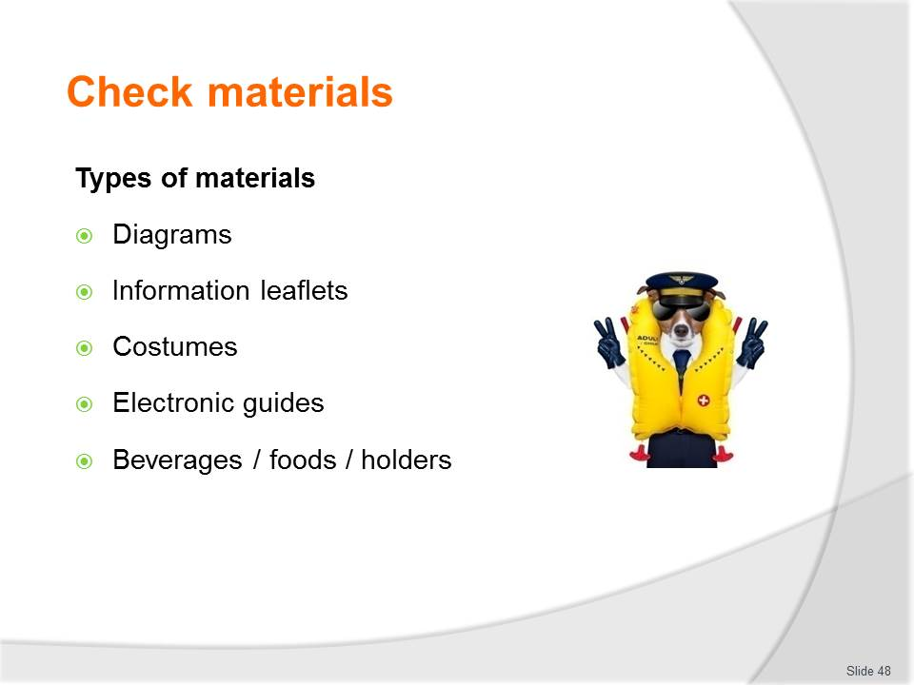
Slide No | Trainer Notes
Class Activity – Discuss types of materials
- Discuss the importance and examples of each type of material
- How can you check to ensure each of these are ready for a tour?

Slide
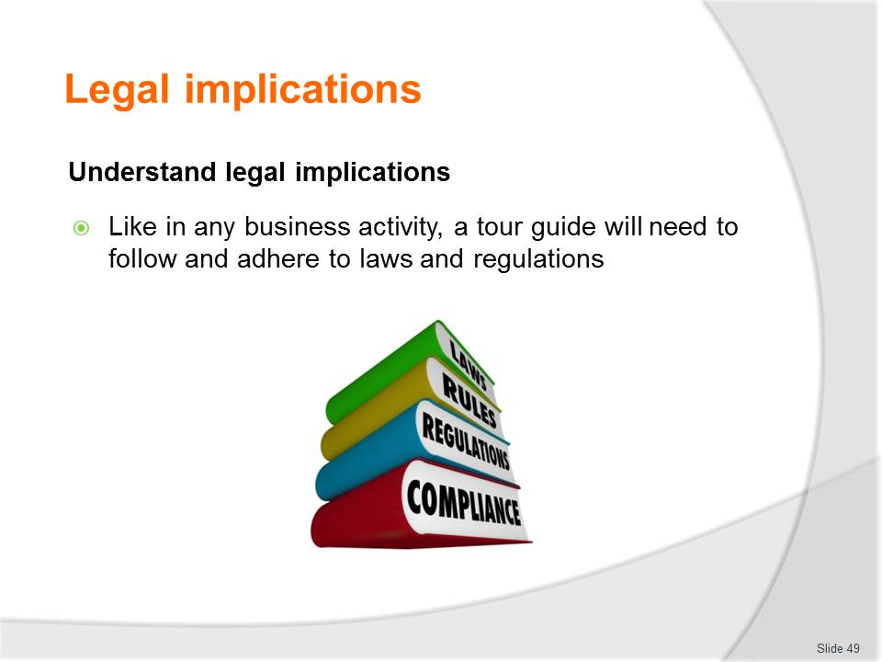
Slide No | Trainer Notes
Class Activity – List legal implications that impact on a tour
- Audience to prepare a list of any legal implications that impact on a tour.

Slide
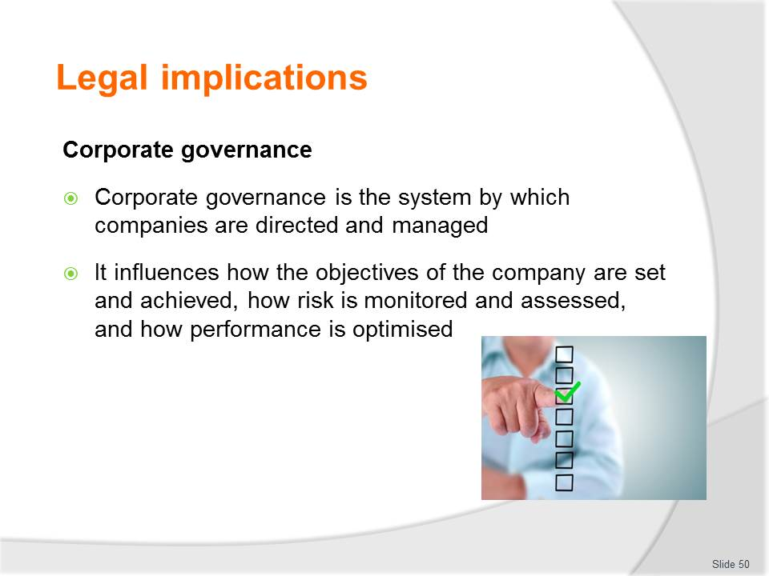
Slide No | Trainer Notes
Class Activity – Discuss importance of corporate governance
- Why is corporate governance important?
- How can you ensure good corporate governance?

Slide
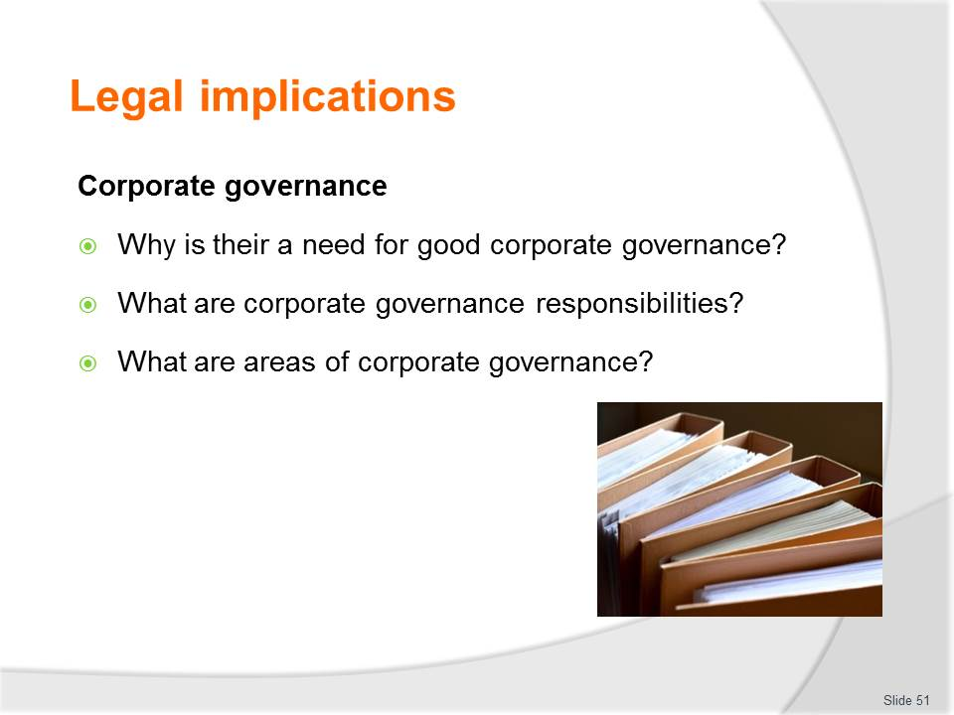
Slide No | Trainer Notes
Class Activity – Discuss importance of corporate governance
- Discuss questions in the slide.

Slide
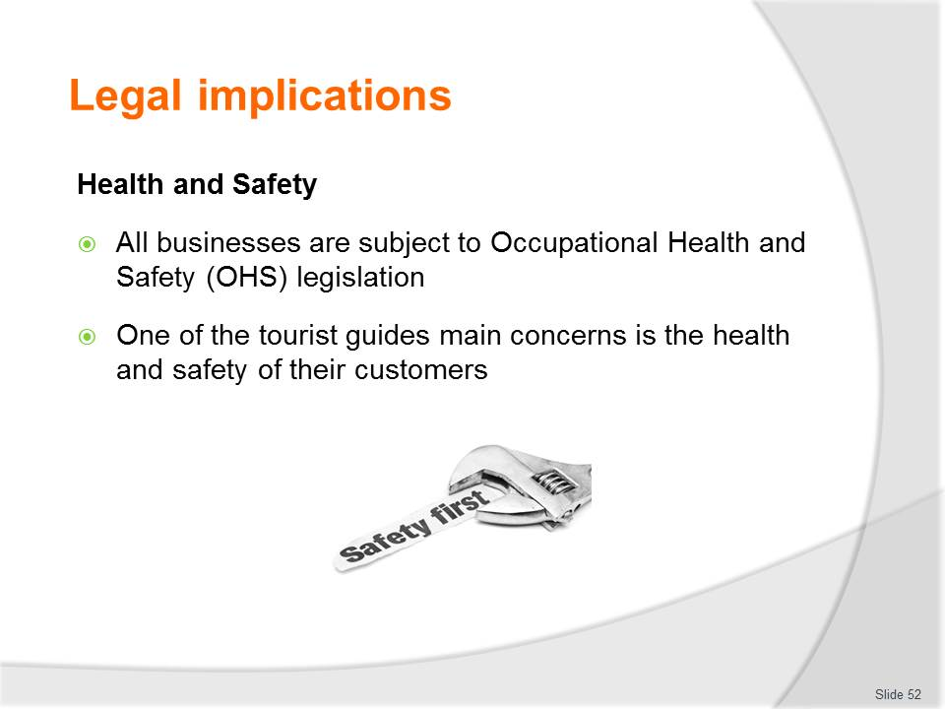
Slide No | Trainer Notes
Class Activity – Discuss importance of Health and Safety
- Why is health and safety important?
- How can you ensure sufficient health and safety for a tour?
- Review Occupational Health and Safety (OHS) legislation.

Slide
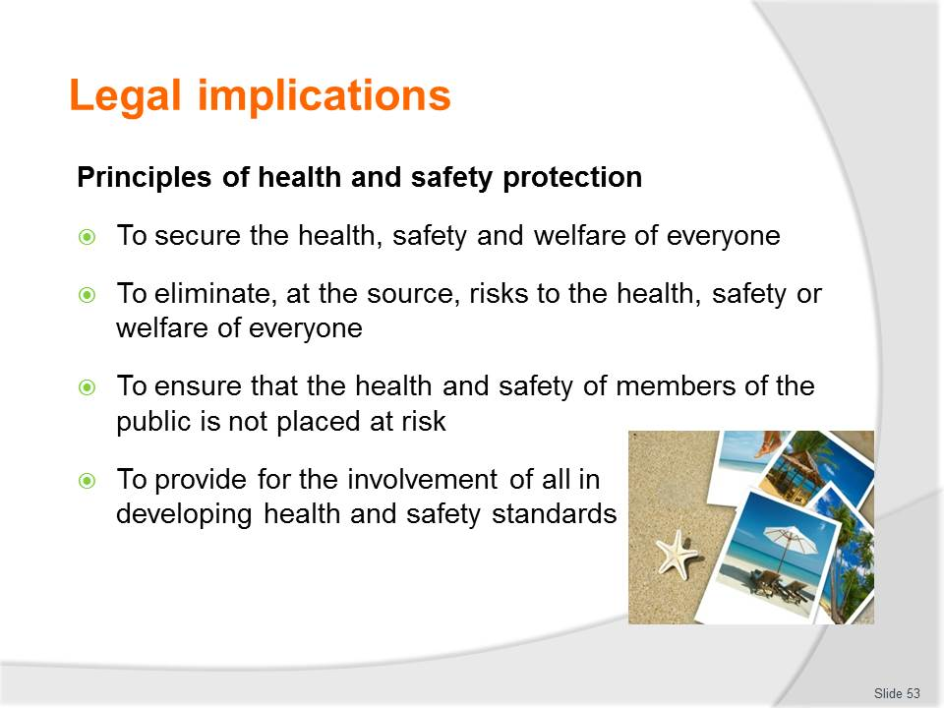
Slide No | Trainer Notes
Class Activity – Discuss importance of Health and Safety
- What are types of health and safety legislation.

Slide
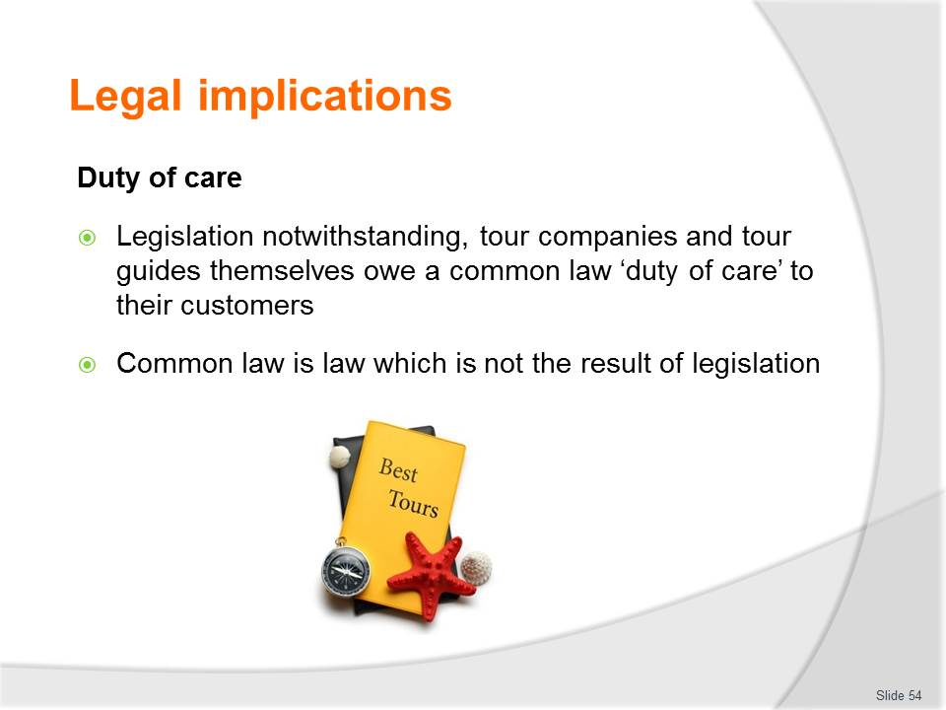
Slide No | Trainer Notes
Class Activity – Discuss importance of Duty of care
- Why is duty of care important?

Slide

Slide No | Trainer Notes
Class Activity – Discuss importance of Duty of care
- What are examples of duty of care?

Slide
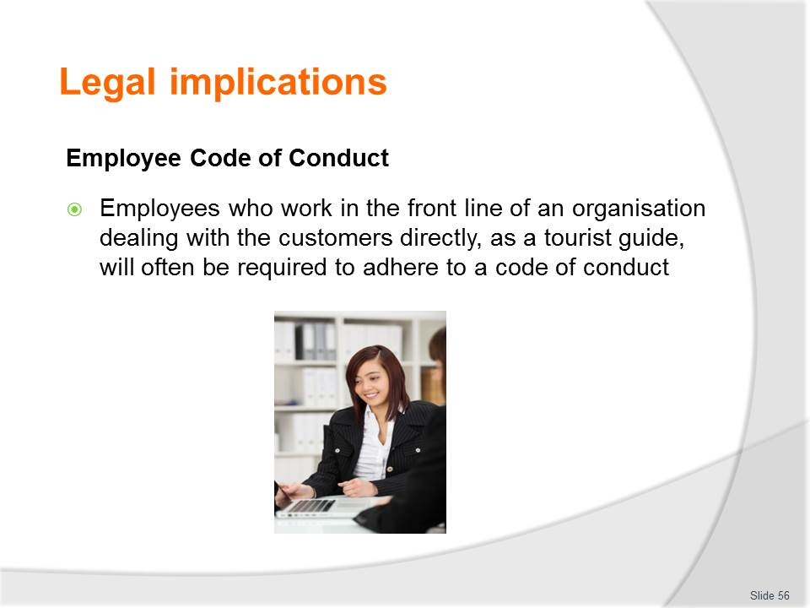
Slide No | Trainer Notes
Class Activity – Discuss importance and review Employee Code of Conduct
- Why it is important to have an Employee Code of Conduct?
- What information is contained within an Employee Code of Conduct?
- Review an example of this document.

Slide
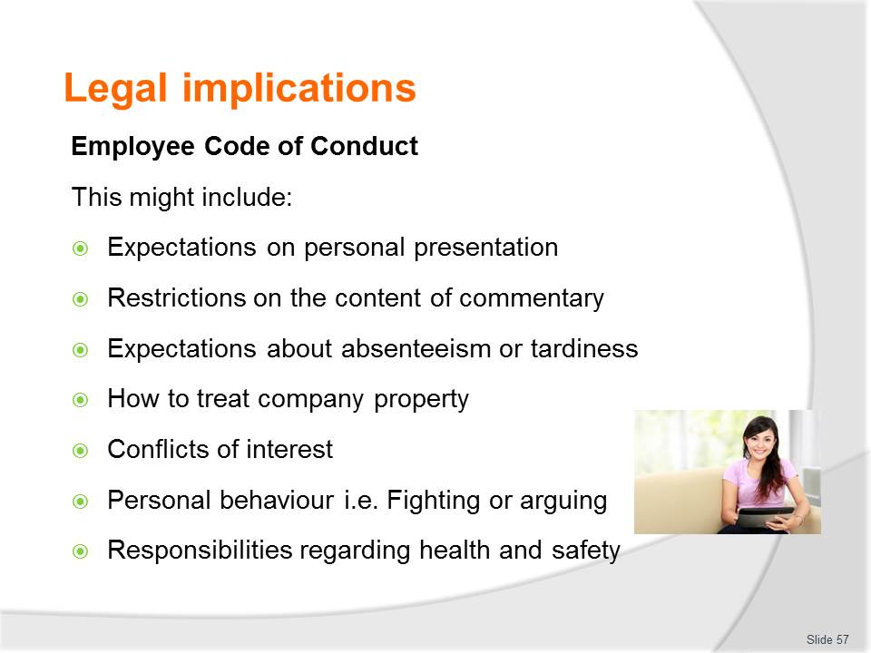
Slide No | Trainer Notes
Class Activity – Discuss importance and review Employee Code of Conduct
- Identify examples of each point.

Slide

Slide No | Trainer Notes
Class Activity – Discuss importance of Fair trading legislation
- Why is this important?
- What are examples of fair trading?

Slide
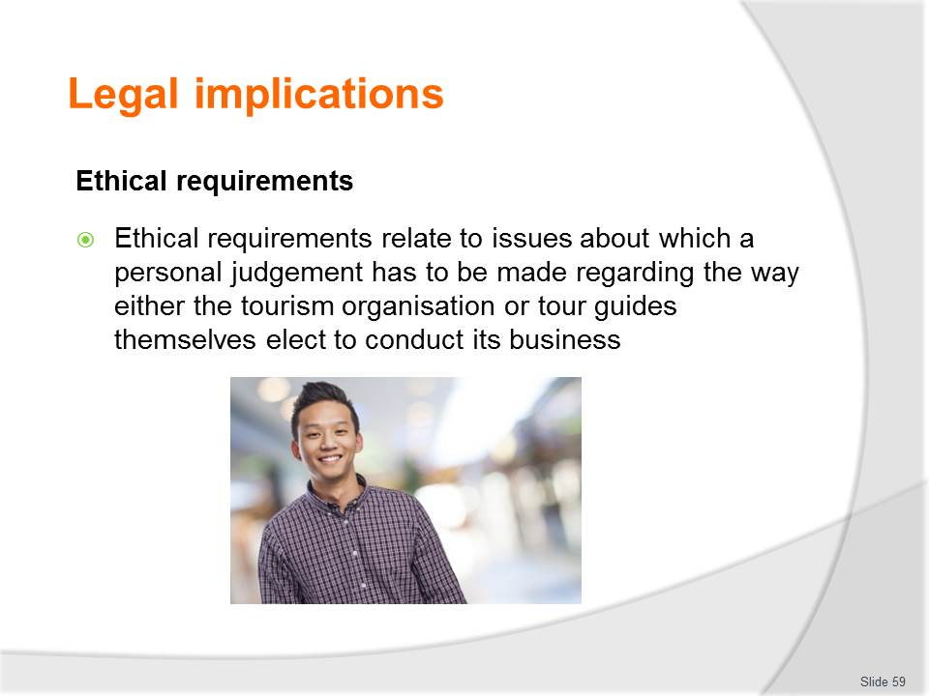
Slide No | Trainer Notes
Class Activity – Discuss importance of Ethical requirements
- What are ethics?
- Why is this important?
- What are examples of ‘ethical behaviour’?

Slide
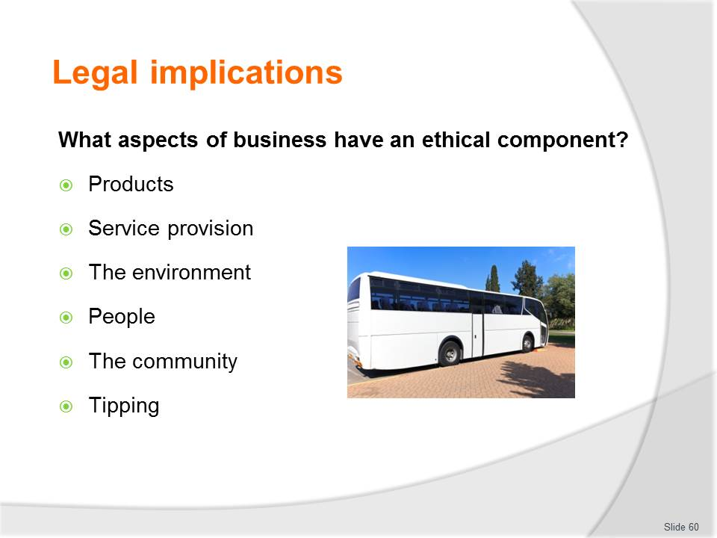
Slide No | Trainer Notes
Class Activity – Discuss importance of Ethical requirements
- What are examples of ‘ethical behaviour’ in each of these categories?

Slide

Slide No | Trainer Notes
Class Activity – Discuss importance of Ethical requirements
- Discuss these points
- What are examples of ‘non-ethical’ behaviour for each point.

Slide
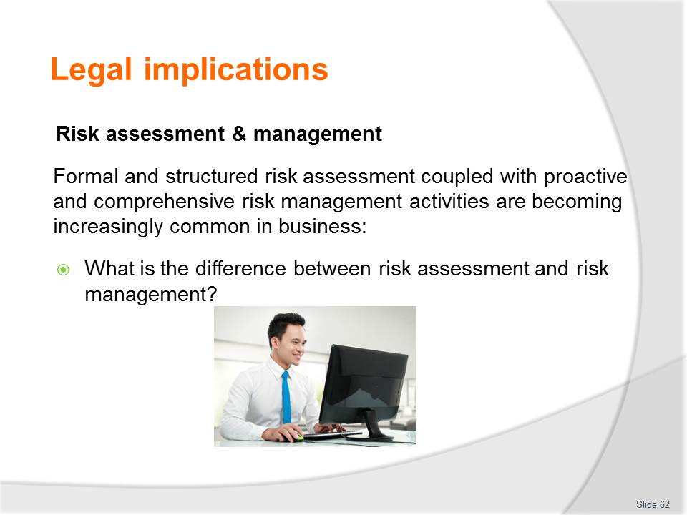
Slide No | Trainer Notes
Class Activity – Discuss importance of Risk assessment & management
- Why is Risk assessment & management important?
- Discuss the question in the slide.

Slide
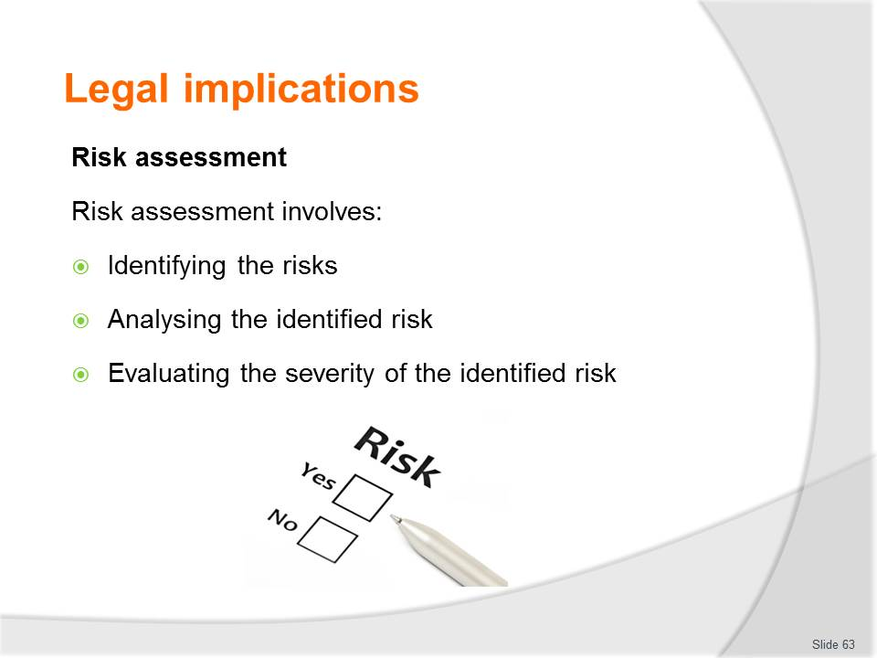
Slide No | Trainer Notes
Class Activity - Risk assessment Activity
- Participants are to conduct a risk assessment for a tour of their choice.

Slide
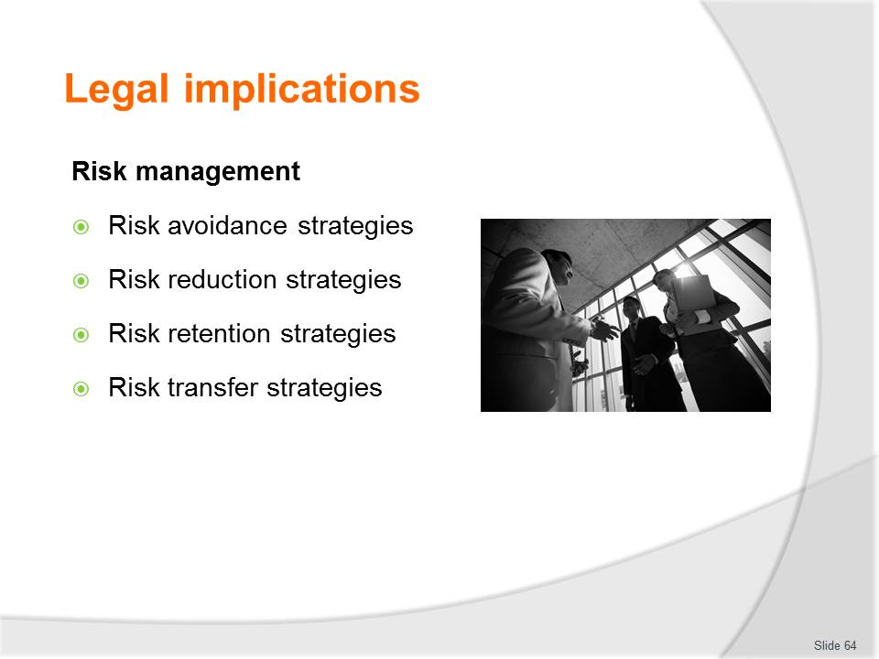
Slide No | Trainer Notes
Class Activity - Risk management Activity
- Based on the risk assessment activity in the previous slide, participants are to identify a risk management plan for risks identified.

Slide
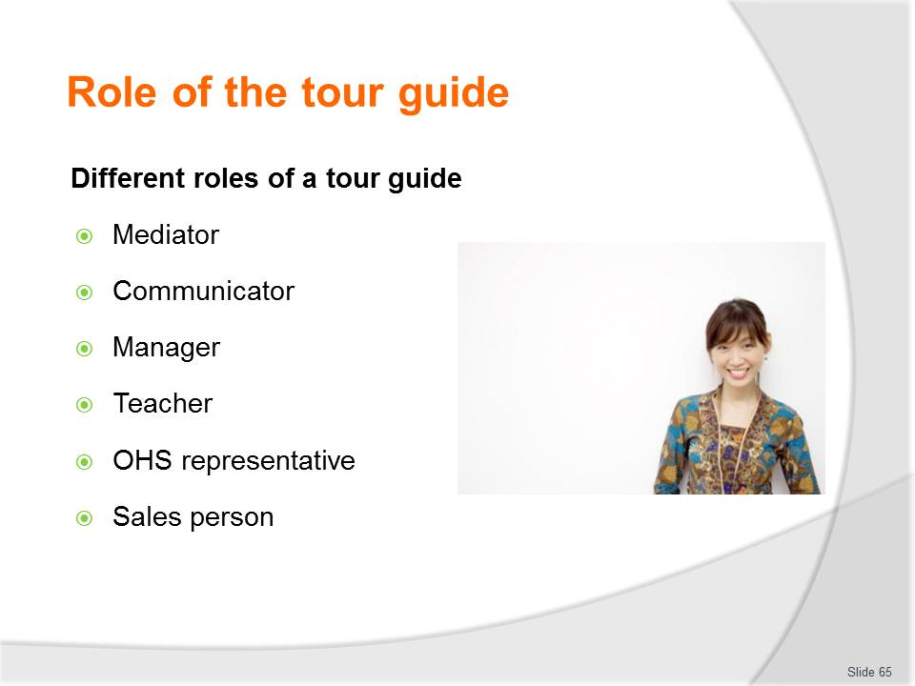
Slide No | Trainer Notes
Class Activity – Discuss roles of a tour guide
- Provide examples of activities or situations for each of these points.

Slide
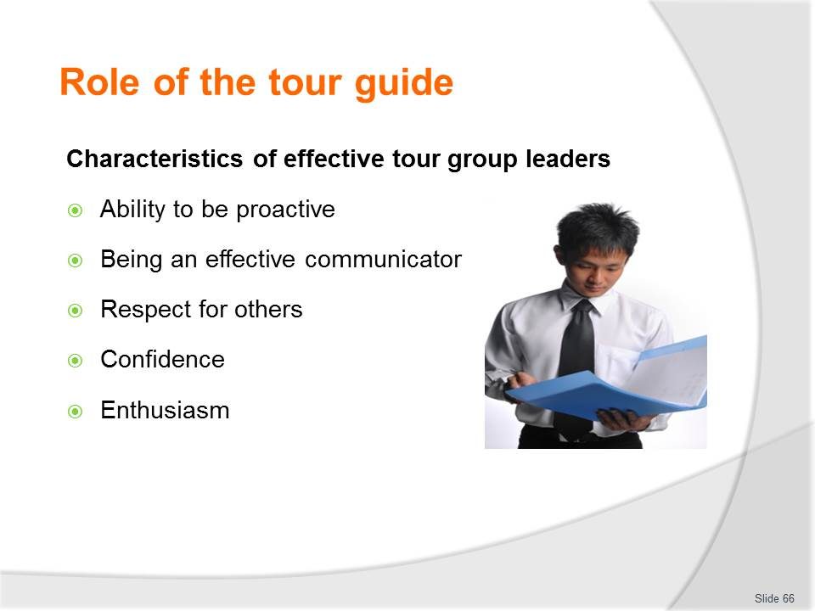
Slide No | Trainer Notes
Class Activity – Discuss characteristics of a tour guide
- Provide examples of situations for each of these points.

Slide
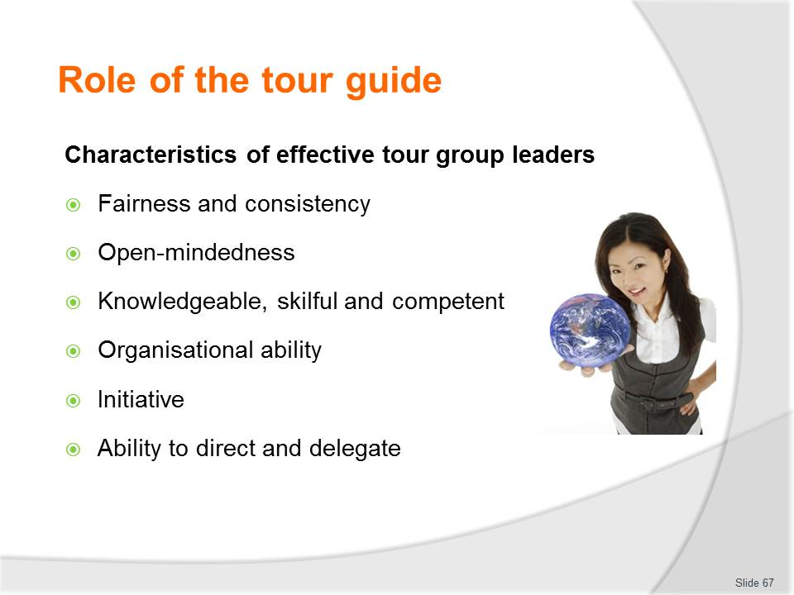
Slide No | Trainer Notes
Class Activity – Discuss characteristics of a tour guide
- Provide examples of situations for each of these points.

Slide
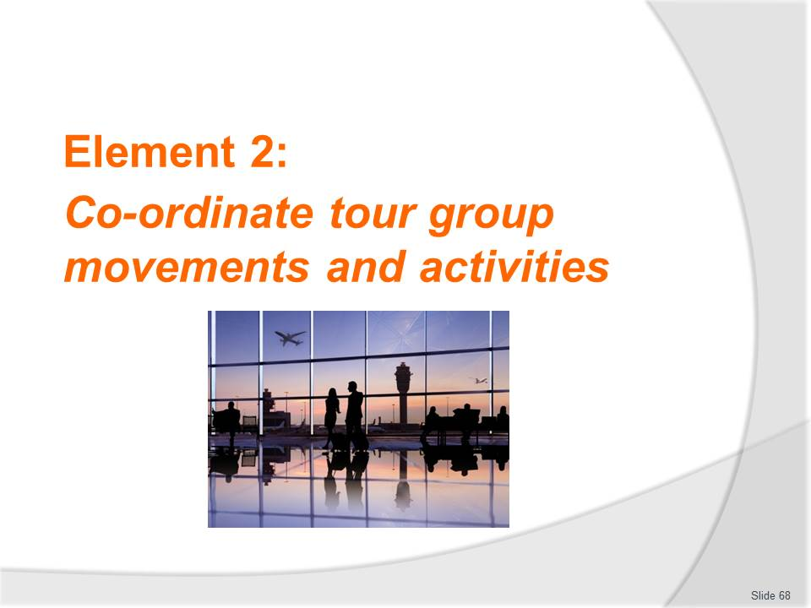
Slide No | Trainer Notes
Introduce topic
Class Activity – General Discussion
Ask general questions:
- What are different activities that are undertaken as part of a tour?
- What are key activities performed by a tour guide whilst a tour is being conducted?

Slide
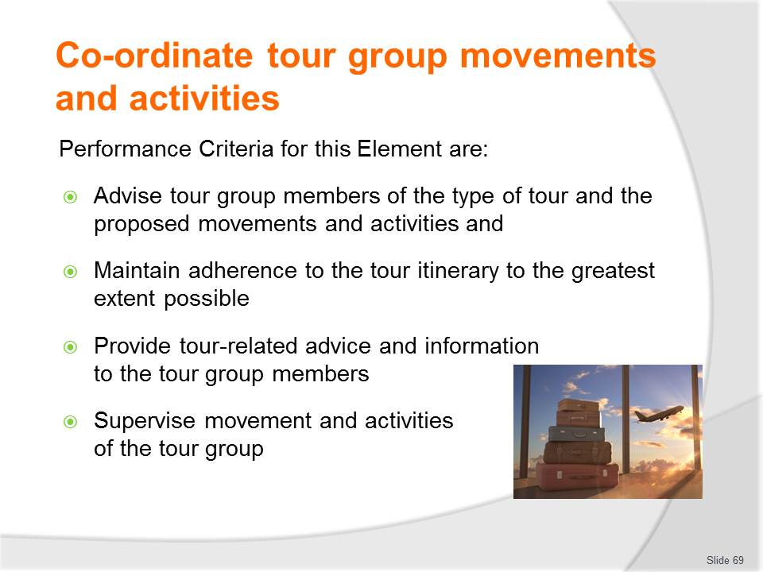
Slide No | Trainer Notes
 | Trainer identifies the Performance Criteria for this Element, as listed on the slide.

Slide
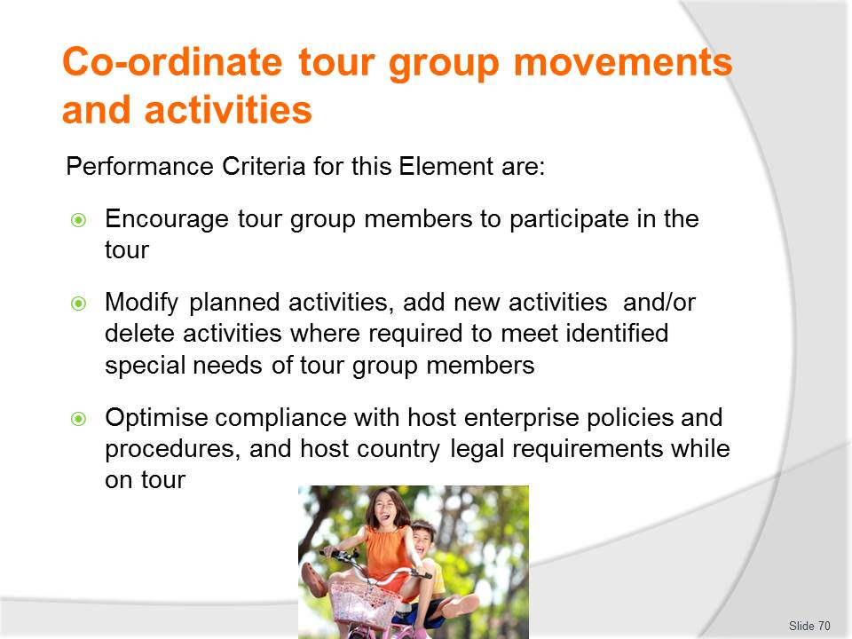
Slide No | Trainer Notes
 | Trainer identifies the Performance Criteria for this Element, as listed on the slide.

Slide
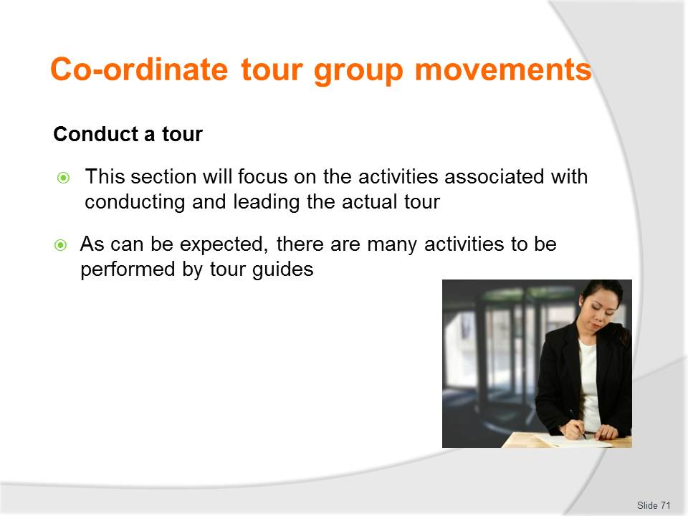
Slide No | Trainer Notes
Class Activity – Discussion
- What are key activities performed by a tour guide whilst a tour is being conducted?

Slide
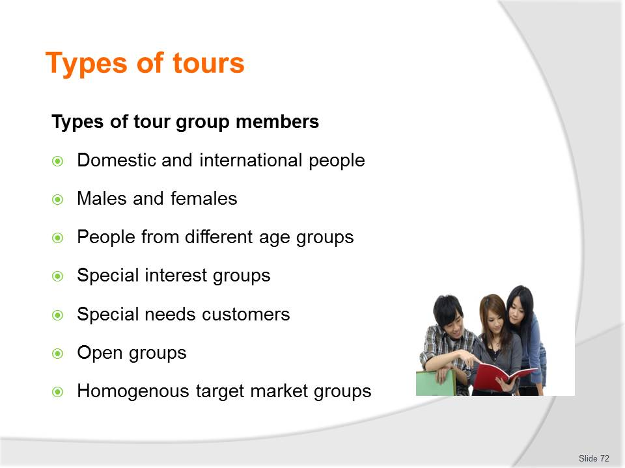
Slide No | Trainer Notes
Class Activity – Discussion about types of tour group members
- What are the needs of each type of group member that tour guides must take into consideration?
- How can they meet these needs?

Slide
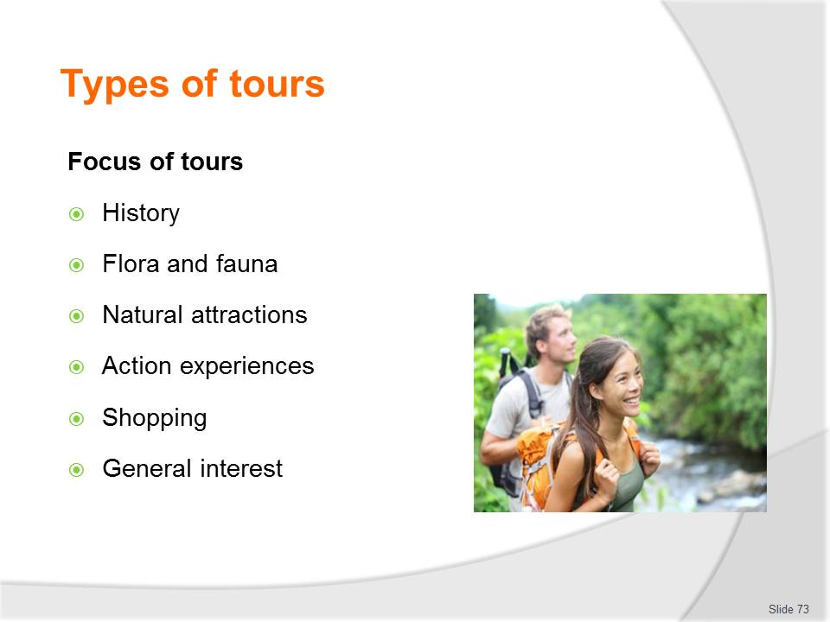
Slide No | Trainer Notes
Class Activity – Discussion about focus of tours
- What activities / attractions would you include for each of these tours?
- What are other possible focuses of tours?

Slide
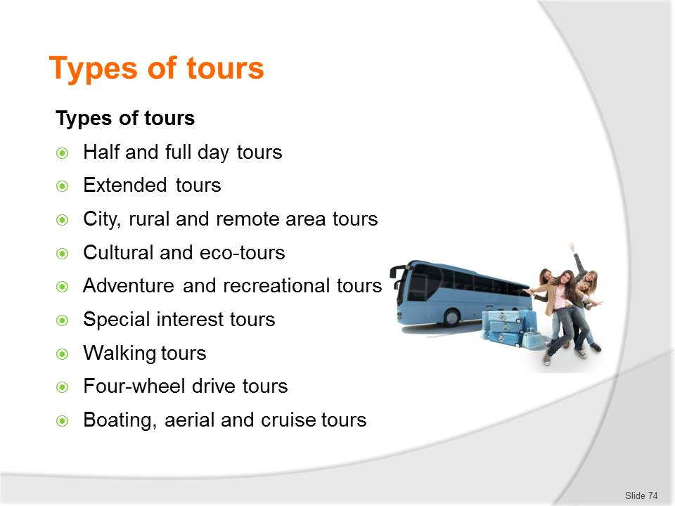
Slide No | Trainer Notes
Class Activity – Review / internet research into types of tours
- Review brochures or conduct internet research in relation to each of these tours to provide examples.

Slide
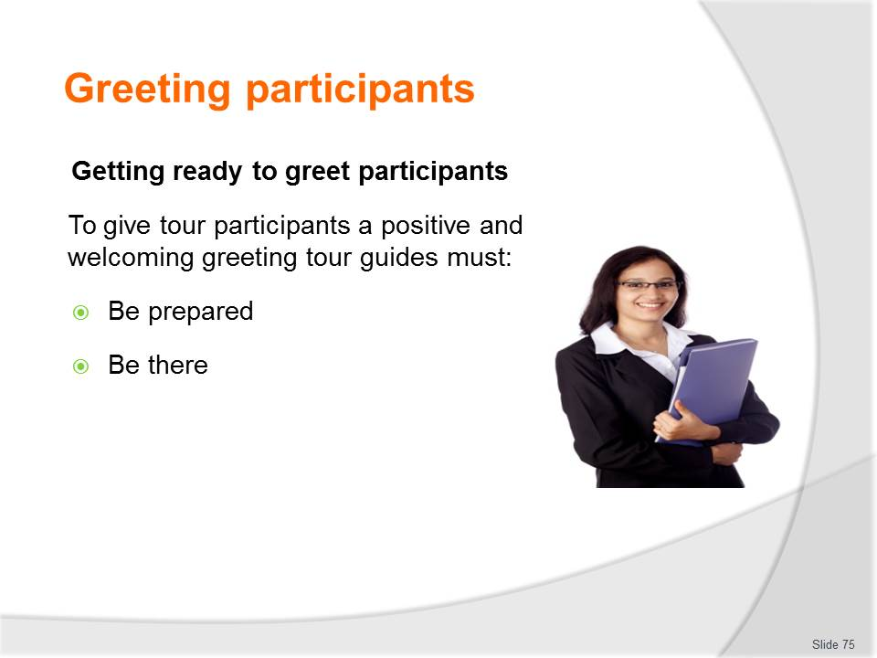
Slide No | Trainer Notes
Class Activity – Discussion
- What needs to be prepared to greet participants?

Slide
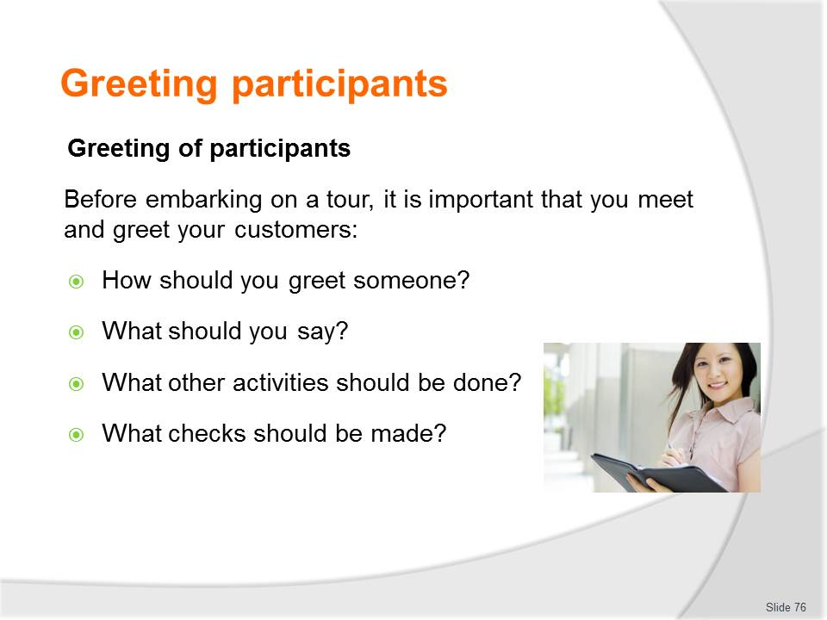
Slide No | Trainer Notes
Class Activity – Discussion
- Discuss questions in the slide.

Slide
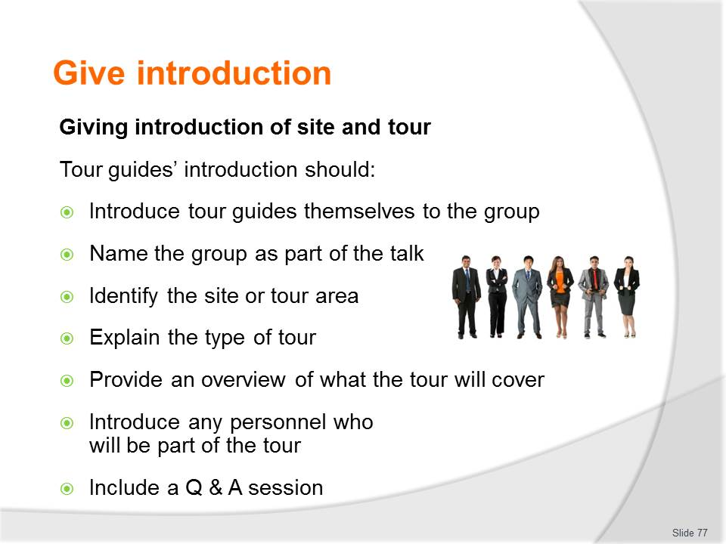
Slide No | Trainer Notes
Class Activity – Discussion & Role Play
- Discuss information to be explained for each of these points
- Role Play in greeting and introducing a tour.

Slide
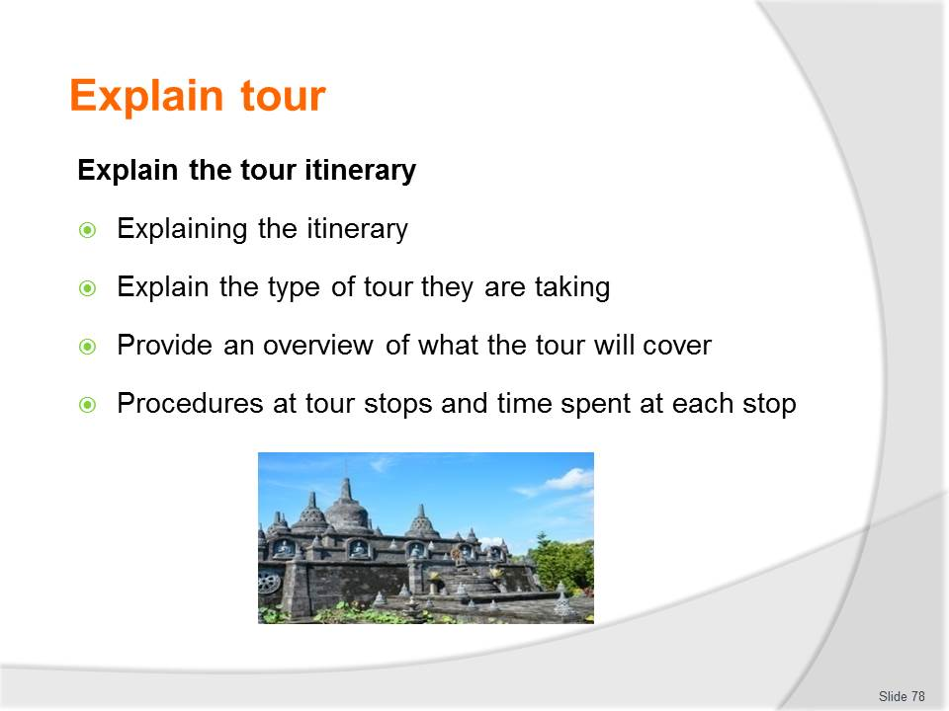
Slide No | Trainer Notes
Class Activity – Discussion & Role Play
- Discuss information to be explained for each of these points
- Role Play in explaining the tour itinerary.

Slide
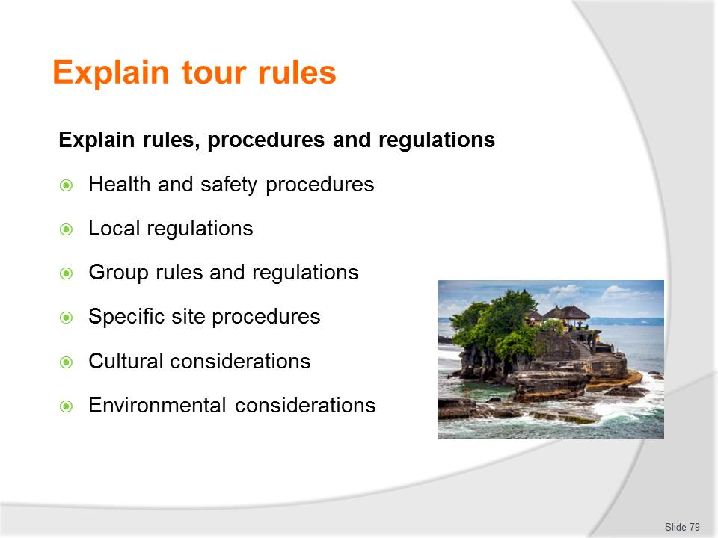
Slide No | Trainer Notes
Class Activity – Identify rules, procedures and regulations
- What is the different between rules, procedures and regulations
- For each of the points in this slide, provide examples of possible rules, procedures and regulations.

Slide
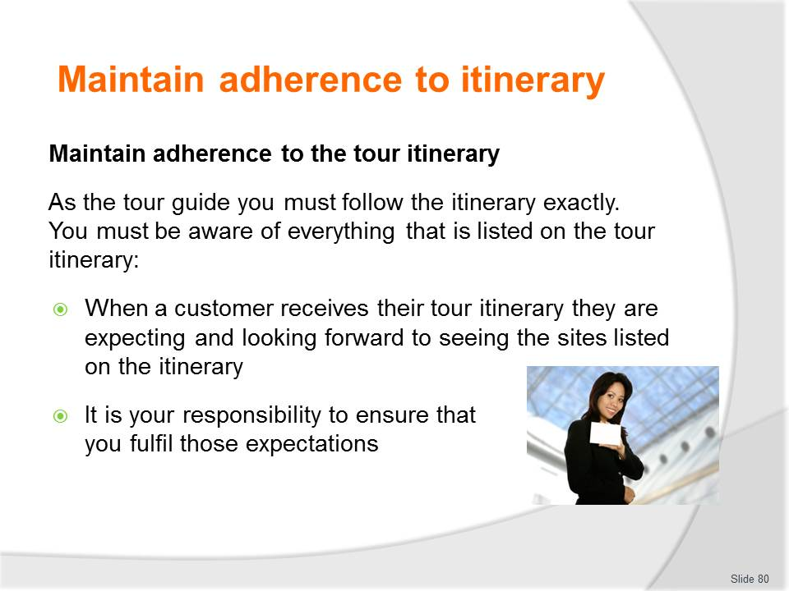
Slide No | Trainer Notes
Class Activity – Maintain adherence
- Why is it important to maintain adherence to the tour itinerary?
- How can this be done?

Slide
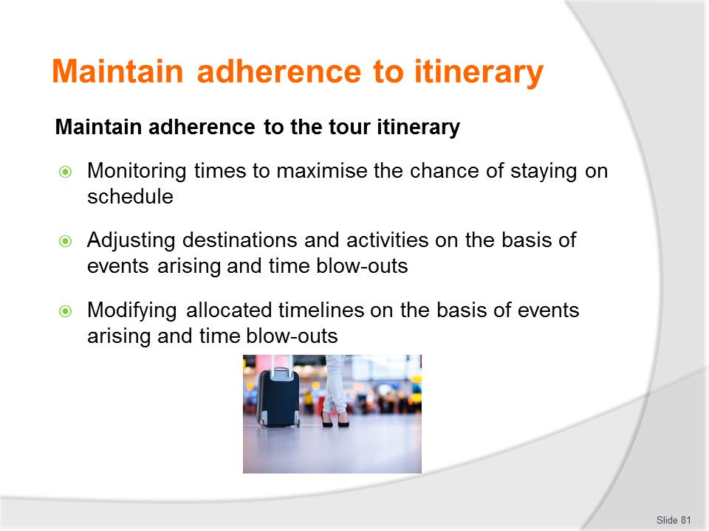
Slide No | Trainer Notes
Class Activity – Maintain adherence
- Discuss the points in the slide, providing examples.

Slide
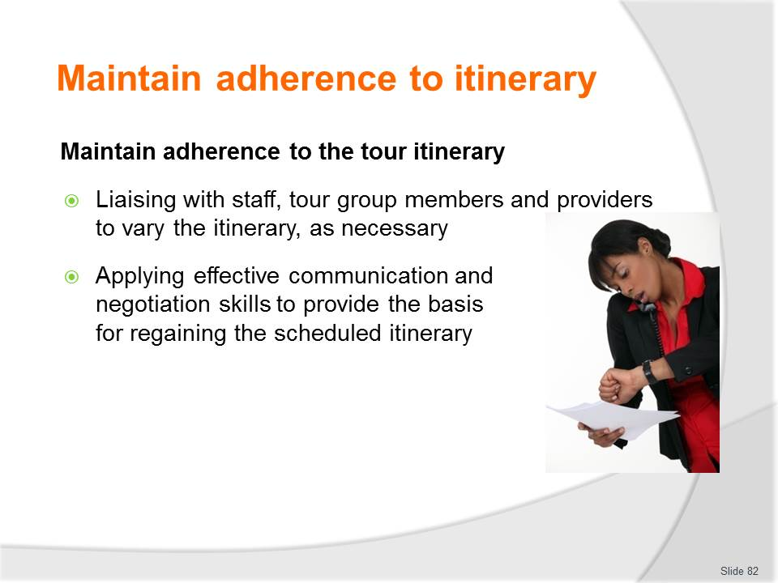
Slide No | Trainer Notes
Class Activity – Maintain adherence
- Discuss the points in the slide, providing examples.

Slide
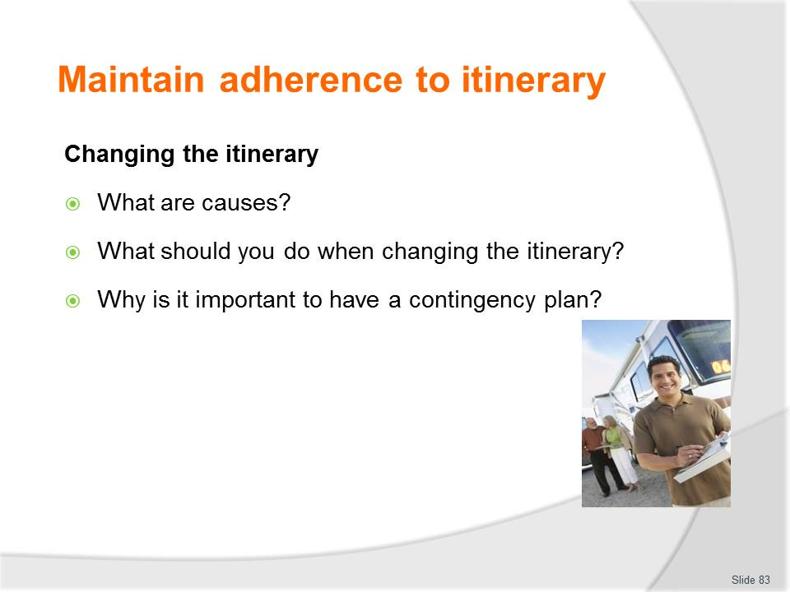
Slide No | Trainer Notes
Class Activity – Discussion about changing the itinerary
- Discuss the questions in the slide.

Slide
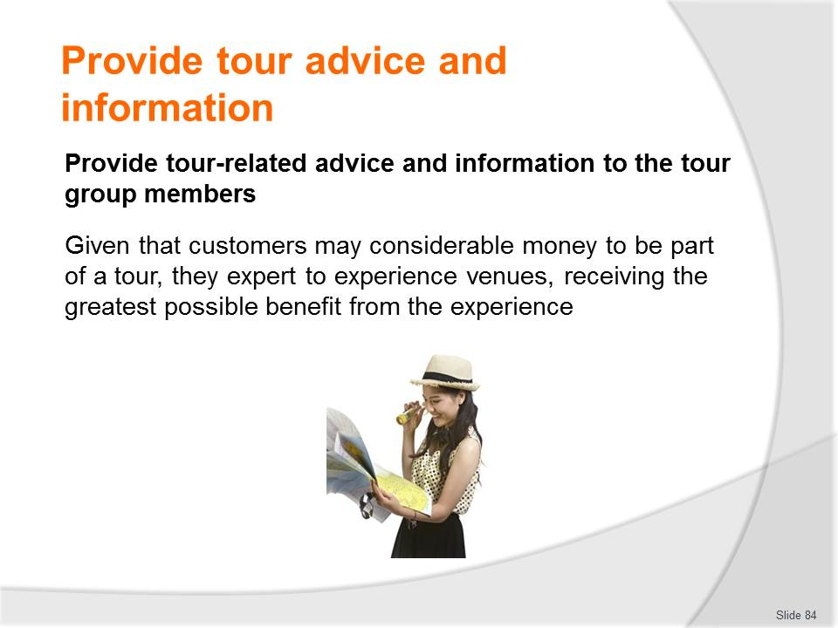
Slide No | Trainer Notes
Class Activity – Discussion about providing tour-related advice
- What do tour members expect in terms of information?

Slide
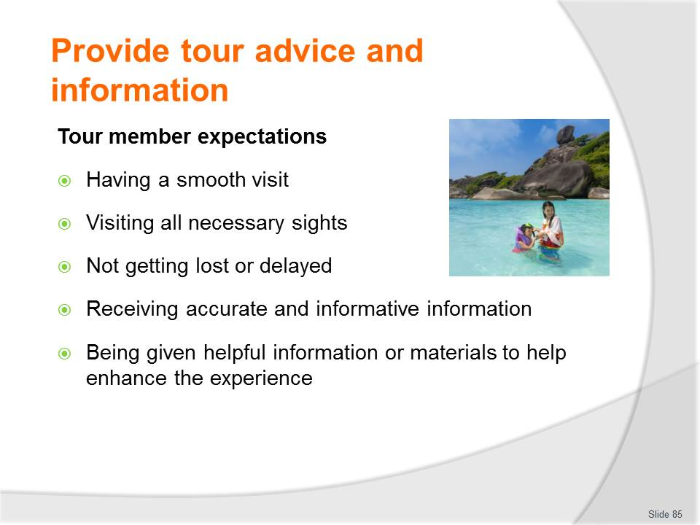
Slide No | Trainer Notes
Class Activity – Discussion about providing tour-related advice
- Discuss these expectations
- How can you ‘exceed’ these expectations?

Slide
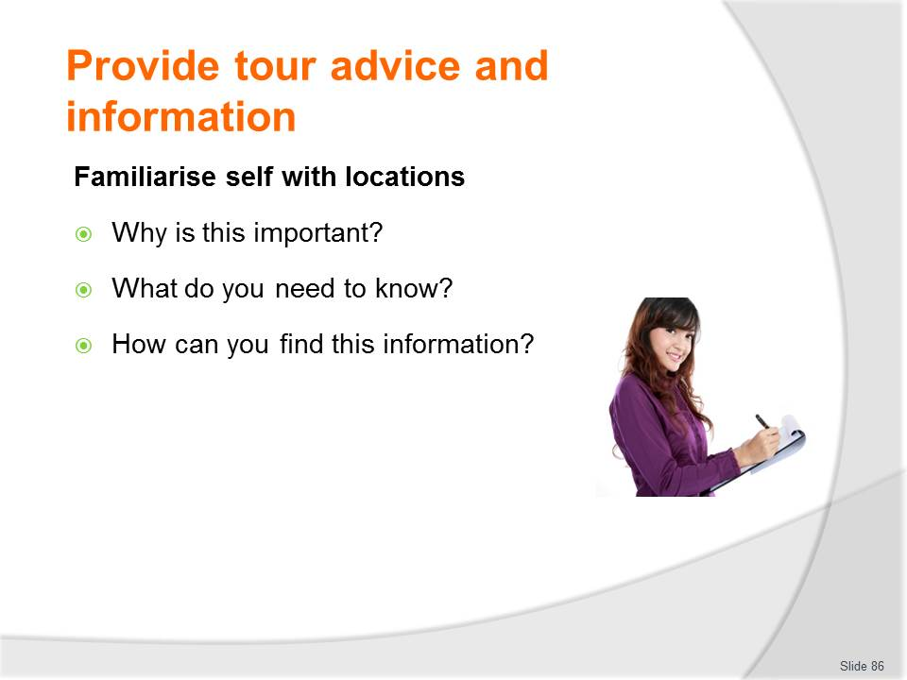
Slide No | Trainer Notes
Class Activity – Discussion about providing tour-related advice
- Discuss the questions in the slide.

Slide
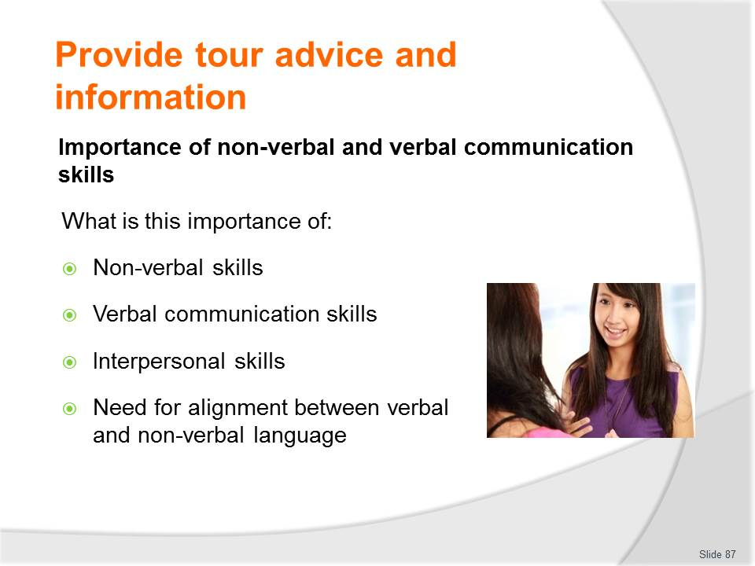
Slide No | Trainer Notes
Class Activity – Discussion importance of communication skills
- Why are communication skills important?
- Discuss the different types of communication skills in this slide.

Slide
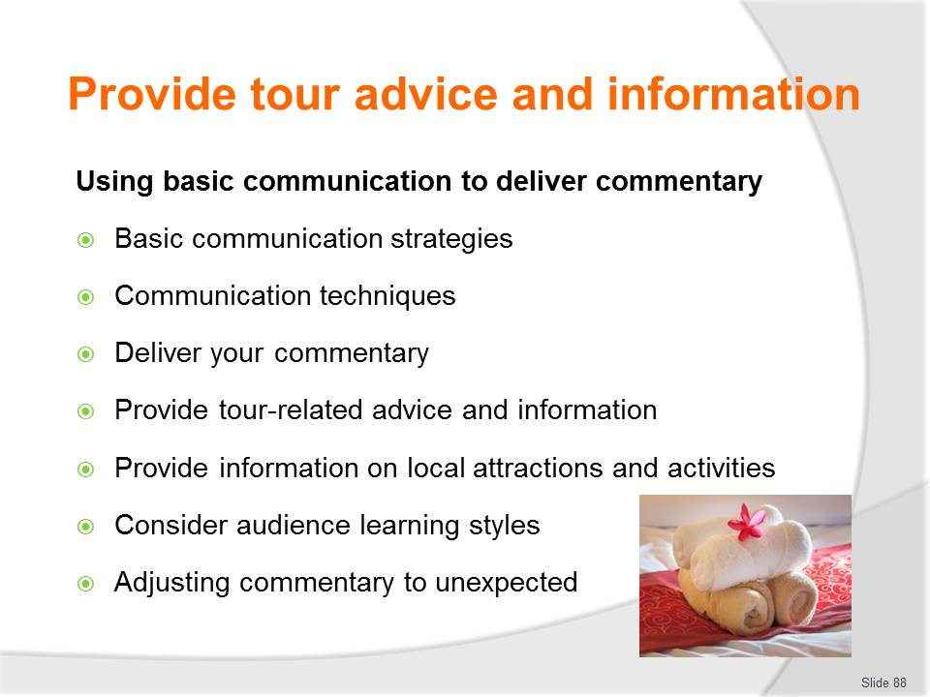
Slide No | Trainer Notes
Class Activity – Discussion about importance of communication skills
- Discuss strategies on how you can maximise your communication skills to meet the points in this slide.

Slide
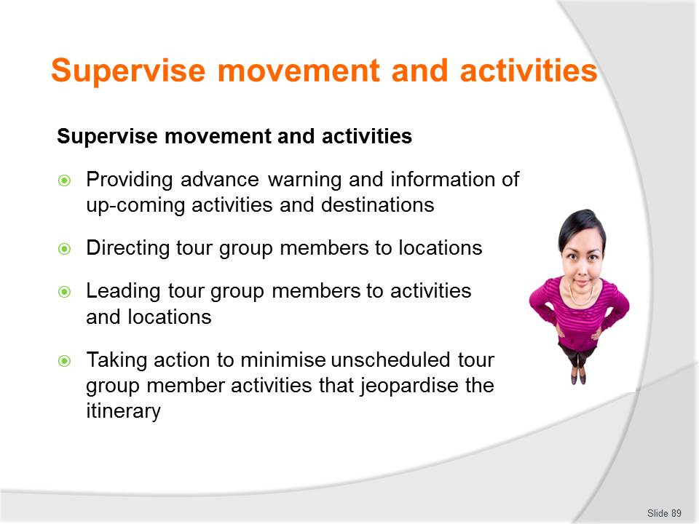
Slide No | Trainer Notes
Class Activity – Discussion about importance of supervising movement and activities
- Why is it important to supervising movement and activities?
- What do you need to supervise?
- How can you do this?
- Review documents / tools used to supervise and manage movement.

Slide
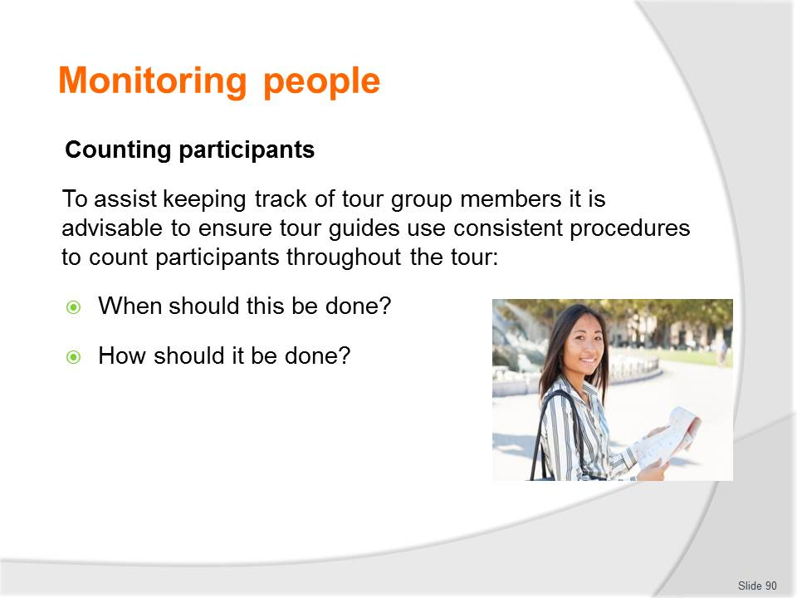
Slide No | Trainer Notes
Class Activity – Discussion about importance of counting participants
- Discuss questions in the slide.

Slide
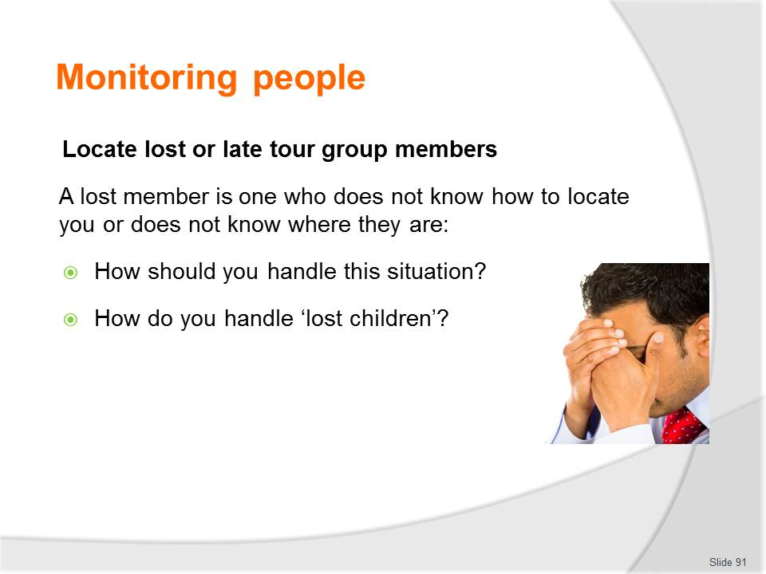
Slide No | Trainer Notes
Class Activity – Discussion about importance of locating lost persons
- Discuss questions in the slide.

Slide
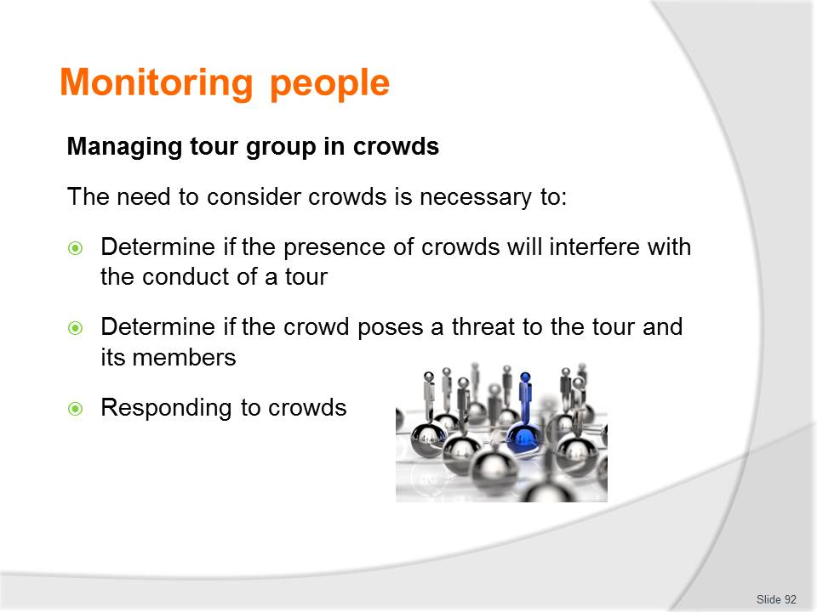
Slide No | Trainer Notes
Class Activity – Discussion about managing tour group in crowds
- How can you manage tour group in crowds?

Slide
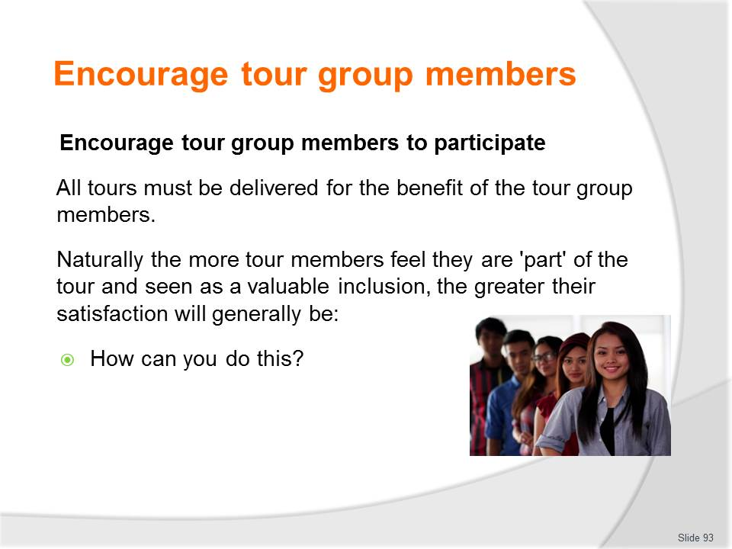
Slide No | Trainer Notes
Class Activity – Discussion about encouraging tour group members
- Discuss question in the slide.

Slide
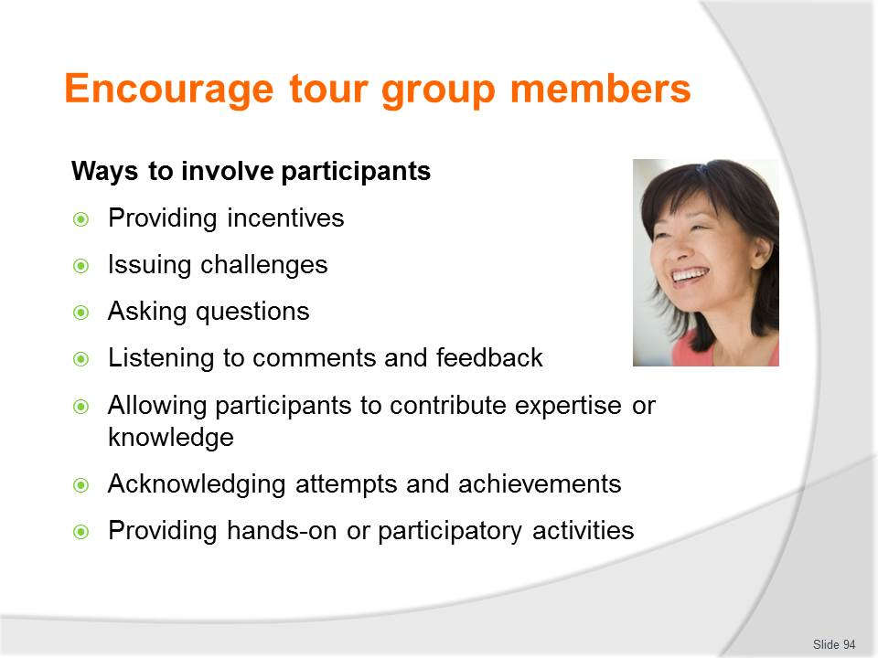
Slide No | Trainer Notes
Class Activity – Discussion about encouraging tour group members
- Provide examples / strategies for each point in this slide.

Slide
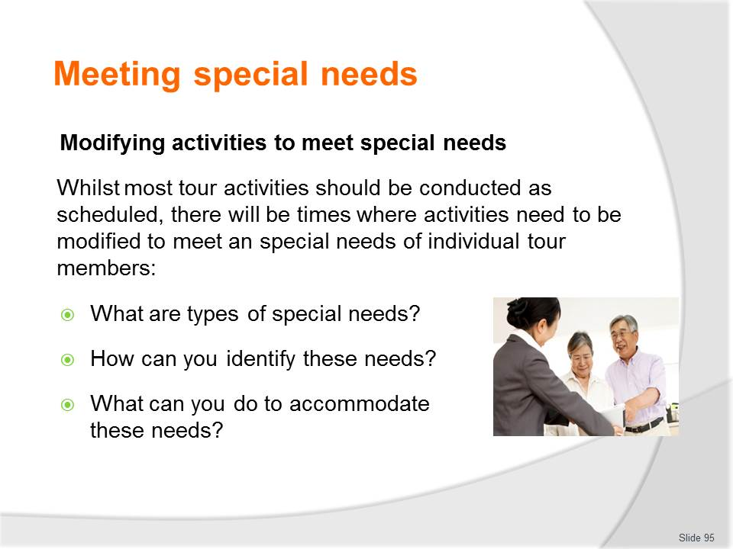
Slide No | Trainer Notes
Class Activity – Discussion about modifying activities
- Discuss question in the slide.

Slide
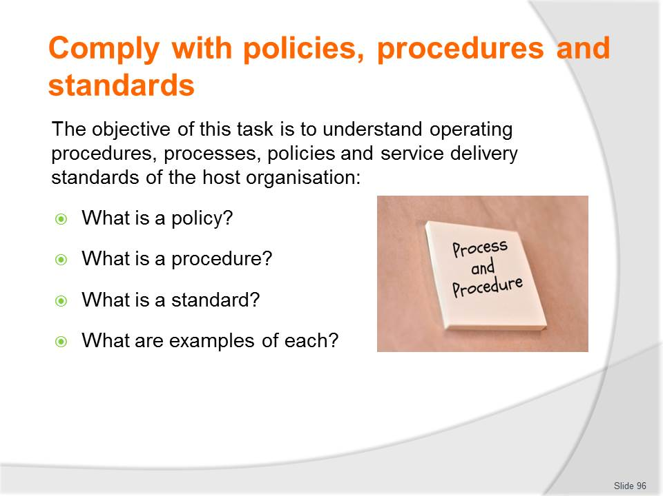
Slide No | Trainer Notes
Class Activity – Discussion
- Discuss question in the slide.

Slide
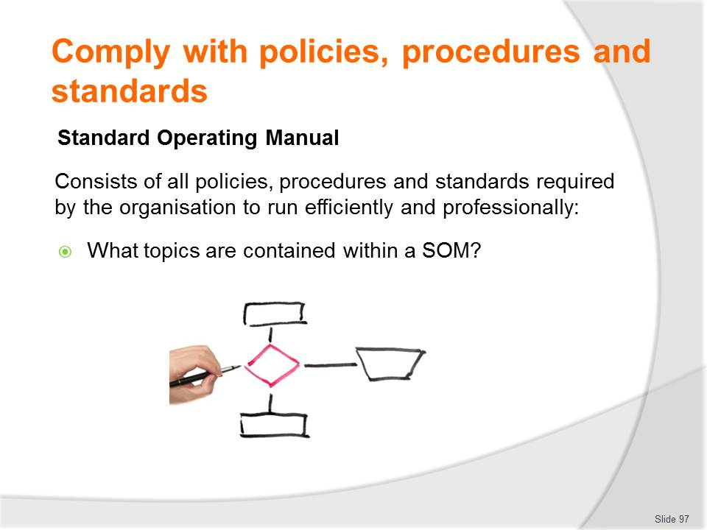
Slide No | Trainer Notes
Class Activity – Discussion & Review of Standard Operating Manual
- Discuss question in the slide
- Review of Standard Operating Manual.

Slide
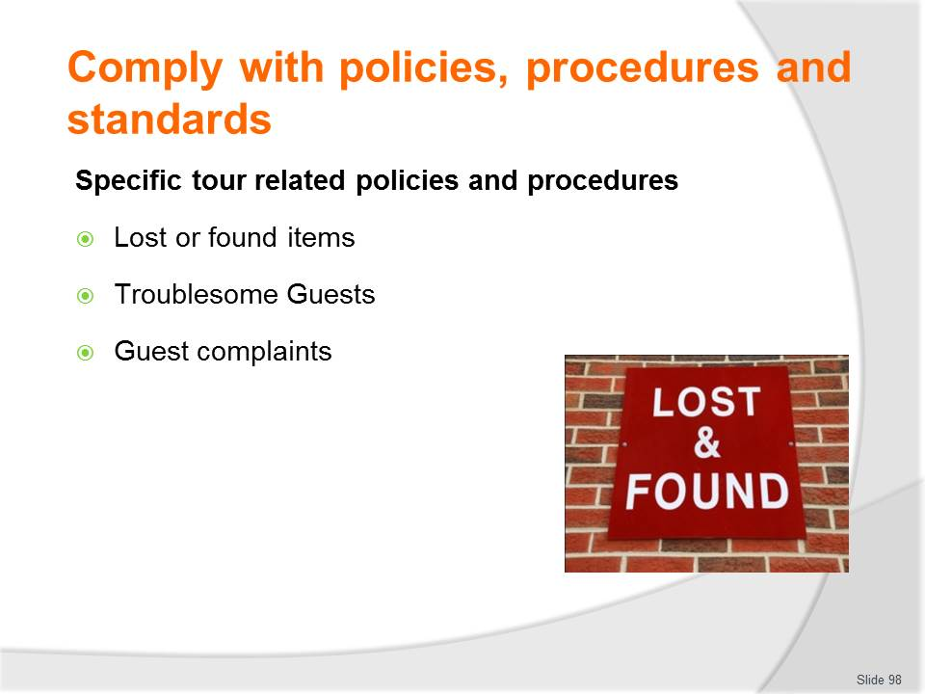
Slide No | Trainer Notes
Class Activity – Identify specific tour related policies and procedures
- Identify specific tour related policies and procedures for each of the points in this slide
- Are there other specific tour related policies and procedures for other aspects of a tour?

Slide
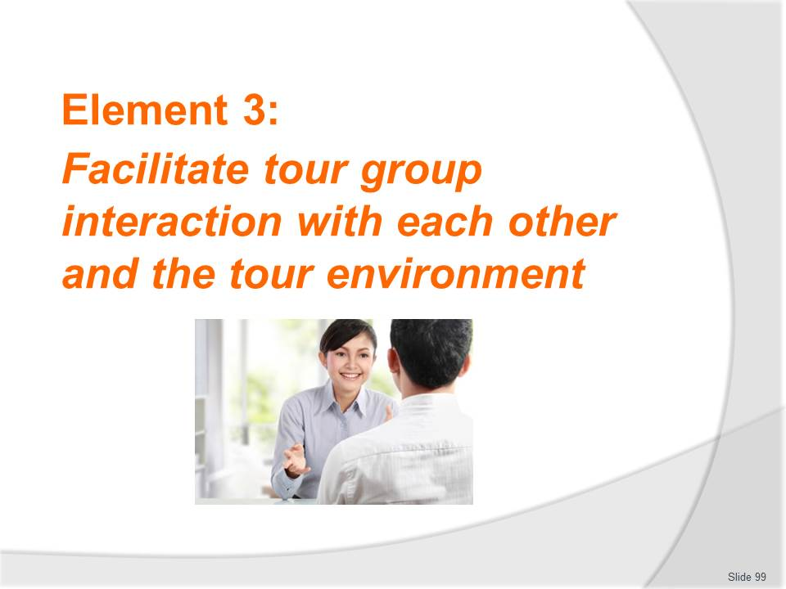
Slide No | Trainer Notes
Introduce topic
Class Activity – General Discussion
Ask general questions:
- Why is it important for tour group members to interact with each other?

Slide
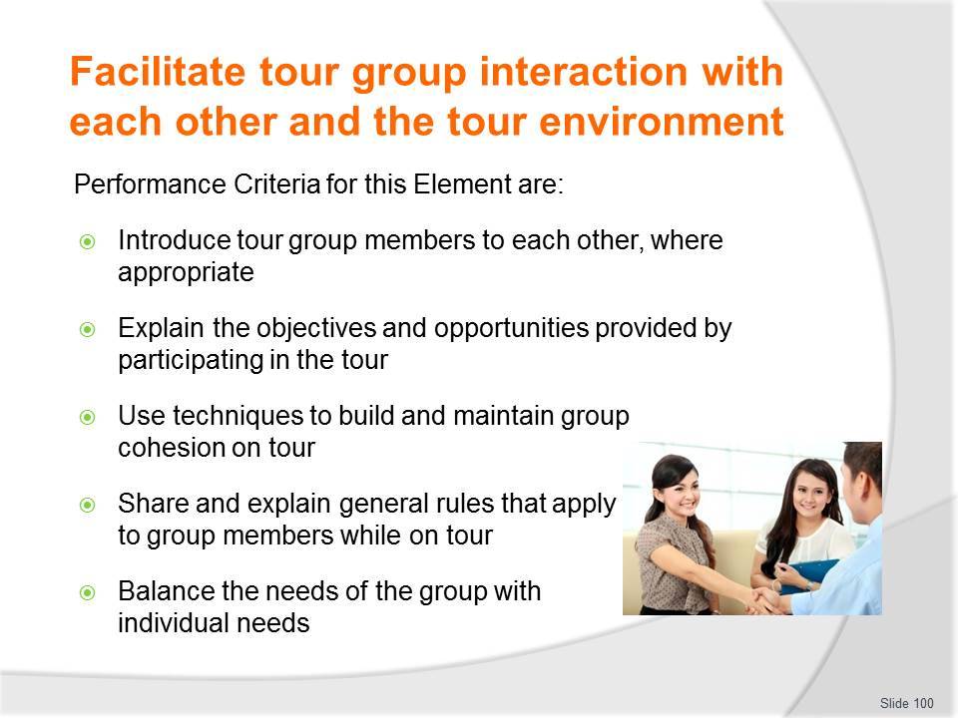
Slide No | Trainer Notes
 | Trainer identifies the Performance Criteria for this Element, as listed on the slide.

Slide
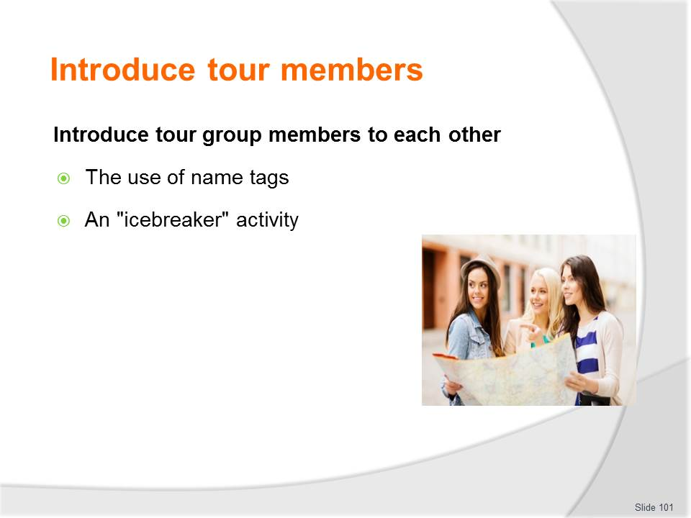
Slide No | Trainer Notes
Class Activity – Conduct an "icebreaker" activity
- Audience is to prepare and conduct an "icebreaker" activity.

Slide
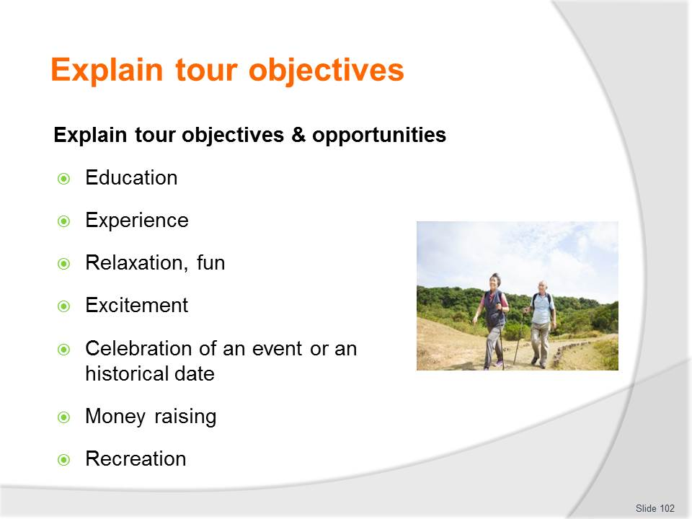
Slide No | Trainer Notes
Class Activity – Identify tour inclusions based on objectives
- For each of these objectives, what are possible tour inclusions that can be considered?

Slide
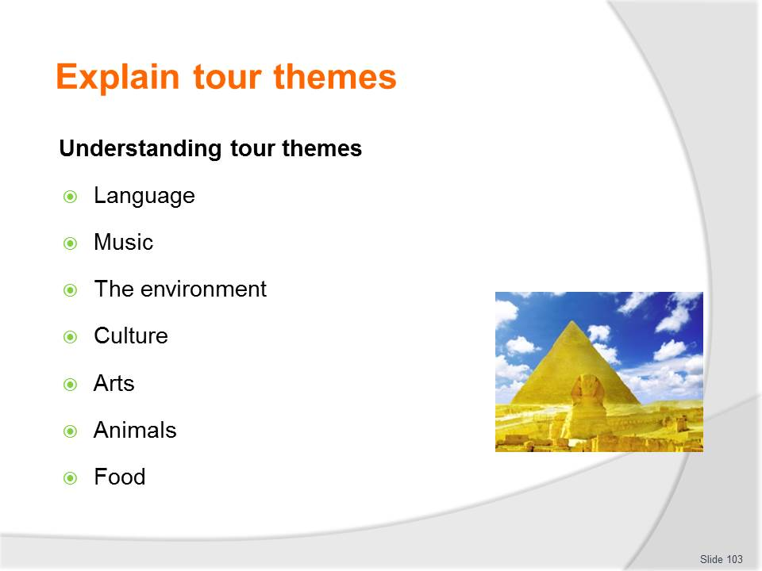
Slide No | Trainer Notes
Class Activity – Identify tour inclusions based on themes
- For each of these themes, what are possible tour inclusions that can be considered?

Slide
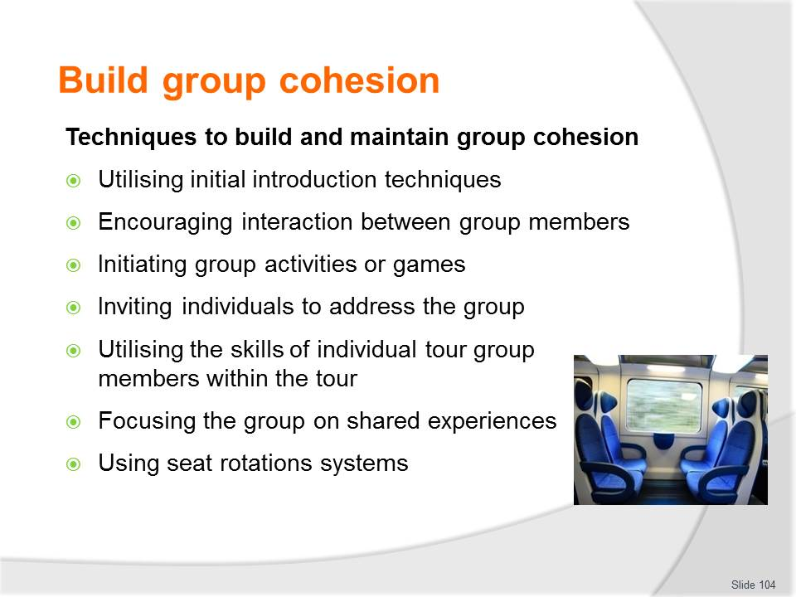
Slide No | Trainer Notes
Class Activity – Discussion to build and maintain group cohesion
- Why is it important to build and maintain group cohesion?
- What are other strategies you can use?

Slide
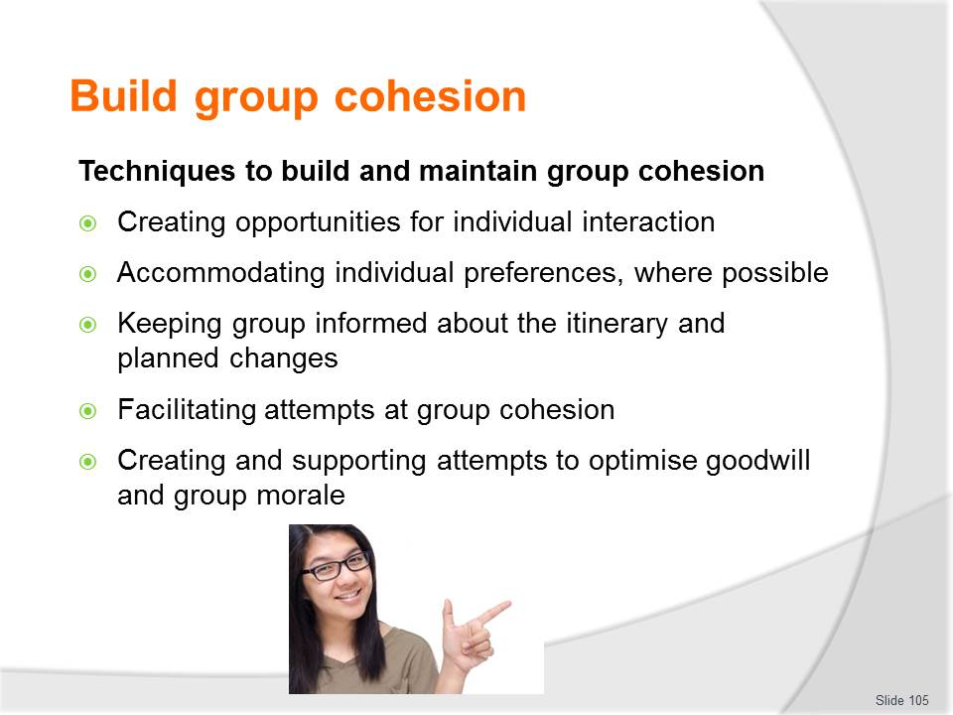
Slide No | Trainer Notes
Class Activity – Discussion to build and maintain group cohesion
- Why is it important to build and maintain group cohesion?
- What are other strategies you can use?

Slide
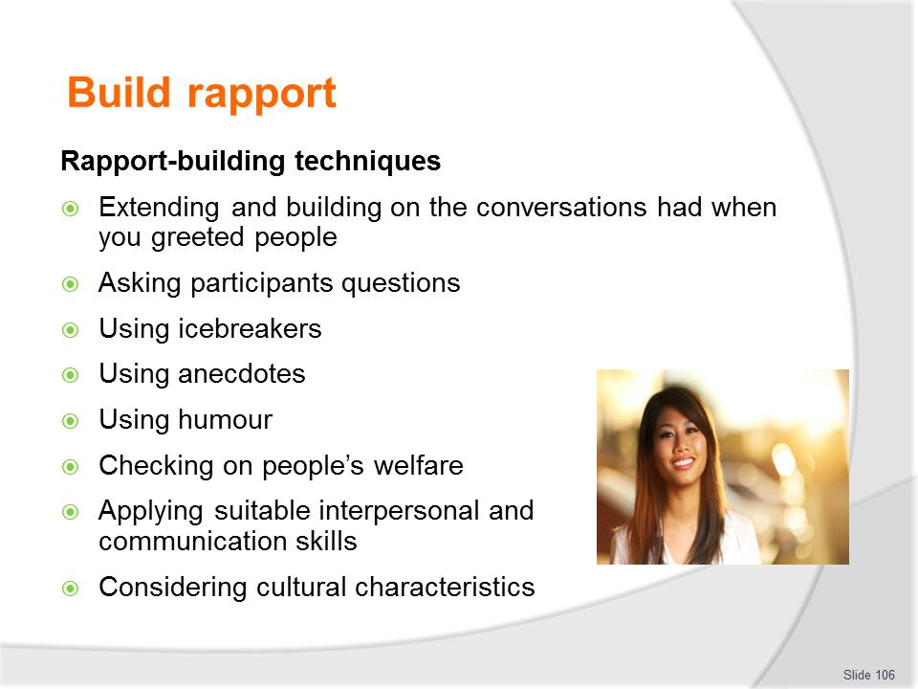
Slide No | Trainer Notes
Class Activity – Discussion to build rapport
- What is rapport?
- Why is it important to rapport?
- Identify examples for each point.
- What are other strategies you can use?

Slide
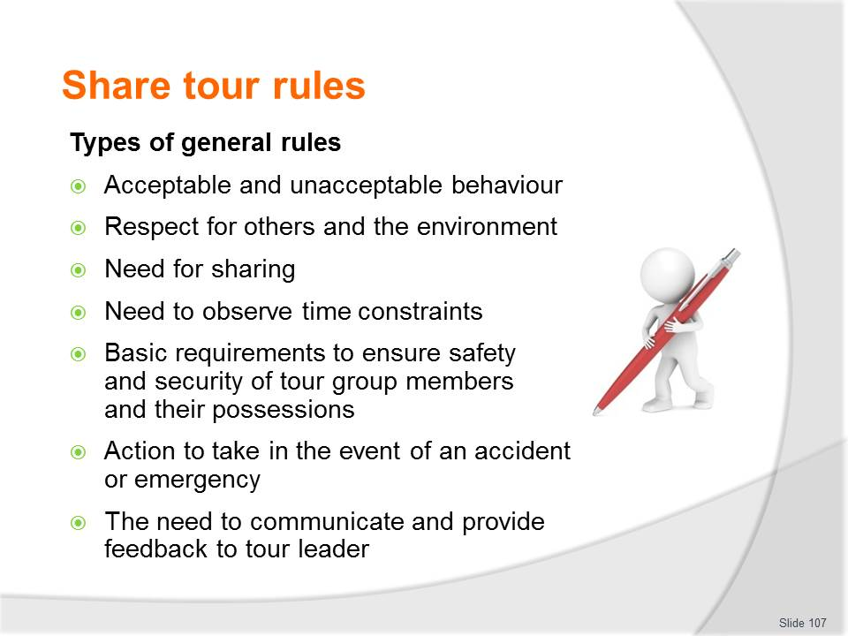
Slide No | Trainer Notes
Class Activity – Discussion about rules.
- Why are these rules important?
- What are examples for each of these points?
- What other rules would you implement if you were a tour guide?

Slide
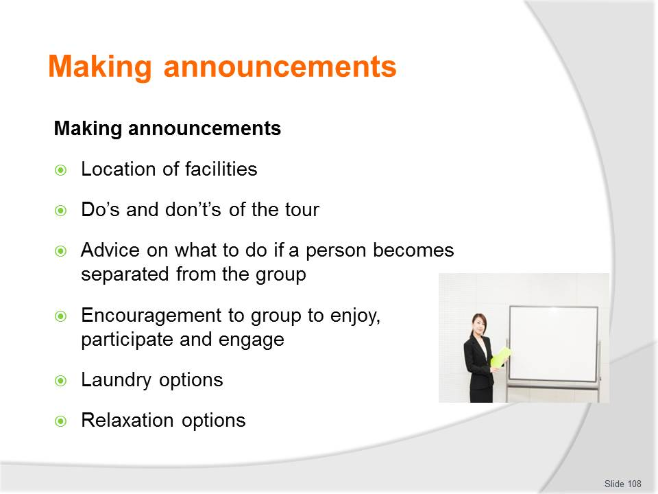
Slide No | Trainer Notes
Class Activity – Discussion about making announcements
- What are pieces of information that would be included in each of these points?

Slide
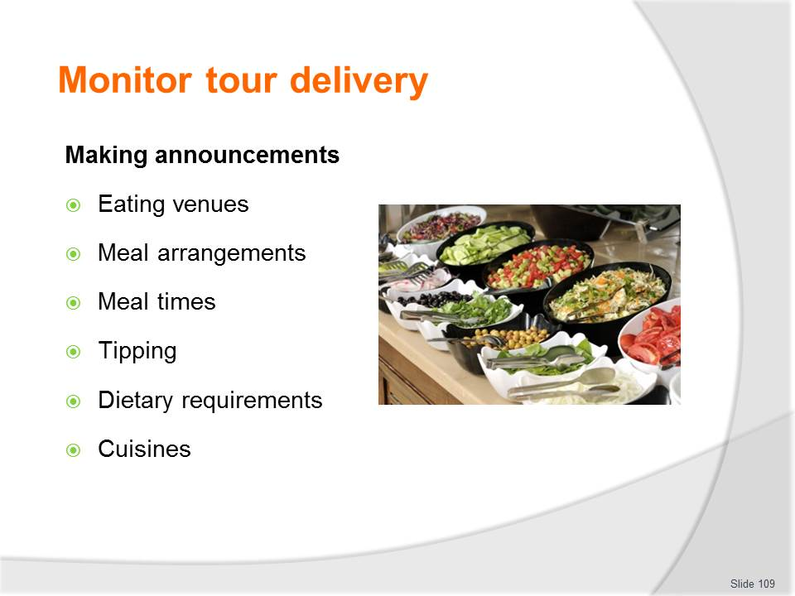
Slide No | Trainer Notes
Class Activity – Discussion about making announcements
- What are pieces of information that would be included in each of these points?

Slide
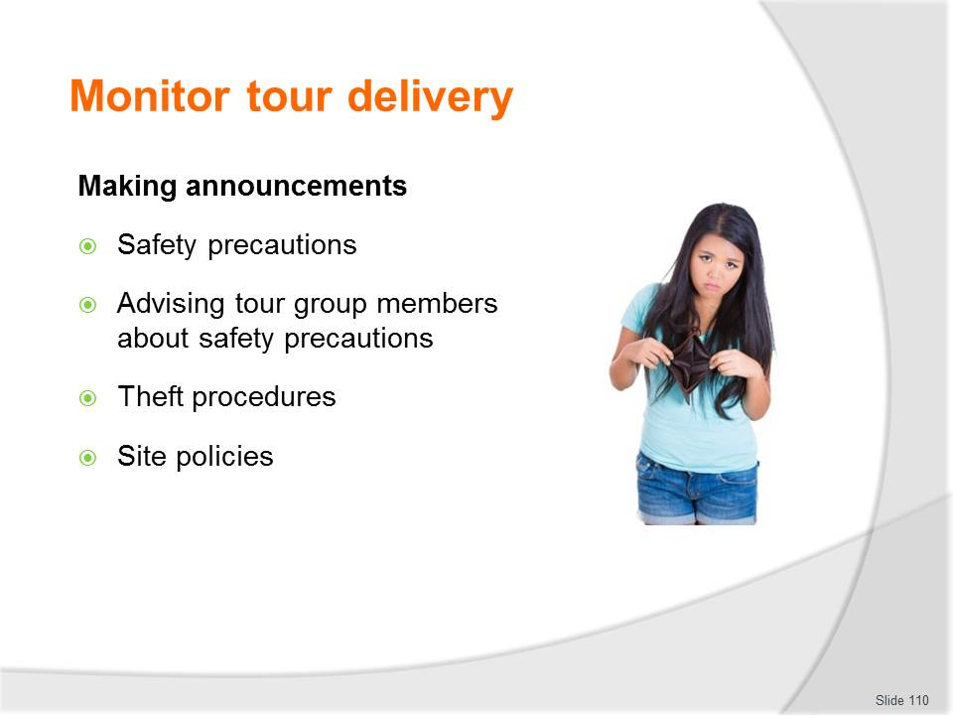
Slide No | Trainer Notes
Class Activity – Discussion about making announcements
- What are pieces of information that would be included in each of these points?

Slide
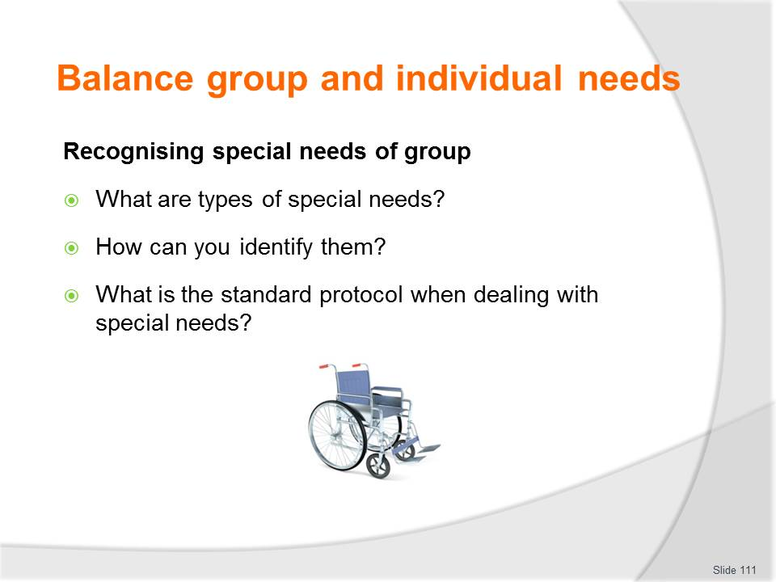
Slide No | Trainer Notes
Class Activity – Discussion about recognising special needs of group
- Discuss the questions in this slide.

Slide
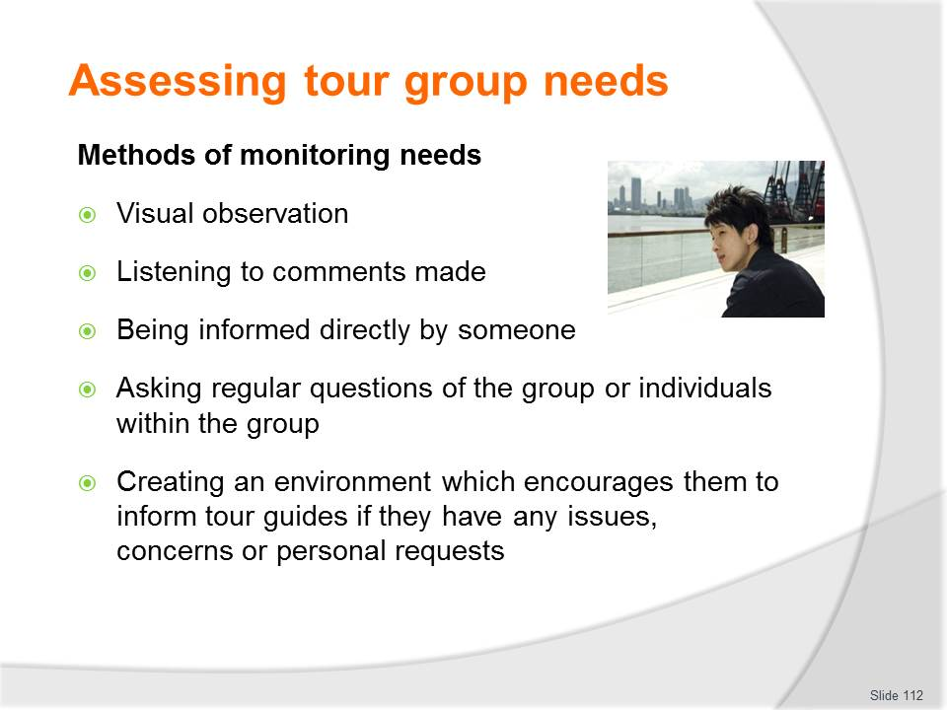
Slide No | Trainer Notes
Class Activity – Discussion about importance of monitoring needs
- Why is it important to monitoring needs?
- What activities are associated with each of these points?
- What other monitoring methods can be used?

Slide
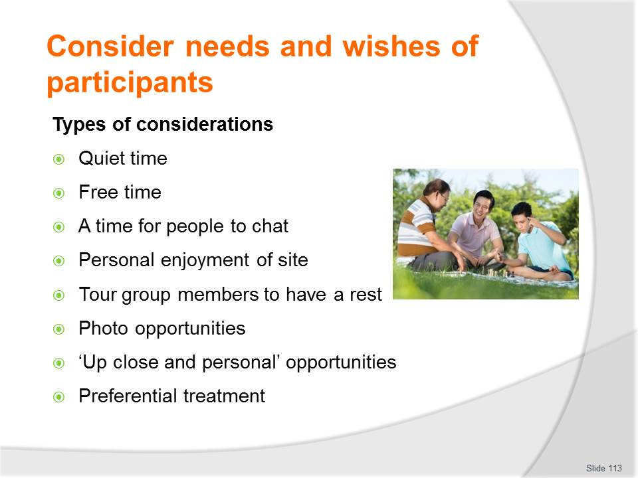
Slide No | Trainer Notes
Class Activity – Meeting customer considerations
- Provide examples of how you can accommodate these considerations.

Slide
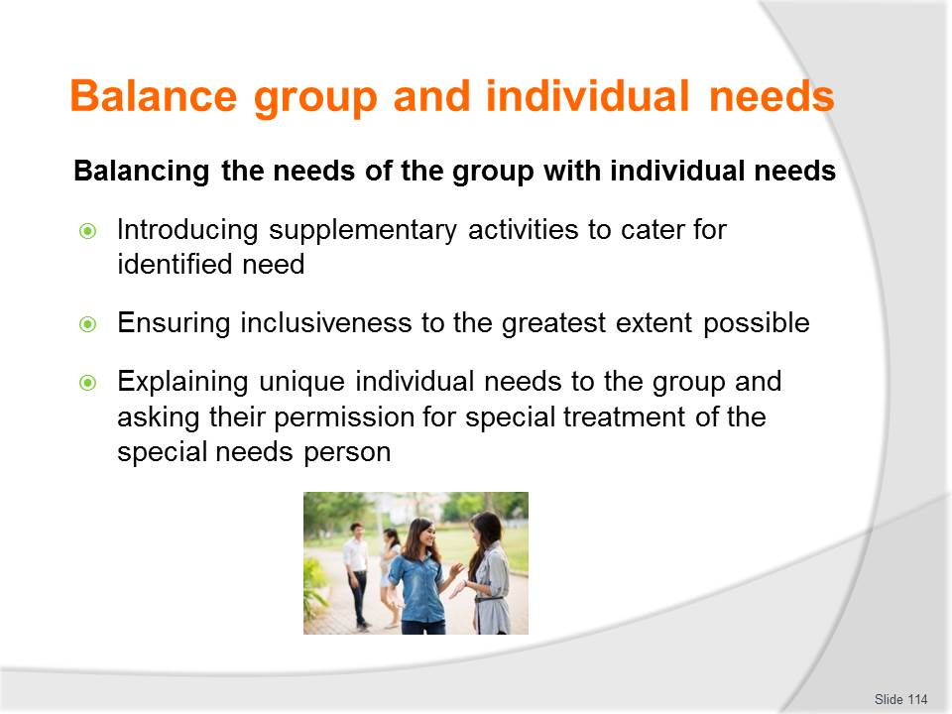
Slide No | Trainer Notes
Class Activity – Discussion about balancing the needs of the group with individual needs
- How can you meet the needs of both the group and individual if they clash?

Slide
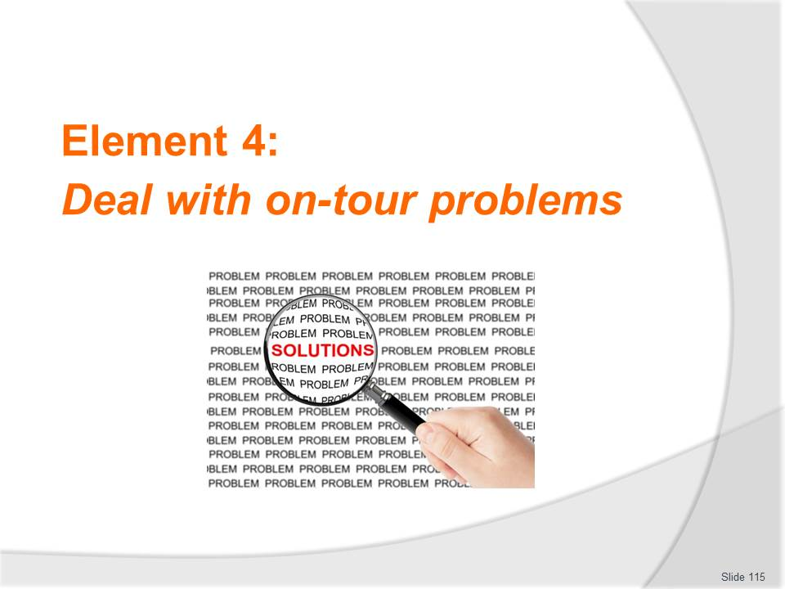
Slide No | Trainer Notes
Introduce topic
Class Activity – General Discussion
Ask general questions:
- What are examples of on-tour problems?
- What causes them?
- Why is it important to resolve them quickly?
- How can you resolve them?

Slide
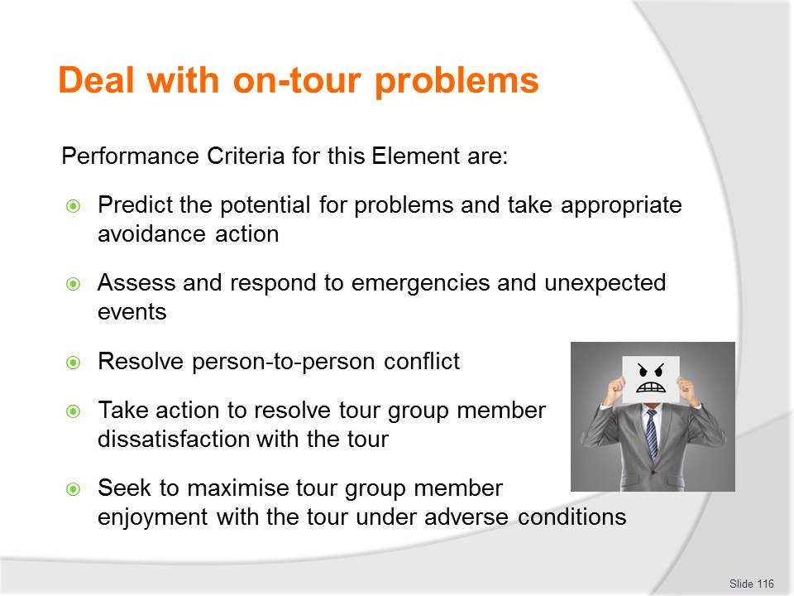
Slide No | Trainer Notes
 | Trainer identifies the Performance Criteria for this Element, as listed on the slide.

Slide
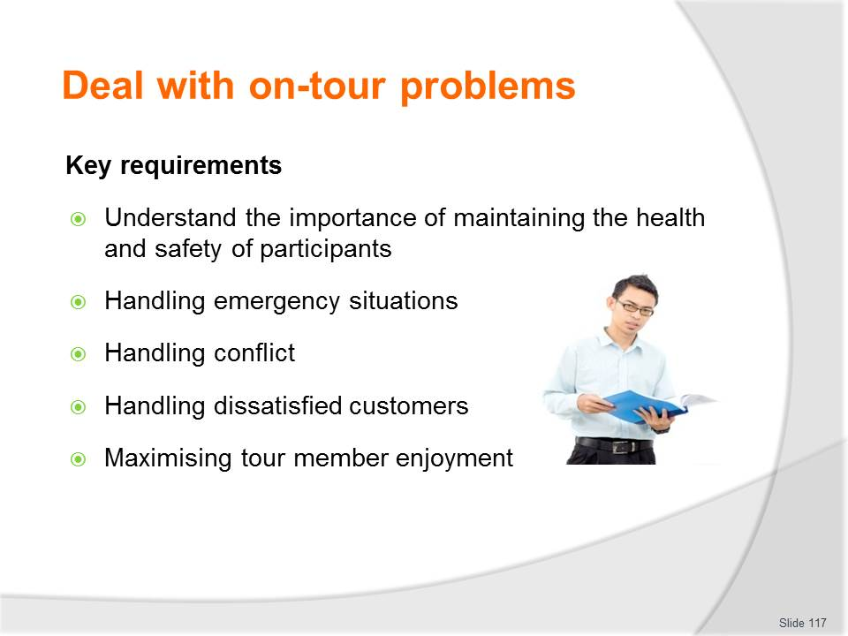
Slide No | Trainer Notes
Class Activity – Discussion about key requirements when handling problems
- Discuss personal stories relating to each type of problem, including how they were handled.

Slide
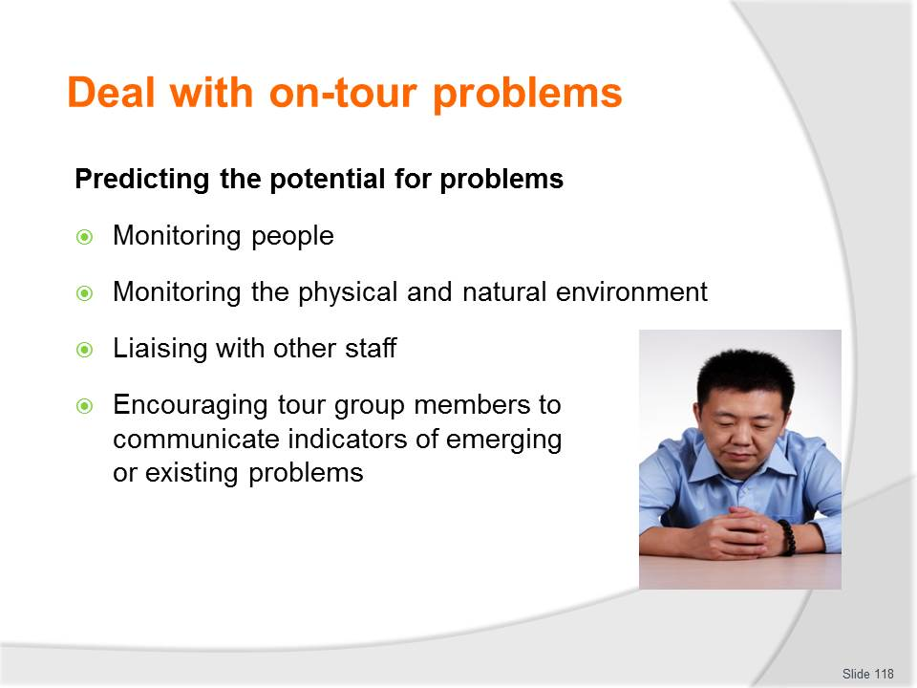
Slide No | Trainer Notes
Class Activity – Discussion about predicting the potential for problems
- How else can you predict problems?

Slide
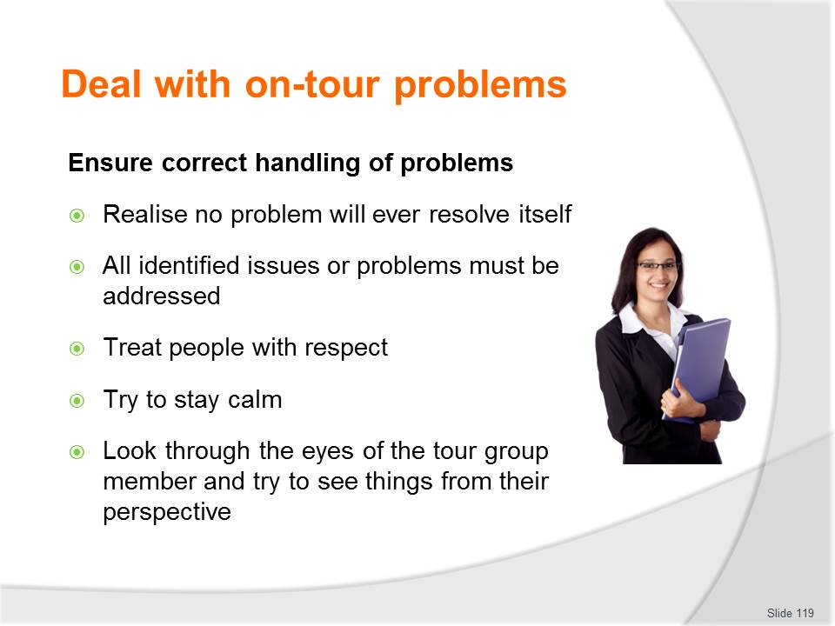
Slide No | Trainer Notes
Class Activity – Handling problems
- What are other considerations when handling problems?

Slide
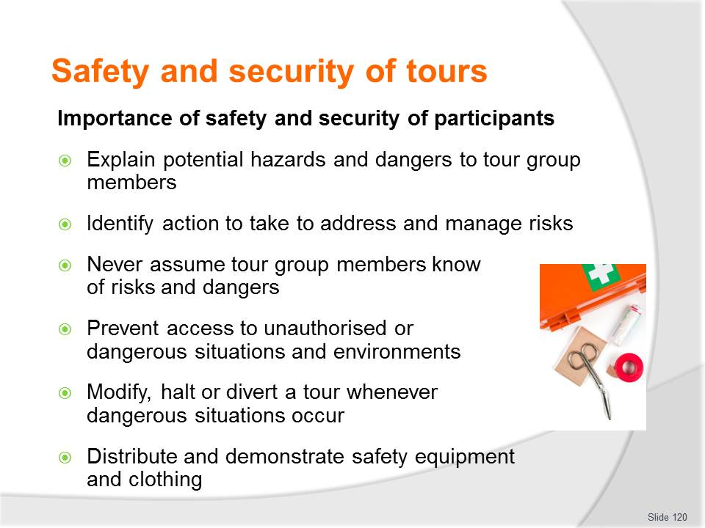
Slide No | Trainer Notes
Class Activity – Importance of safety and security
- Discuss the importance of these points, providing examples.

Slide
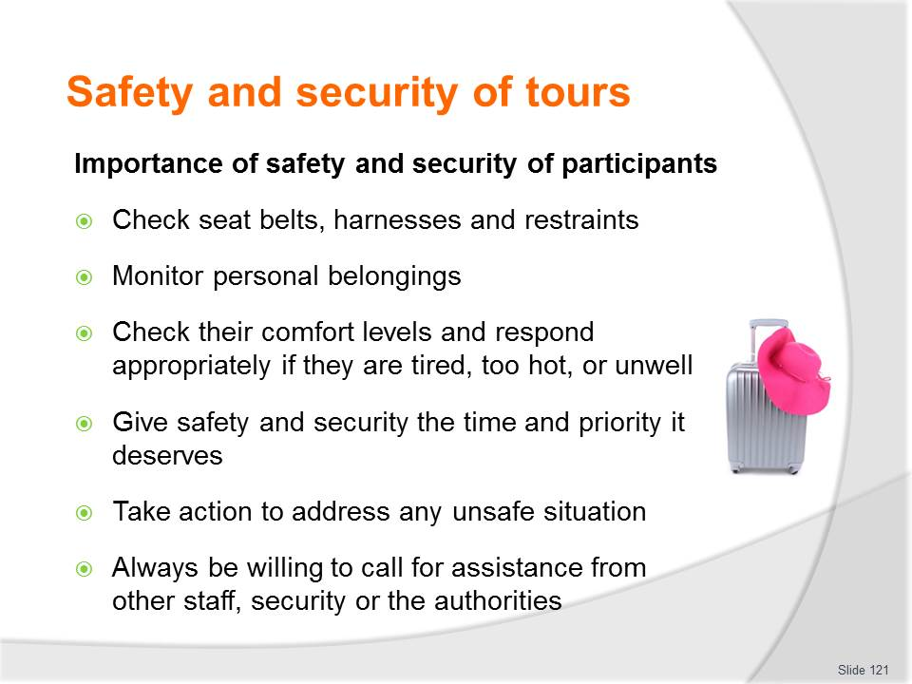
Slide No | Trainer Notes
Class Activity – Importance of safety and security
- Discuss the importance of these points, providing examples.

Slide
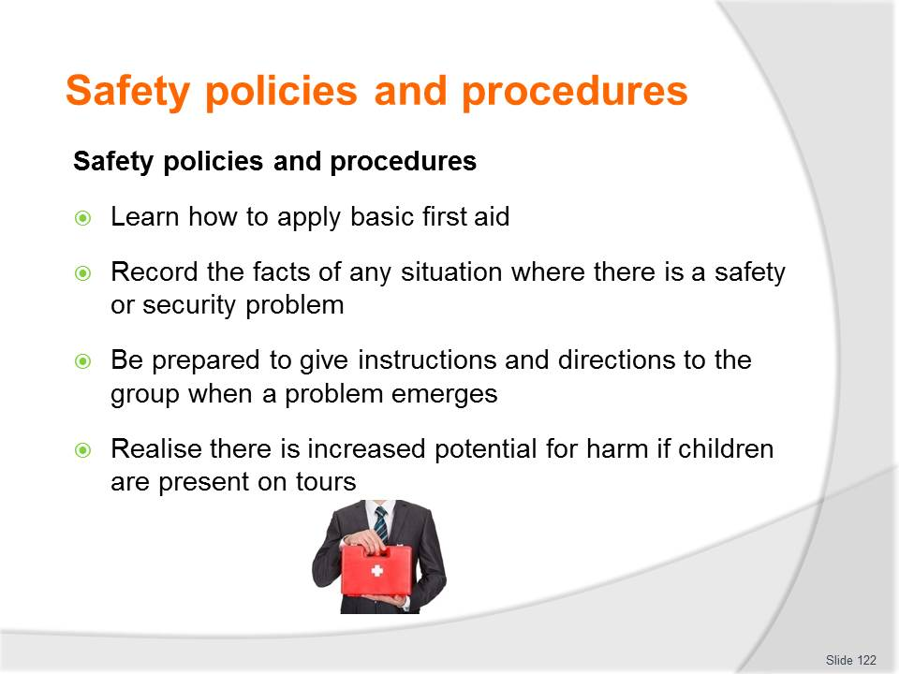
Slide No | Trainer Notes
Class Activity – Importance of safety policies and procedures
- Discuss the importance of these points, providing examples.

Slide
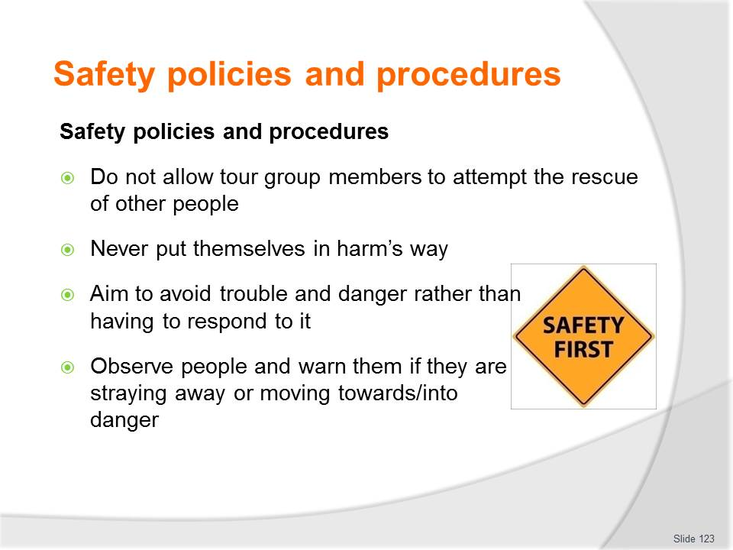
Slide No | Trainer Notes
Class Activity – Importance of safety policies and procedures
- Discuss the importance of these points, providing examples.

Slide
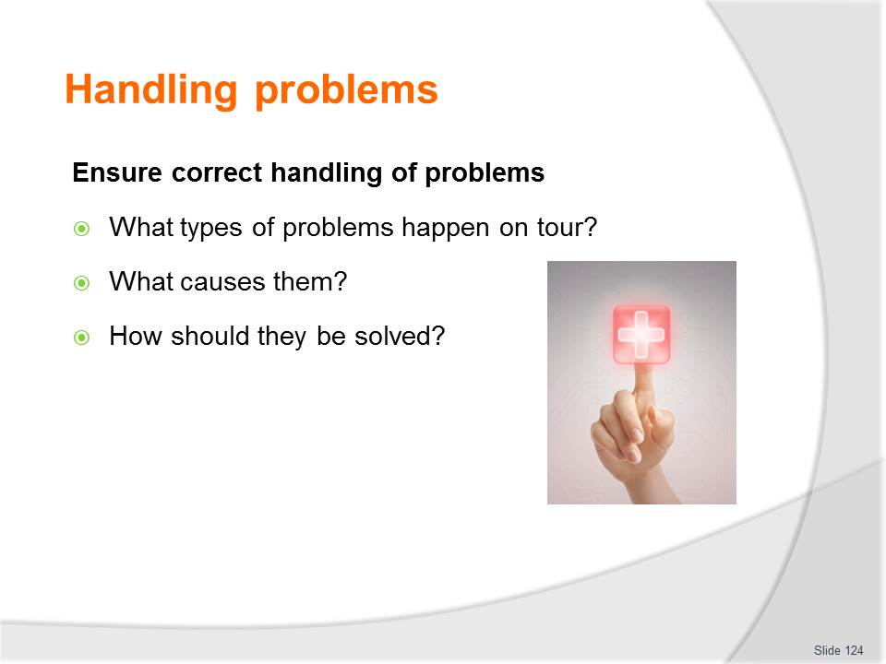
Slide No | Trainer Notes
Class Activity – Importance of correct handling of problems
- Discuss questions in the slide.

Slide
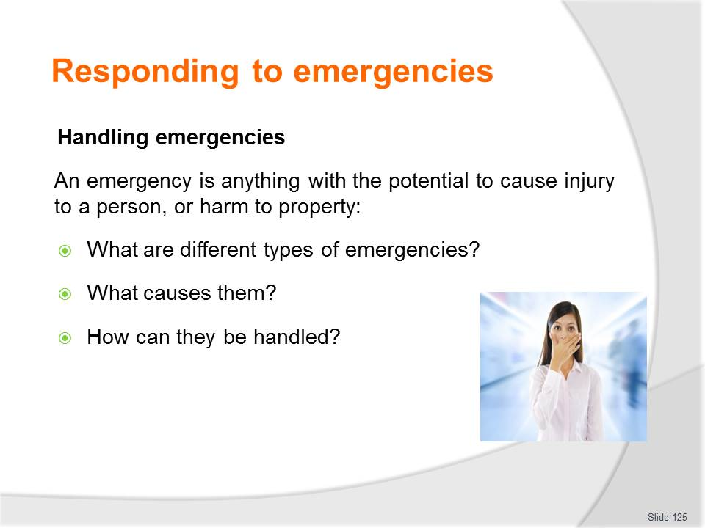
Slide No | Trainer Notes
Class Activity – Importance of handling emergencies
- Discuss questions in the slide.

Slide
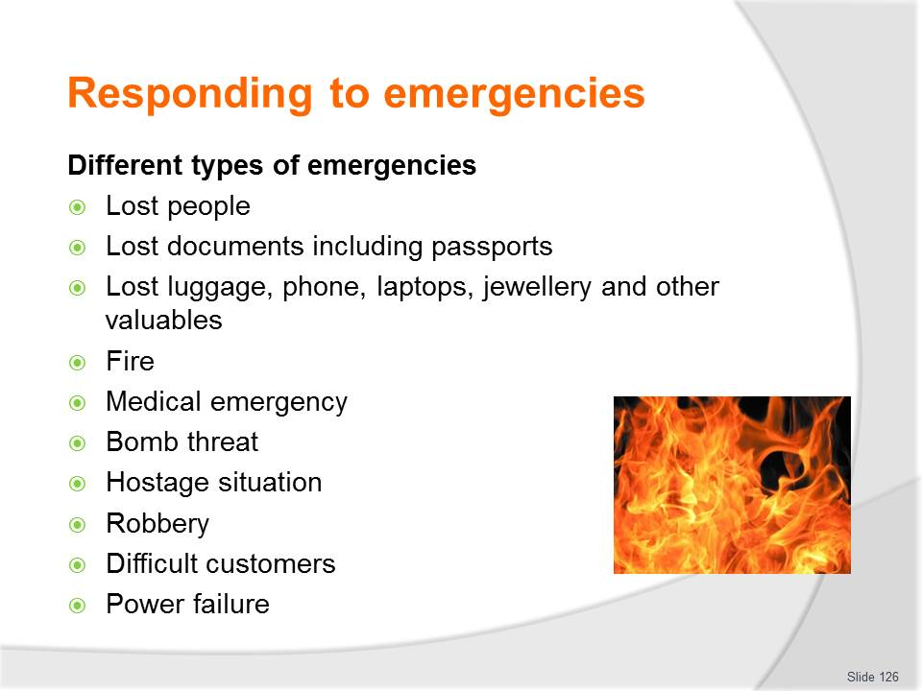
Slide No | Trainer Notes
Class Activity – Importance of handling emergencies
For each of the points in the slide:
- Identify causes for these emergencies
- Steps to handle and overcome these emergencies.

Slide
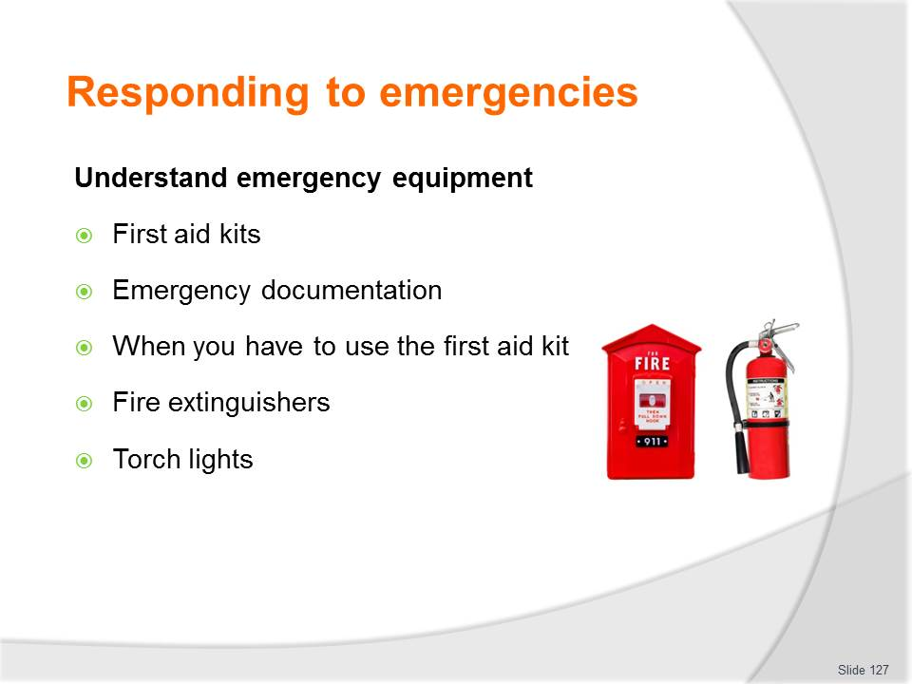
Slide No | Trainer Notes
Class Activity – Demonstrate emergency equipment
- Trainer to demonstrate and explain purpose and use for each of these pieces of emergency equipment.

Slide
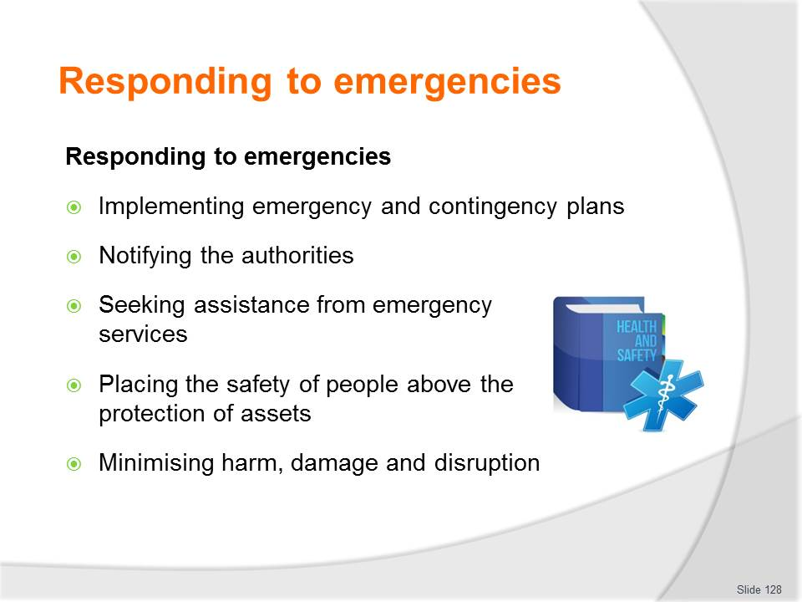
Slide No | Trainer Notes
Class Activity – Discuss strategies when responding to emergencies
- Trainer to discuss strategies for responding to emergencies
- Trainer to show rules, SOPs etc. where applicable.

Slide
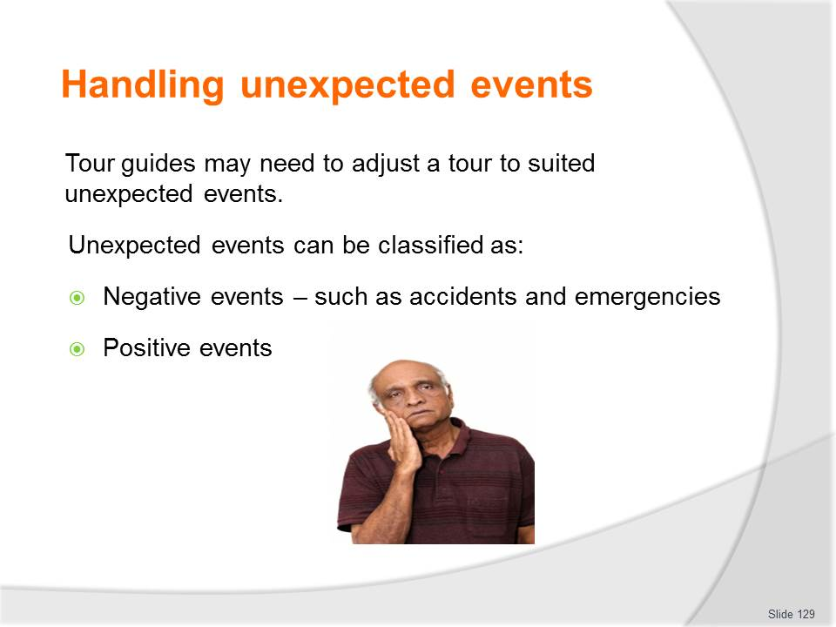
Slide No | Trainer Notes
Class Activity – Discuss unexpected events
- What are examples of negative events?
- How can these be overcome of minimised?
- What are examples of positive events?
- How can these be maximised to the benefit of tour members?

Slide
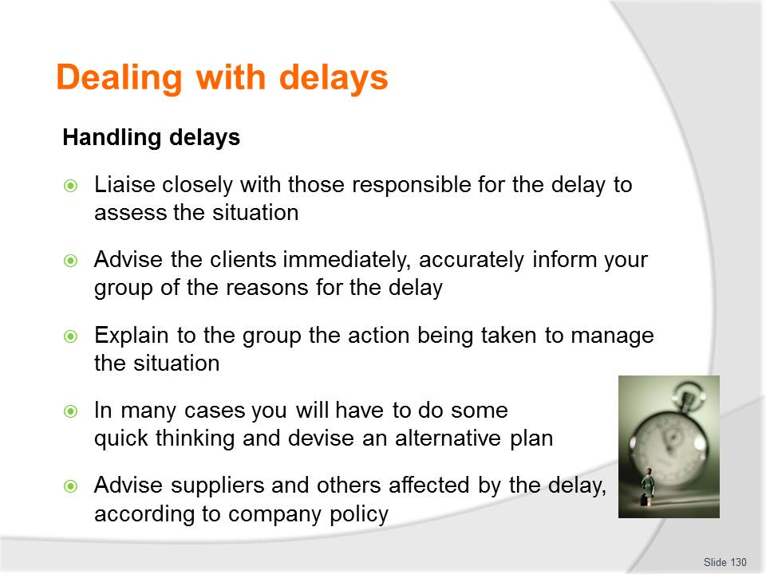
Slide No | Trainer Notes
Class Activity – Handling delays
- What are examples of common delays?
- What causes them?
- How can you be overcome?

Slide
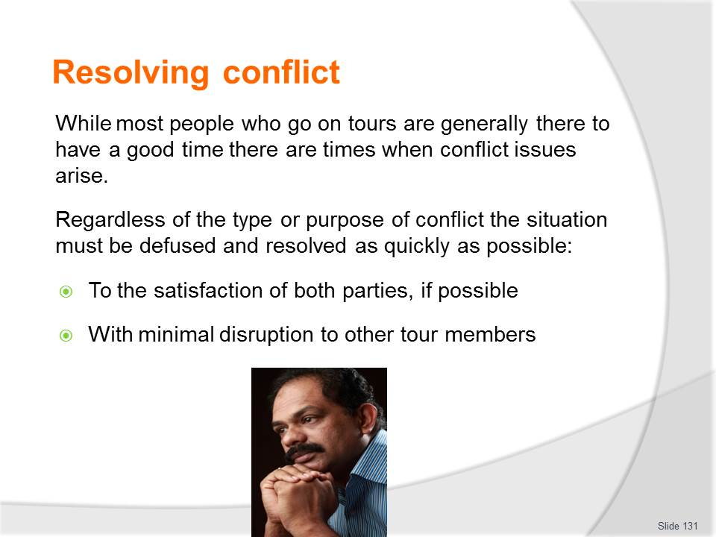
Slide No | Trainer Notes
Class Activity – Resolving conflict
- What are examples of conflict?
- How do you resolve conflict?

Slide
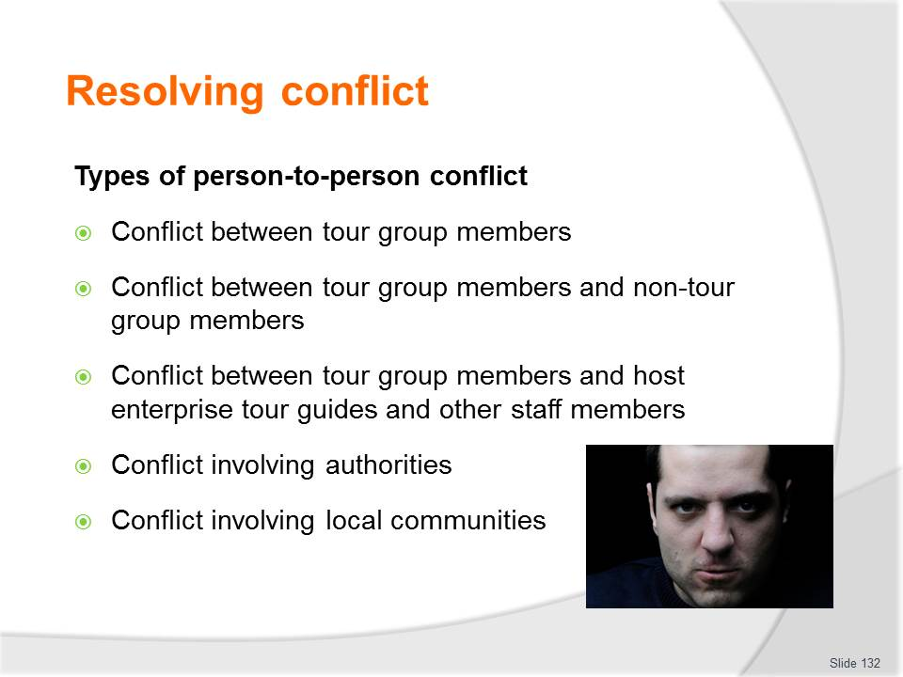
Slide No | Trainer Notes
Class Activity – Resolving conflict
- What are examples of each type of conflict?
- How do you resolve this conflict?

Slide
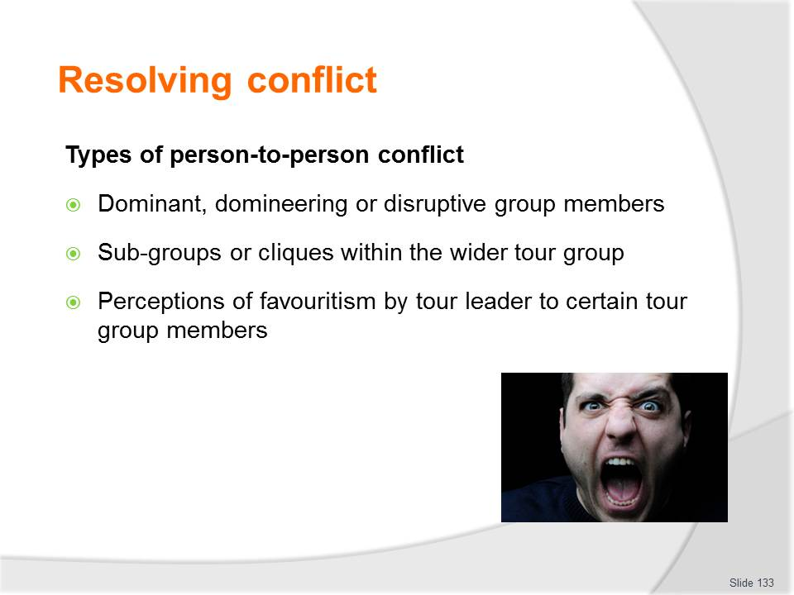
Slide No | Trainer Notes
Class Activity – Resolving conflict
- Reflect on personal experiences.

Slide
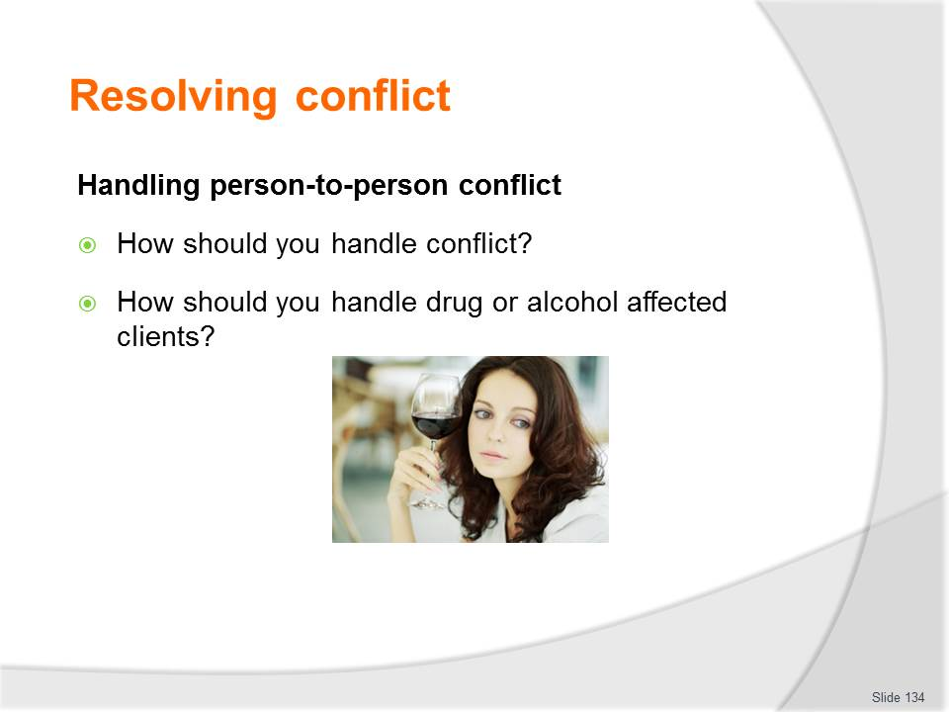
Slide No | Trainer Notes
Class Activity – Resolving conflict
- Discuss the questions in the slide.

Slide
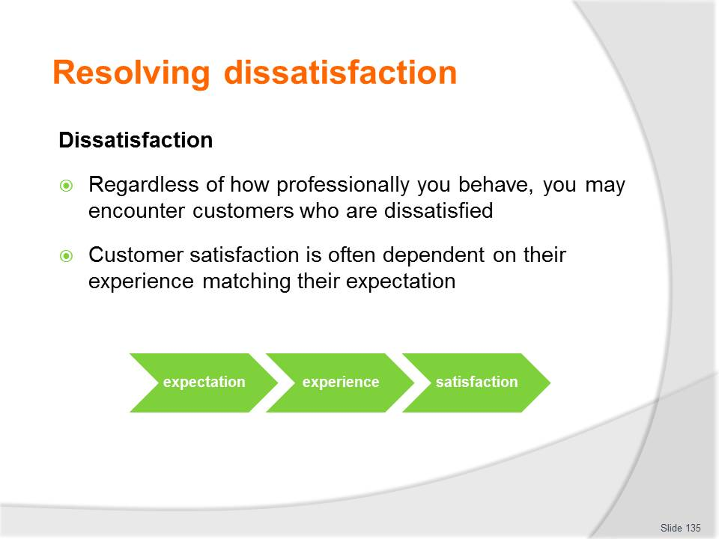
Slide No | Trainer Notes
Class Activity – Resolving dissatisfaction
- Why is it important to resolve dissatisfaction?
- How can you do this?
- What are common causes of dissatisfaction?

Slide
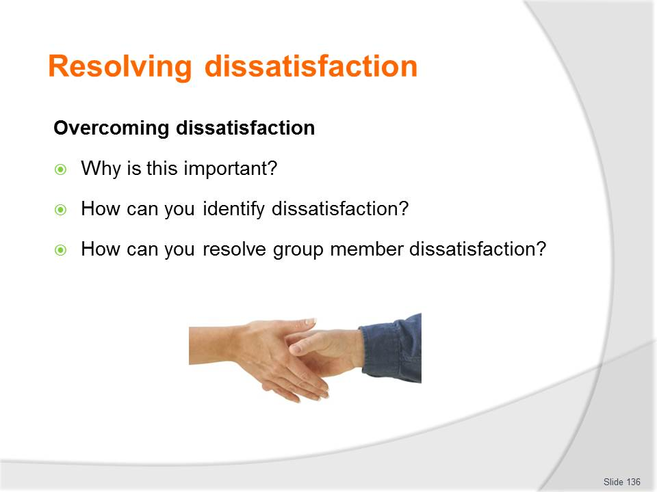
Slide No | Trainer Notes
Class Activity – Resolving dissatisfaction
- Discuss the points in this slide.

Slide
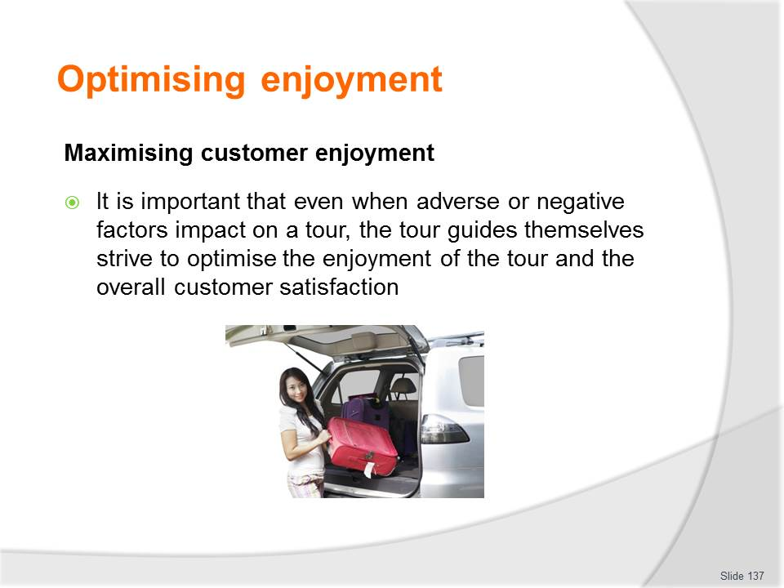
Slide No | Trainer Notes
Class Activity – Resolving dissatisfaction in ‘adverse’ conditions?
- What are examples of ‘adverse’ conditions?
- How would you overcome these adverse’ conditions to the benefit of customers?

Slide
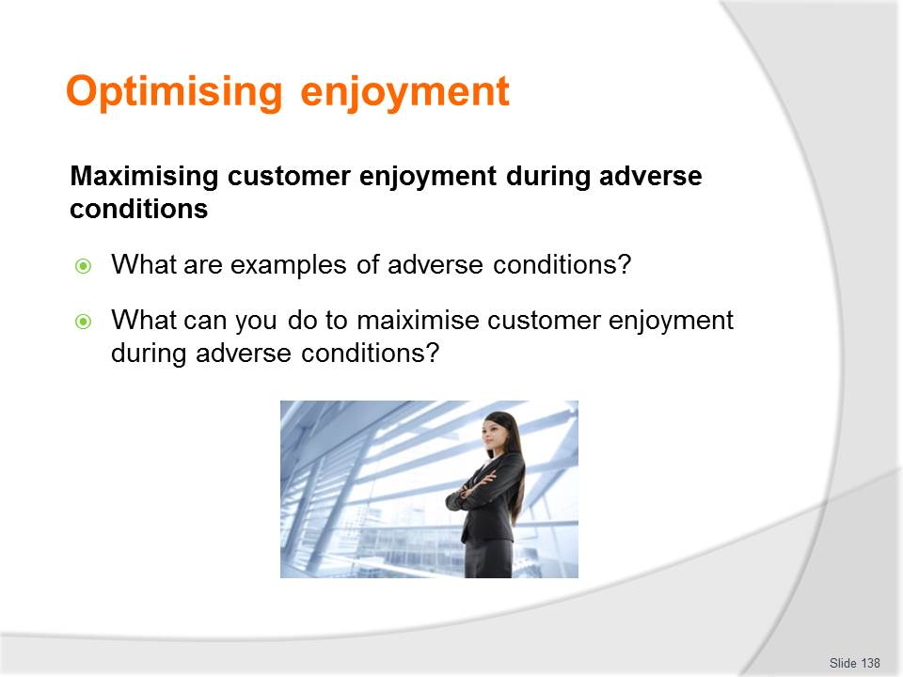
Slide No | Trainer Notes
Class Activity – Resolving dissatisfaction in ‘adverse’ conditions?
- Discuss questions in the slide.

Slide
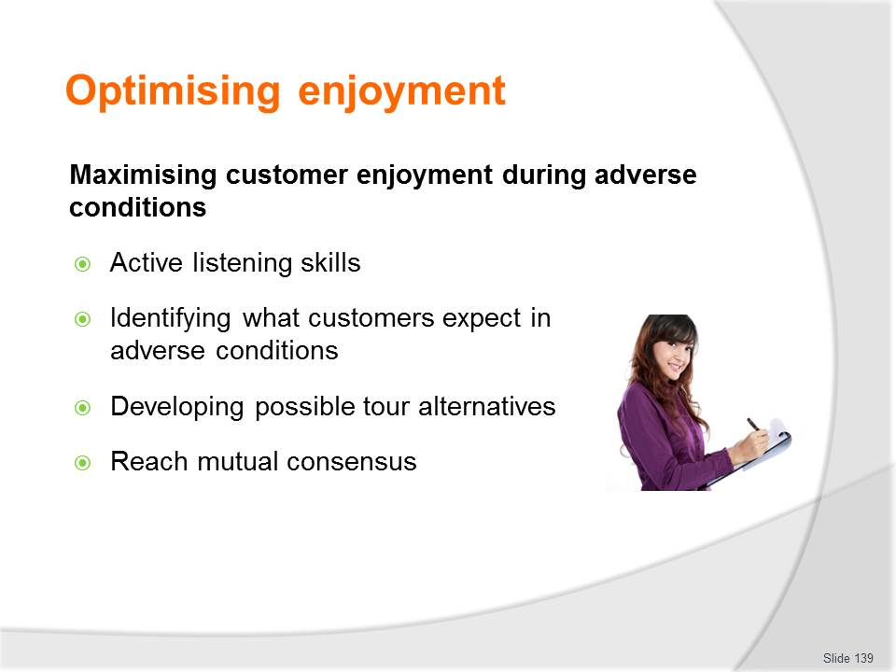
Slide No | Trainer Notes
Class Activity – Resolving dissatisfaction in ‘adverse’ conditions?
- What other strategies could you utilise?

Slide

Slide No | Trainer Notes
This is the conclusion of the subject.
Thank the audience and deliver assessments as required.

Recommended training equipment
- Advanced Bookings/Group Bookings file
- Commentaries - templates and examples
- Emergency procedures
- Employee Code of Conduct
- Tour related legislation
- Personal grooming and attire guidelines
- Public address system:
- In-house systems
- Portable system
- Megaphones
- Security policies and procedures
- Tour brief
- Tour itinerary
- Tour related assets:
- Keys
- Security Passes
- Equipment
- Tour related documents and information including:
- Log book
- Inspection checklists
- Support materials or props
- Merchandise/give-aways
- Tickets and vouchers
- Name tags
- Communication equipment
- Personal protective equipment and clothing
- Equipment
- Brochures and site maps
- Handouts
- A ‘We are here’ flag
- Tour related materials including:
- Props, materials and aids might include:
- Work sheets
- Pens and pencils
- Binoculars
- Maps
- Photos
- Posters
- Diagrams
- Information leaflets
- Costumes
- Electronic guides
- Beverages / foods / holders
- Tour related rules, procedures and regulations
- Tour related Standard Operating Manual.

Instructions for Trainers for using
PowerPoint – Presenter View
Connect your laptop or computer to your projector equipment as per manufacturers’ instructions.
In PowerPoint, on the Slide Show menu, click Set up Show.
Under Multiple monitors, select the Show Presenter View check box.
In the Display slide show on list, click the monitor you want the slide show presentation to appear on.
Source: http://office.microsoft.com
Note:
In Presenter View:
You see your notes and have full control of the presentation
Your trainees only see the slide projected on to the screen
More Information
You can obtain more information on how to use PowerPoint from the Microsoft Online Help Centre, available at: http://office.microsoft.com/training/training.aspx?AssetID=RC011298761033
Note Regarding Currency of URLs
Please note that where references have been made to URLs in these training resources trainers will need to verify that the resource or document referred to is still current on the internet. Trainers should endeavour, where possible, to source similar alternative examples of material where it is found that either the website or the document in question is no longer available online.

Appendix – ASEAN acronyms
AADCP | ASEAN – Australia Development Cooperation Program
ACCSTP | ASEAN Common Competency Standards for Tourism Professionals
AEC | ASEAN Economic Community
AMS | ASEAN Member States
ASEAN | Association of Southeast Asian Nations
ASEC | ASEAN Secretariat
ATM | ASEAN Tourism Ministers
ATPMC | ASEAN Tourism Professionals Monitoring Committee
ATPRS | ASEAN Tourism Professional Registration System
ATFTMD | ASEAN Task Force on Tourism Manpower Development
CATC | Common ASEAN Tourism Curriculum
MRA | Mutual Recognition Arrangement
MTCO | Mekong Tourism Coordinating office
NTO | National Tourism Organisation
NTPB | National Tourism Professional Board
RQFSRS | Regional Qualifications Framework and Skills Recognition System
TPCB | Tourism Professional Certification Board





